




FINAL PROJECT

The Passive house

PASCUAL SANCHIS, ISAAC

Escuela técnica superior de ingeniería de la edificación (UPV)

Jade Hochschule (Oldenburg)

Index
- Introduction
  - Limiting values for Passive House Standard
  - Passive House criteria
  - Advantages through Passive House standard
- Main features of Passive House
  - Insulation
  - Design avoiding thermal bridges
  - Air Tightness to Avoid Structural Damages
  - Why a mechanical ventilation system is recommended
  - Windows for Passive Houses
- Passive Houses in Germany
  - History of passive houses

3.2 The energy laboratory of the University
- Passive Houses in Spain
- Passive House Planning Package
- Passive-On
- Project of Passive House
  - Valencia
    - Localitation and features
    - Architecture
    - Climate
  - Celular concrete
    - Insulation
    - Humidity
    - Mechanical resistence
    - Sound proofing

  - Geothermal Solar building
    - Taking avantage of the subsoil temperance
    - An unbeatable efficiency
    - Technology for energy efficiency
    - An investment-saving
    - Examples of geothermal energy in practice
  - Description of the construction
  - Calculations

- Bibliography

- Introduction
Passive houses are buildings that use resources architecture bioclimatic energy with an efficiency much higher than traditional construction, according to the conventional definition of Passivhaus Institute of Darmstadt: "a building that achieves a very high comfort, almost without any heating in winter or air conditioning in summer "
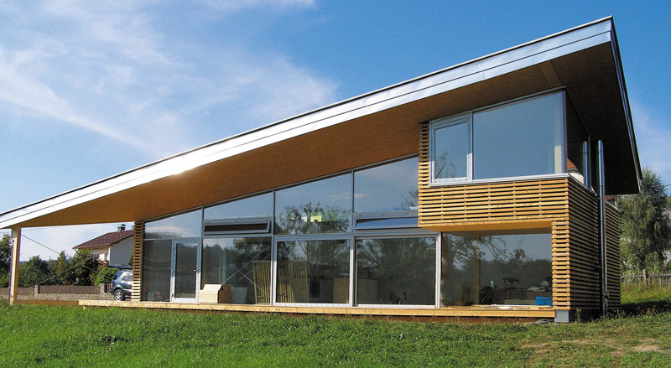
Buildings are designed to maximize light and heat received from this source of energy, resulting a temperature and humidity comfort, fit and healthy. There are a healthy environment at any time of year, without further heat production. Basically, to make this possible, the isolation of these houses is absolute and the air exchange takes place via a mechanical ventilation system that renews and purifies the air without letting heat escape.

By comparing the energy expenditure of a passive house with a house conventional can say that the heating energy is 80-90% lower.
The energy that we take is from a lesser extent the heat of the occupants and especially the sun that is almost enough to keep the building warm.

  - Limiting values for Passive House Standard

-The total energy for heating and cooling of the house must be less than or equal to 15kWh/m2 / year, or what is the same 1.5 liters of diesel litres/m2 / year.
- The coefficient of heat transmission of the exterior walls of the building (U value) must be less than 0.15 W / m² K
-The final energy should be less than 120 kWh / m² / year (15 kWh / m² / year + thermal energy to heat water + electricity consumed by the ventilation air + consumption +electricity)
- You must get a minimum flow, air renewal required per 30 m ³ / h.

- To unheated space through the ventilation system must be controlled to limit energy demand in a room to 10W / ​​m (u)

- The rehabilitation may increase the harsh limitations of standard 15 up to 25 kW/m2kW/m2 to since it has to work on predefined conditions.

1.2 Passive House criteria

-Construction with super-insulation, U value to be less than 0.15 W / (m2 K)
-We should avoid all thermal bridges
-We must use skilled labor, because the details have to be as constructive in the project; we don’t admit variation, this may vary the transmittance values
-The construction should be as compact as possible
-We should use solar energy for the south facing and must consider the construction of shadows, (mobile or fixed shadows).
-The window frames and glass must have a transmittance value of less than 0.8 W / (m2 K)
-The buildings should be of great tightness
-Efficiency savings in electrical machines
-Use of renewable energy
-You can use duct ground heat exchanger to maintain temperature

1.3 Advantages through Passive House standard

-The main advantage would be savings in energy consum
-Can be regulate the humidity
-Great indoor air quality
-There's no problem for people allergic to air filters, because it have high quality
-Thanks to the absence of thermal bridges, we avoid moisture and mold infestation
-Thanks to the high insulation, we reduce cold in winter and heat in summer
-There are no radiators, we have no problems of dust dispersion footprint
-Great sound insulation

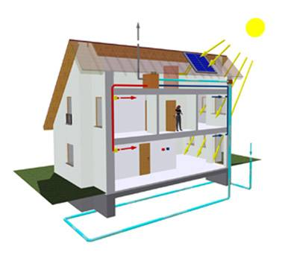
The aim of Passive House standards is more comfort, simultaneous to lower monthly debit for financing and secondary costs, to maintain a high value in the long run high and protect the environment as well.
- Main features of Passive House

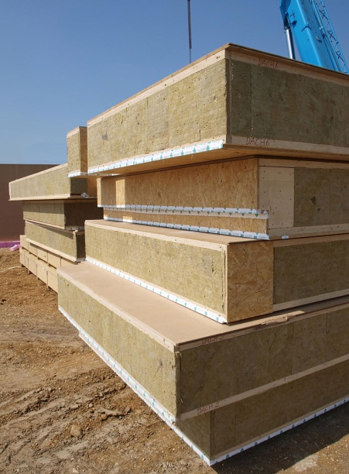
2.1 Insulation
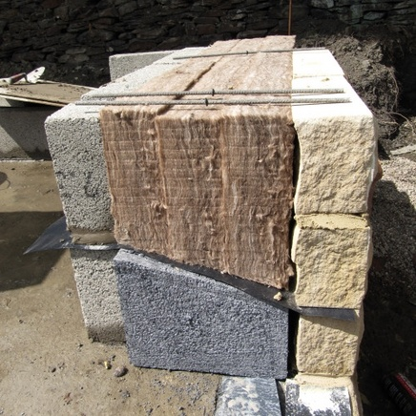
In a Passive Home the whole building envelope has an excellent thermal insulation. The envelope consists of all parts of the construction, which separate the indoor climate from the outdoor climate. All construction methods can be used for Passive Houses and have been tested successfully: masonry construction, lightweight construction, prefabricated elements, insulating concrete formwork construction, steel construction, and all combinations of the methods above.
The thermal heat loss coefficients (U-Values) of external walls, slabs to the ground, and roofs are within 0.1 to 0.15 W/(m²K) These are upper level values for all contemporary constructions. As a consequence the transmission heat losses during the cold season are negligible. Another consequence is that the temperatures of the internal surfaces are almost the same as the indoor air temperature. This leads to a very comfortable indoor climate and avoids damages caused by the humidity of indoor air.
During hot periods in summer, a high thermal insulation is a protection against heat, too. To ensure high thermal comfort during summer, well designed shading and sufficient ventilation are important, too.
Good thermal insulation and an airtight construction are well proved in Passive Houses. Another basic principle used is"Construction Avoiding Thermal Bridging": The insulation is applied continuously around the envelope of the building without serious thermal bridging. By this method there will be no cold spots and no increased heat losses. This is a contribution to high quality, comfortable, and long lasting construction, too.
Insulation is efficient for energy conservation, increasing thermal comfort in existing buildings, too. This will be shown by retrofit examples in Workshops on using Passive House components for refurbishment.

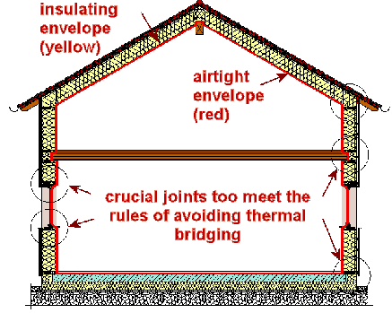
click on the figure will provide a larger one
The most important principle of a Passive House: insulation (yellow), applied continuously around the building envelope without thermal bridging - this reduces the heat losses like a warm coat. Most insulation materials are not airtight, however. Therefore the envelope has to be airtight, too. The airtight envelope can be seen in the section, too - it is given by the red line. The reduction of thermal bridges is very important; A special design method, the "Construction Avoiding Thermal Bridging" has been developed to simplify this design detail.

2.2 Design avoiding thermal bridges
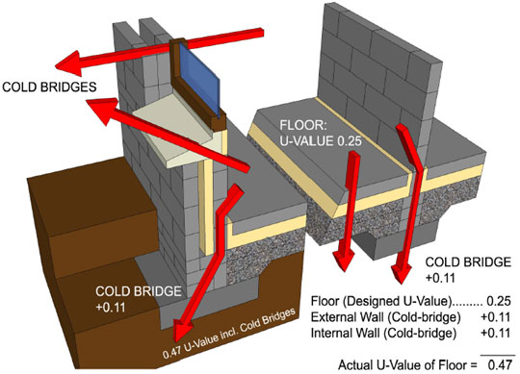
Heat will flow the easiest path from the heated space to the outside - the path with the least resistance. And this will not necessarily be the path perpendicular to the surfaces. Very often heat will “short circuit” through an element which has a much higher conductivity than surrounding material. In such cases the experts call this a "thermal bridge".
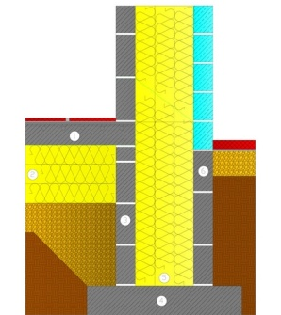
Typical effects of thermal bridges are:
- Decreased interior surface temperatures; in the worst cases this can result in high humidity in parts of the construction
- Significantly increased heat losses.
Both can be avoided in Passive Houses: The internal surface temperatures are high enough that a critical humidity can not occur at any place, and the additional heat losses will be negligible. If the thermal bridge coefficient (which is an indicator of the extra heat losses of a thermal bridge) is lower than 0.01 W/(mK), the detail is said to be “Thermal Bridge Free”.
If this criterion of avoiding thermal bridges is fullfilled throughout the thermal envelope, neither the designer nor the builder has to worry about cold and humid parts in the construction - and it will be far much simpler to calculate the heat energy balance.
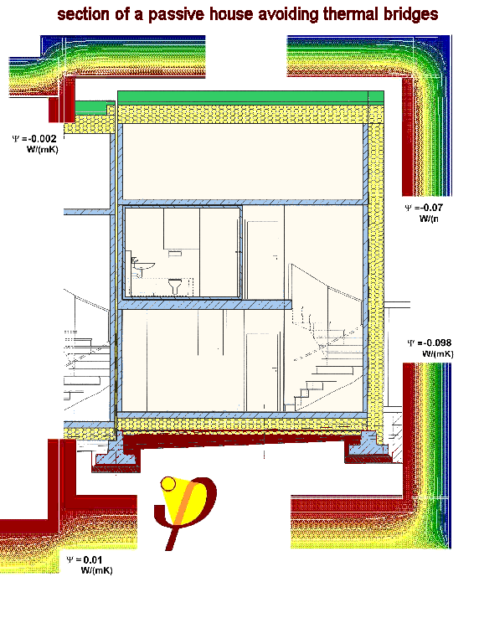
This section illustrates a building envelope avoiding thermal bridges end-to-end.

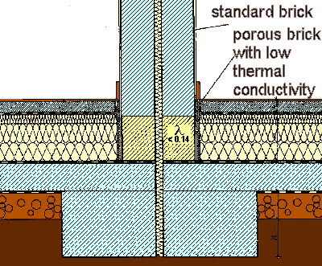
An example: The thermal bridge at the joint of the interior masonry wall withthe slab-on-grade can be avoided almost completely if a porous concrete block (yellow) is used for the first row of bricks.

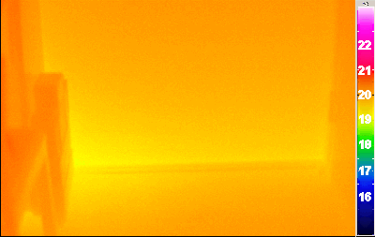
This is an infrared picture documenting that the thermal separation of the external wall from the concrete basement floor is working: There is no significant temperature drop (IR-photo taken by PHI).
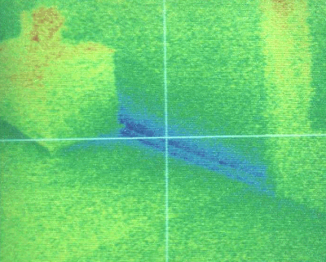
This is how it looks if no care is taken about the thermal separation: a cold band (blue) all along the baseboard is visible.This will often cause damages by high humidity. It can be eliminated by a design for avoiding thermal bridges.

2.3 Air Tightness to Avoid Structural Damages
The external envelope of a building should be as airtight as possible - this is true for conventional as well as for passive houses. It is the only means to avoid damage caused by condensation of moist, room warm air penetrating the construction. Such damage not only occur in cold climates; in hot and humid climates the problem can occur from airflows from the outside to the inside. The cause is the same in both cases: a leaky building envelope.
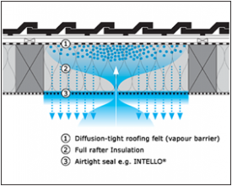
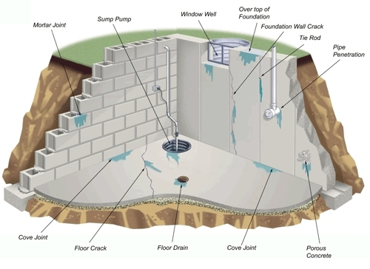
Drafts in living spaces are not tolerated by occupants any more: Therefor a very airtight construction is essential to fulfil modern thermal comfort expectations. Most building codes, worldwide, require airtight building envelopes and this is a reasonable and useful requirement.
Air tightness should not be mistaken forinsulation. Both qualities are essential characteristics of a high quality building envelope, but in most cases both have to be achieved independently:
- A well insulated construction is not necessarily airtight, too. Air can easily pass through insulation made from coconut, mineral or glass wool. These materials have excellent insulation properties, but are not airtight.
- On the other hand an airtight construction is not necessarily well insulated: e.g. a single aluminium foil can achieve excellent air tightness, but has no relevant insulation property.
Air tightness is an important, but not the most important requirement for energy efficient buildings. Further, achieving air tightness should not be mistaken with the function of a "vapour barrier". The latter is a diffusion tight layer: An oiled paper e.g. is airtight, but it allows moisture vapour to pass through. Conventional room plastering (gypsum or lime plaster, cement plaster or reinforced clay plaster) is sufficiently airtight, but allows vapour diffusion.
Infiltration can not guarantee good indoor air quality. Houses built in Germany after 1985, for example, are so airtight that infiltration alone is inadequate to assure acceptable indoor air quality. Yet, these houses are still at risk regarding moisture damage to the construction from moist room air exfiltration.
Careful design and accurate workmanship are the prerequisites to success. Construction details needed to achieve tightness are available for all important joint and envelope penetration situations.
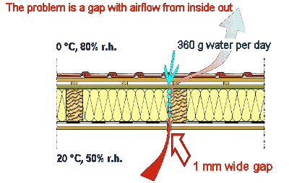
If a construction is not sufficiently airtight, moist room air can penetrate into the construction, condense and cause damage. In hot humid climates infiltration of humid outside air can damage construction. The problem can be solved by thorough, air tight design.
Air tightness is not a mere nicety of energy saving construction, it is essential to avoid construction damage. Gaps in the construction will lead to substantial humidity transport by convection.
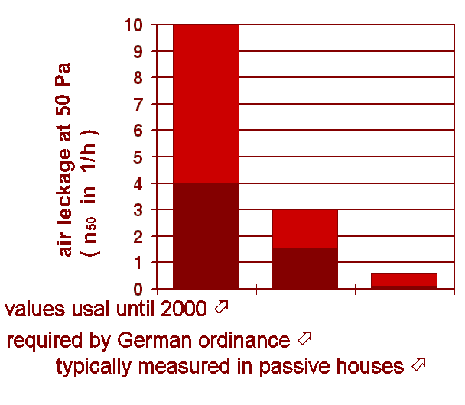
The diagram compares the air tightness of passive houses to that of existing and typical new construction.
Everybody who plans to build a new house is well advised to pay attention to the air tightness of the envelope construction. Fixing the problem after the house is built can be difficult and costly.
2.4 Why a mechanical ventilation system is recommended
The health and comfort of the inhabitants are the most important objectives of a Passive House design. Excellent indoor air quality is indispensable. But this can only be achieved if stale air is exchanged with fresh outdoor air at regular intervals. This can definitely not be done by just opening windows twice a day.
Ventilation will work accurately only if polluted air is removed constantly out of kitchen, bathrooms, and all other room with significant air pollution. Fresh air has to be supplied to the living room, children’s room, sleeping rooms, and workrooms to substitute the removed air.
The system will supply exactly as much fresh air as is needed for comfort and for good indoor air quality; only outdoor air will be supplied – no recirculated air. This will lead to a high level of indoor air quality.
What has been discussed so far could be satisfied by using a simple exhaust fan ventilation system, where the air is supplied through direct vents in external walls. These vents allow fresh (cold) air to enter the room at the required rate. However, for a Passive House, the heat losses caused by such a system are much to high.
In Central Europe Passive Houses will only work with highly efficient heat recovery. Heat from the exhaust air is recovered and applied to the supply air by a heat exchanger. The air flows are not mixed in the process. State of the art ventilation systems may have heat recovery rates of 75% to more than 95%. Of course this only works with counterflow heat exchangers and very energy efficient ventilators.
An additional opportunity to increase the efficiency of ventilation systems is the use of earth buried ducts. The ground during winter has a higher temperature than outdoor air, and during the summer a lower temperature than outdoor air. Therefore it is possible to preheat fresh air in an earth buried duct in winter, or to cool it in summer. This can be done directly with air ducts in the ground, or indirectly with brine circulating in earth buried pipes and heating or cooling the air with a water-to-air heat exchanger.
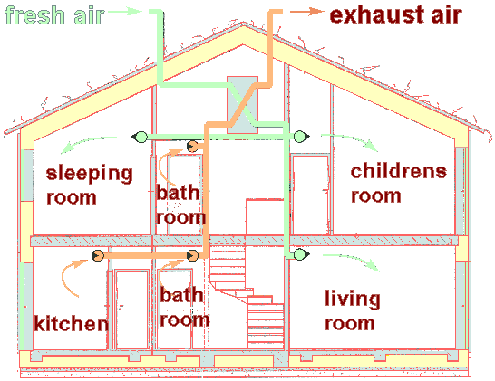
The scheme of a comfortable ventilation system. Stale air (brown) is removed permanently from the rooms with the highest air pollution. Fresh air (green) is supplied to the living rooms.

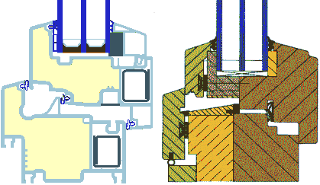
2.5 Windows for Passive Houses
To build Passive Houses, highly efficient windows have to be used. The type of glazing and frames will depend on climate, however. In the Central European climate there are three essentials:
- Triple glazing with two low-e-coatings (or another combination of panes giving a comparable low heat loss)
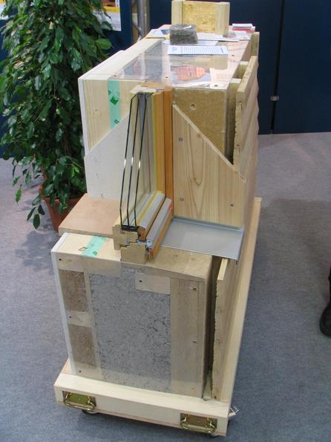
- "Warm Edge" - spacers,
- Super-insulated frames.
These components harmonize in a way that the total heat loss of such a window is only half as high as compared to a conventional new window. But direct and indirect solar gains are collected through the glazing, too. Therefore, it has been demonstrated that by using these highly efficient windows, the result will be a positive energy balance even in the Central European winter period, as long as the orientation is suitable and the shading not excessive.
The thermal loss coefficients, U_{w}, of such Passive House windows are lower than 0.8 W/(m²K) according to the new European standard (EN 10077). One consequence of such a low heat loss is that the interior surface temperature of such a window, even in cold European winter nights, will exceed 17 °C. This results in excellent thermal comfort even near the window: There will be neither trouble with "cold radiation" from the window nor an unpleasant lake of cold air at the floor.
The 17 °C condition for minimum internal surface temperatures of windows in a Passive House is the defining requirement for Passive House windows in any given climate.
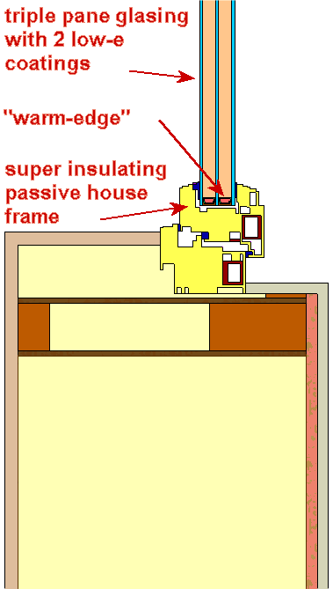
A Passive House window with an U_{w}-value lower than 0.8 W/(m²K) assures a high thermal comfort.

- Passive Houses in Germany

  - History of passive houses

The standard Passivhaus officially formulated in 1988 by Professors Bo Adamson of Lund University in Sweden, and Wolfgang Feist, German Institute of Construction and Environment
The first Passivhaus residences were built in Darmstadt, Germany in 1990, and Occupied by the clients by the Following year .
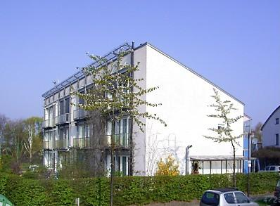
They were built by architects Professor Bott, Professor Ridder and Professor Westermeyer. The building has four townhomes that has been subjected to numerous studios, this construction has an annual heat requirement of about 10 kWh / (m² a).
In 1994, Dr. Wolfgang Feist founded the Institut PassivHaus in Darmstadt (Hessen, Germany).
It is estimated that there are about 20,000 constructions made in this standard would mean (In Germany alone there are over 10,000 passive house examples in both domestic and commercial buildings).

The region Vorarlberg (Austria) requires that all new apartment blocks are made in standard Pasivhaus.
It is an energy concept applies to any style of architectural design to any style of construction and / or any material used. Energy consumption is minimized through the implementation of passive measures and the technical features of the standard.

3.2 The energy laboratory of the University
The energy laboratory of Carl von Ossietzky University of Oldenburg is used for building research and teaching the use of renewable energies in the physics department since 1982.
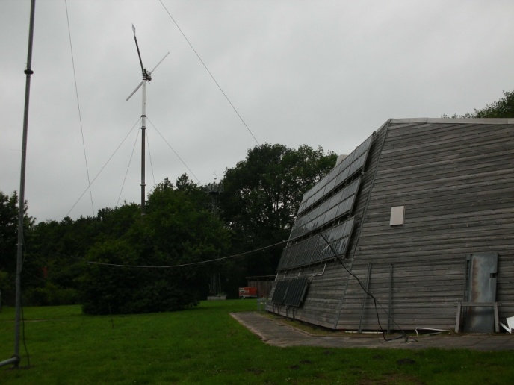
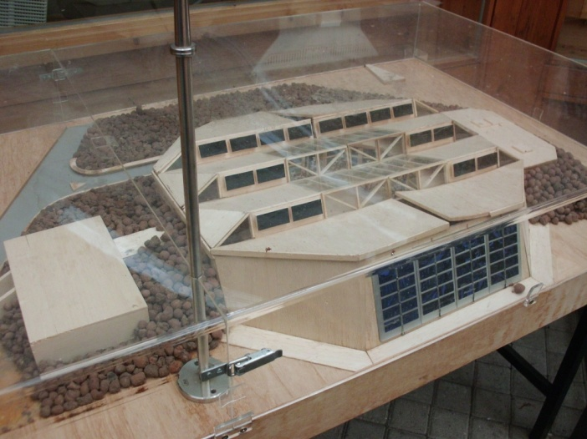

The basic idea of ​​this construction is to save energy, construction shaped house and well insulated.

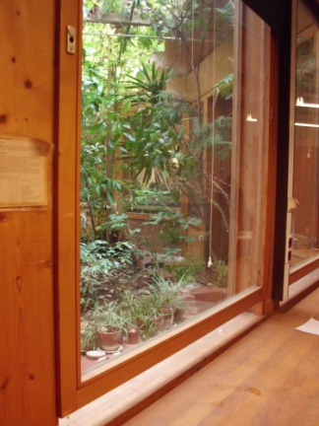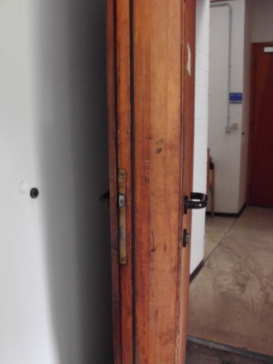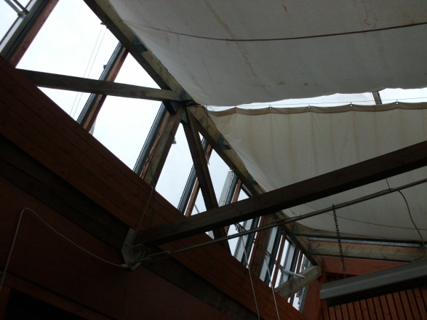

Moreover, the laboratory has a supply of energy based on renewable energy independent. Energy solar, wind and geothermal provide all the electricity needed, but when there is insufficient energy to work the combination of propane gas, heat and power . Thanks to use of thermal and electrical energy can be said that it achieve high efficiency.
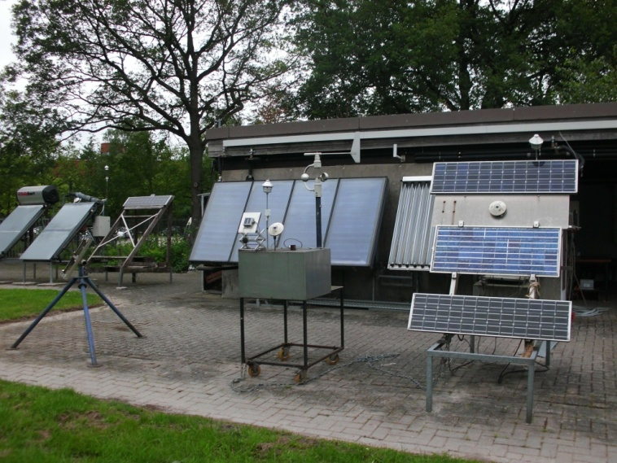
The power generation system in the laboratory of energy is based on the production of electricity by the photovoltaic generation (PV), wind energy and combined heat and power converter. The term "photovoltaic" means that the solar cells that convert sunlight directly into electricity.
The building's electricity demand for lighting, computers, laboratory equipment, measuring equipment, circulation pumps, etc. is about 15,000 kWh per year.
The Energy Laboratory isn’t a model for home energy supply, it is a continue experiment in physics; the new techniques and the interaction of different modules are practically tested and improved.

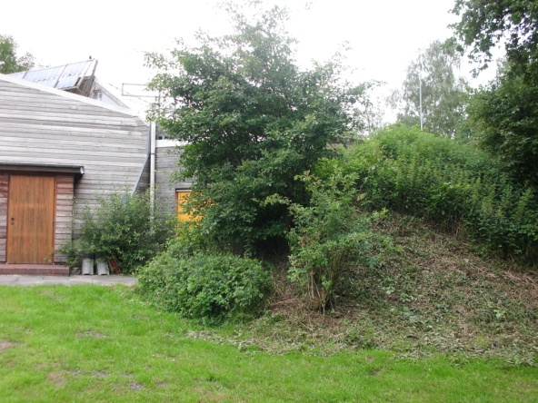
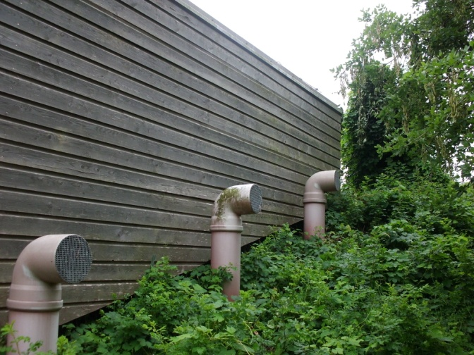

- Passive Houses in Spain
The word “Passivus” originating in Latin, the subject is said that receives the action of the agent without cooperating with it. Spain is suffering extreme temperatures and has had to adapt to all types of weather conditions by using different elements depending on the geographic area: granite walls or adobe, whitewashed walls or baked bricks, large or small windows, decks tile, slate, gypsum. All systems, passed down from generation to generation, simple but effective we can see across and along the more rural areas of Spain.
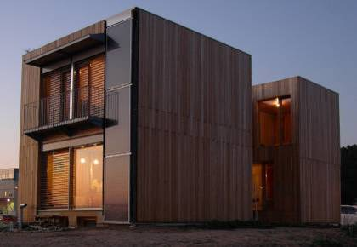
The first passive house in Spain was built in 2009 and is the work of an architect of Lleida, Josep Bunyesc. It is located in Lleida and incorporates building elements such as recycled wood boards glued to prevent condensation on the walls and sheep's wool to allow the evacuation of humidity. It also has large windows to capture light energy from the sun, and a method of venting air channels and wells that gives the home a constant temperature of 23 º C.
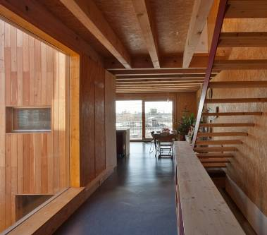
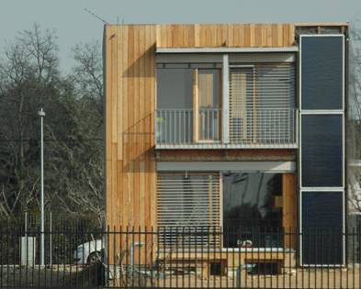
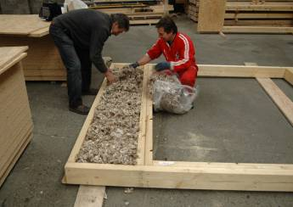
To complement this; if the Projekt Passivehaus combined with renewable energy, energy efficiency achieved easily switch from a "passive house" to an "autonomous house".

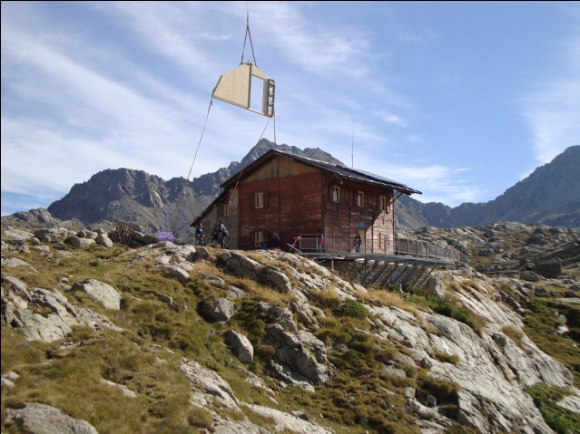
Josep Bunyesc architecture could be Guinness. After building the first passive house in Spain, in Lleida his own house, the architect completed the expansion of the Refuge Colomina. It is built to 2,400 meters high, and it takes two hours to walk to the nearest road and was built in one week. This is a remodeling of a building of 1917, the Keller House, which was named by the German engineer who signed the first hydroelectric work in Spain. In the montain “Encantats de Pallas”, in the “Aigues Tortes” National Park, the largest lake area in the Pyrenees, with more than 24 lakes, receives regular visits from hikers who made ​​the crossing “Pallars-Ribagorça-Aran”.
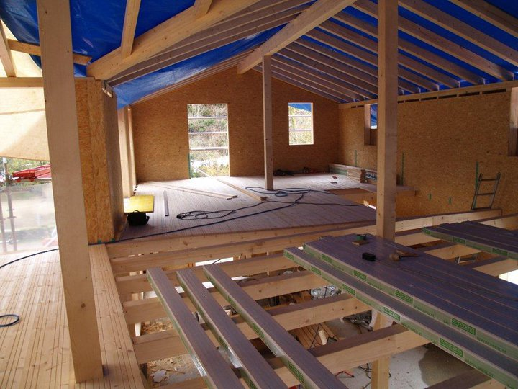
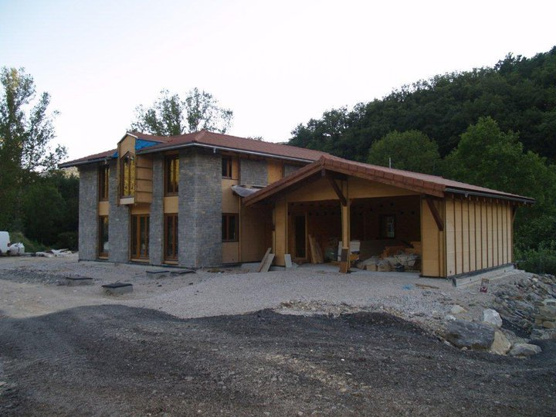
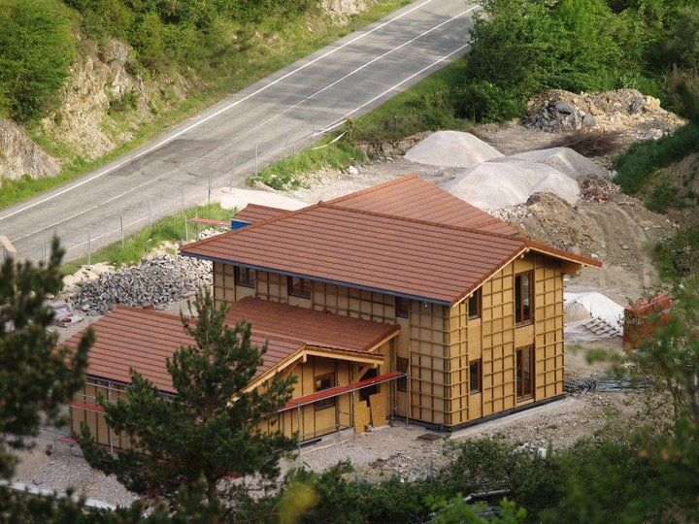
The "Casa Arias"is the second in Spain to receive the certificate of "passive house"by the German Institut Passivhaus, was inaugurated last April 14, 2011 in the town of Roncal, Navarra.
This house will be used, as well as residence Arias normal family, as a testing laboratory to study the behavior of materials and systems installed and functioning energy. In addition to comparing the projected values ​​and certificates will be made compared with values ​​in normal operation as a residence. This energy concept is applicable to any architectural style, any style of construction, or any equipment used.

The next certified passive house in Spain may be in Mallorca in the municipality of Santanyi, as was recently approved construction of a luxury mansion certified by the Passivhaus institut (Darmstadt). Technology uses a passive house in a typical Majorcan Country House in “S’Alqueria Blanca” in the south east of Mallorca.

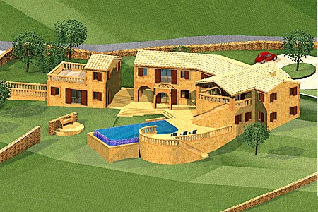
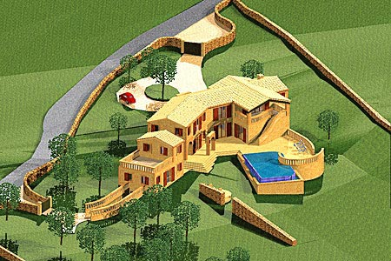

And despite these extra costs, when a 'passive house' would be economically viable in Spain?
The extra cost for Spain is considering between 8-12% of the cost of conventional implementation, depending on the case. If a house worth 200,000 euros, would cost 20,000 of extra cost. From the outset it is worth the investment. The energy cost difference between a obligatory “Clase E” and Passive House, currently allows an annual depreciation of between 8 and 12 years depending on the case, which is an investment with an annual profit of about 10% of investment performed.
Is this type of housing has some public support to be built?
Currently there are subsidies for housing made ​​with energy rating class A as the “Código Técnico de la Edificación” (spanish regulation). The demand, the thrust of the industry and competitiveness, which also generated many new jobs in specials labor, made the extra cost would be reduced to between 3 and 5% of the additional costs of the “conventional house”. This also reduces the return periods of the initial investment. Being a home with few energy costs, banks are informed and more willing to lend. Apart from any subsidies that may exist in each territory (communities of Spain).

The European Union is preparing a directive that will determine that the power ofpublic buildings to be neutral in 2015 and the rest of the property five years later. All buildings will have to be like this, not to exceed the 15 kWh/m2/year or, which is the same, 1.5litros/m2/año. If a normal house spends 2,000 euros per year in heating, this only uses 200 euros.

- Passive House Planning Package
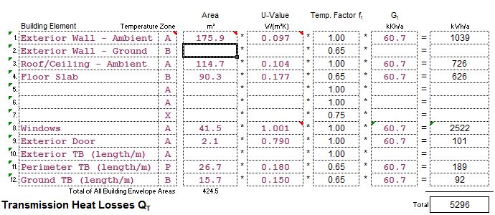
Passive House Planing Package is a computer program on a spreadsheet (Excel) for architects and designers of passive houses, in order to perform this type of project. The spreadsheet will calculate the U values ​​of the components of thermal insulation, energy balances, determine the ventilation rates calculated comfort and thermal loads, although there aren’t climatic data in locations outside Germany.
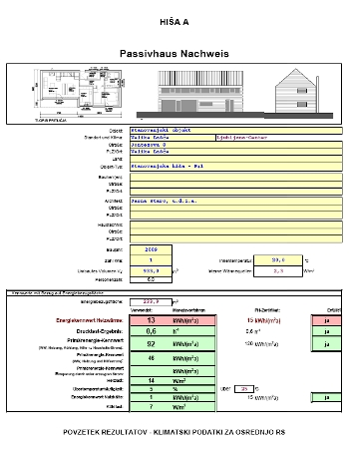
The PHPP has been able to characterize thermally passive houses with surprising approach. It is an application that has been specially developed for passive houses and being a spreadsheet is very easy to use, the user can perform the project without too much complexity. The designer can evaluate design solutions without the need to wait for the execution of simulations.

- Passive-On

It is a calculation program that intends to adapt the concept of passive house the rest of Europe; in this case the rest of Europe would be the south because the climate is different with regard to central Europe. In southern regions there are very high energy consumption in both, summer and winter. Passive-on attempts to adapt the advances that exist for cold climates to warm climates, develop energy savings during the summer cooling.
It is addressed to architects and building professionals to guide them in assessing the actual costs design for all seasons and all climates, both the dominated cooling loads and the dominated by heating loads. Project is aimed mainly Italy, Spain and Portugal which have few resources to develop innovative designs. A portion of the guide is built into the PHPP (Passive House Planning Package) developed by the Passivhaus Institute in Germany (Darmstadt).Passive-on program is to expand the program to allow the user PHPP calculating cooling loads and evaluation of passive solutions in summer. The project will evaluate the definition of passive Standard House, and as shall be amended to take account cooling charges and other energy consumption within the home.
The project will provide a report as to evaluate potential for improvement and procedures to implement it. The project will include an analysis of housing development do you currently passive and low energy consumption in the partner countries, an analysis of selected models of passive houses in partner countries to estimate the total energy savings in the medium and short term an analysis of political and administrative benefits of the development of voluntary certification for passive house.
Finally, the project aims to spread the passive house concept from all users of the member countries

- Project of Passive House

7.1 Valencia
7.1.1 Localitation and features

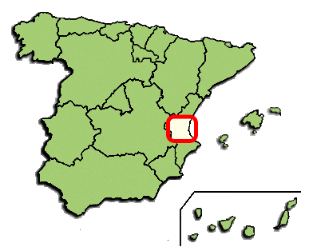
Valencia is the most populous city of the Autonomous Community ofValencia and the third largest city in Spain, with a population of 809,267 in 2010. It is the 15th-most populous municipality in the European Union. About 1,564,145 people live in the Valencia urban area and 1,705,742 in the Valencia metropolitan area.
Valencia city is on the Mediterranean coast of the Iberian Peninsula, in the center of the gulf of Valencia, on the great alluvial plain that form the rivers Júcar and Turia. It is integrated into an industrial area on the Costa del Azahar. Its main festival, the Falles, is known worldwide, while the traditional dish, paella, originated around Valencia.
The city contains a dense monumental heritage, including the Llotja de la Seda (World Heritage Site since 1996), but its landmark is undoubtedly the City of Arts and Sciences, an avant-garde and futuristic museum complex.

7.1.2 Architecture

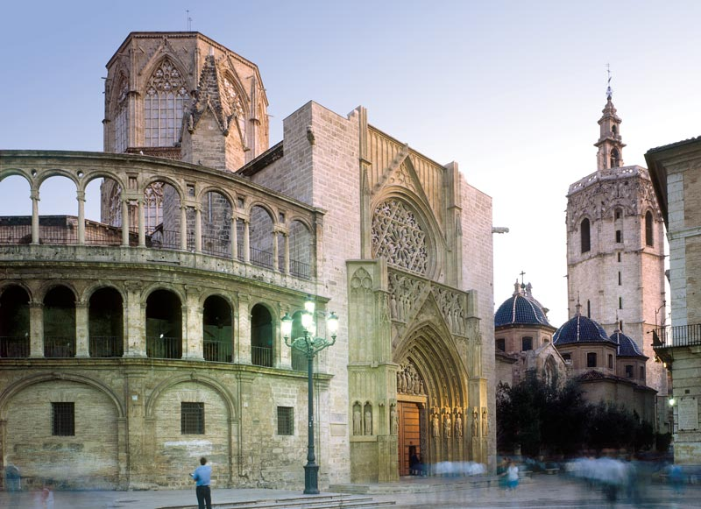
The ancient winding streets of the Barrio del Carmen contain buildings dating to Roman and Arabic times. The Cathedral, built between the 13th and 15th century, is primarily of Gothic style but contains elements of Baroque and Romanesque architecture. Beside the Cathedral is the Gothic Basilica of the Virgin (Basílica De La Virgen De Los Desamparados). The 15th century Serrano and Quart towers are part of what was once the wall surrounding the city.
UNESCO has recognised the silk exchange market (La Lonja de la Seda), erected in early Valencian gothic style, as a World Heritage Site. The modernist Central Market (Mercado Central) is one of the largest in Europe. The main railway station Estación Del Norte is built inmodernisme (the Spanish version of Art Nouveau) style.
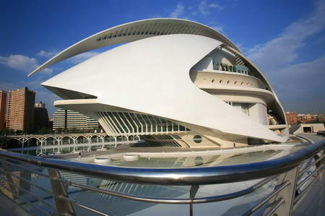
World-renowned (and city-born) architect Santiago Calatrava produced the futuristic City of Arts and Sciences (Ciutat de les Arts i les Ciències), which contains an opera house/performing arts centre, a science museum, an IMAX cinema/planetarium, an oceanographic park and other structures such as a long covered walkway and restaurants. Calatrava is also responsible for the bridge named after him in the center of the city. The Music Palace (Palau De La Música) is another good example of modern architecture in Valencia.
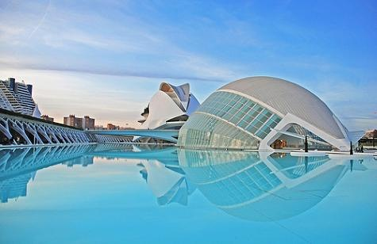

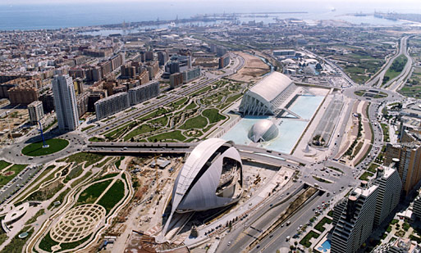
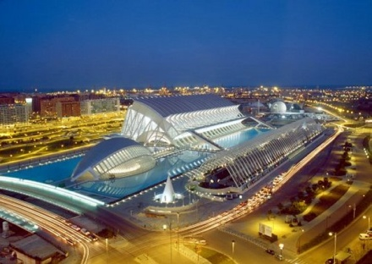

7.1.3 Climate

This particular geography of Valencia contributes in huge measure to the Valencia climate. Know all about the Valencia climate before chalking out your Valencia travel guide to avoid rain delays and the like on your Valencia holidays.

Tourists around the world will vouch for the pleasantness of the Valencia climate. Then climate in Valencia, Spain is a Mediterranean-type climate characterized by warm and dry summers and mild winters. But what endears the Valencia climate to one and all are the endless number of sunny days that the region enjoys throughout the year. Valencia climate sees about 320 sunny days in a year, making for a great outdoors venue.

The weather in Valencia, Spain borders on the warmer side with the yearly average temperature hovering somewhere around 21-degree Celsius and the average humidity around 70%. July and August are the peak summer months whence the average temperature is about 26-degree Celsius. In the winter months, from November to March, the average temperature is around 13-degree Celsius. The mountainous reaches of Valencia however see the temperatures plummeting to below the freezing point in the winter months.

Valencia climate offers pleasant summers and bearable winters (at least in most parts of the region) but important from the Valencia tourism point of view is information regarding the rainy season in Valencia. There are four seasons in Valencia and the rains come down, in copious amount too, in the spring and autumn. In the higher reaches of Valencia, this rainfall sometimes turns into snow.

The Valencia weather is one of the reasons for the tourists flocking to the region almost throughout the year. The Valencia climate with all its equitable coastal climate characteristics almost lulls you into believing that it is always spring here.

 | January | February | March | April | May | June | July | August | September | October | November | Dicember | Total
Month
Daily mean | 11,5 | 12,6 | 13,9 | 15,5 | 18,4 | 22,1 | 24,9 | 25,5 | 23,1 | 19,1 | 14,9 | 12,4 | 17,8
Averege high | 16,1 | 17,2 | 18,7 | 20,2 | 22,8 | 26,2 | 29,1 | 29,6 | 27,6 | 23,6 | 19,5 | 16,8 | 22,3
Averege low | 7,0 | 7,9 | 9,0 | 10,8 | 14,1 | 17,9 | 20,8 | 21,4 | 18,6 | 14,5 | 10,4 | 8,1 | 13,4
Precipitation | 36 | 32 | 35 | 37 | 34 | 23 | 9 | 19 | 51 | 74 | 51 | 52 | 454
Humidity | 63 | 61 | 61 | 60 | 65 | 65 | 66 | 68 | 67 | 66 | 65 | 65 | 65
Days
Av. Precipitation | 4 | 3 | 4 | 5 | 5 | 3 | 1 | 2 | 4 | 5 | 4 | 5 | 44
Av. Snow | 0 | 0 | 0 | 0 | 0 | 0 | 0 | 0 | 0 | 0 | 0 | 0 | 0
Av. Storm | 0 | 0 | 1 | 1 | 2 | 2 | 2 | 3 | 3 | 2 | 1 | 0 | 18
Av. Foggy | 1 | 2 | 1 | 1 | 1 | 1 | 0 | 1 | 1 | 0 | 1 | 1 | 10
Av. Frost | 0 | 0 | 0 | 0 | 0 | 0 | 0 | 0 | 0 | 0 | 0 | 0 | 0
Av. Sunny | 9 | 6 | 7 | 5 | 5 | 8 | 13 | 10 | 7 | 6 | 7 | 7 | 91
Sunshine hours | 169 | 169 | 212 | 229 | 256 | 271 | 314 | 285 | 237 | 201 | 167 | 150 | 2.660
(The measures are from 1971 to 2000)

Its average annual temperature is 17.8 °C: 22.3 °C during the day and 13.3 °C at night. In the coldest month - January - the temperature typically ranges from 10 to 18 °C during the day and 2 to 12 °C at night, with the average sea temperature being between 13–14 °C. In the warmest month - August - the temperature during the day typically ranges from 28–34 °C, above 23 °C at night, the average sea temperature is 26 °C. Sunshine hours are up to 2,660 per year, from 150 (average 4.8 hours of sunshine / day) in December to 314 (average 10 hours of sunshine / day) in July. Average relative humidity is 60% in April to 68% in August. Average number of days above 21 °C is 200, average number of days above 32 °C is 11 (1 in June, 4 in July, 4 in August and 2 in September). Generally, summer temperatures similar to those experienced in northern Europe last about 8 months (from April to November). Two months (December and March) are transitional, with temperatures above 20 °C sometimes occurring.
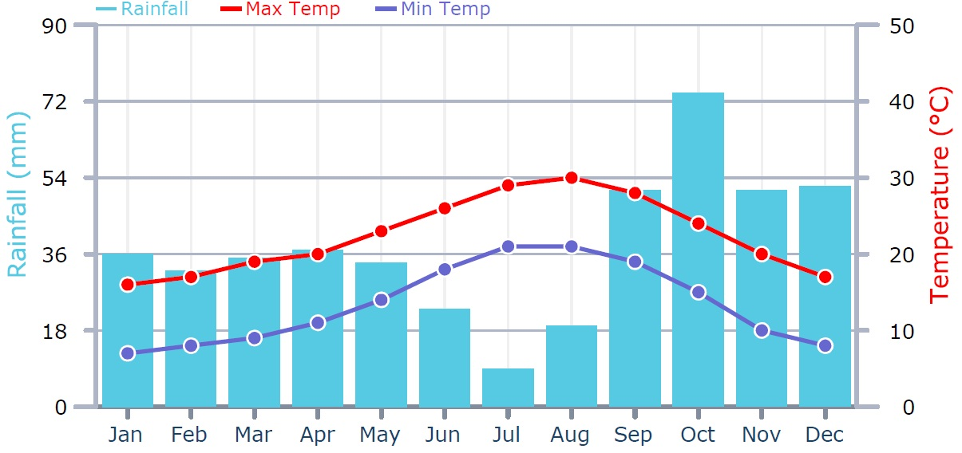

7.2 Cellular concrete. Main features
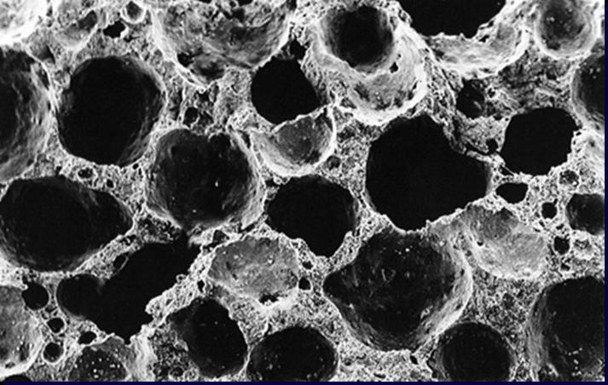
7.2.1 Insulation
The insulating property of a material depends on the amount of air contained in it, as long as the air is captured in small volume cells.
Cellular concrete is made up of millions of micropores closed air and evenly distributed, reaching up to 80% of total volume.
What really makes him unique is that posses a high mechanical strength, can be used as a structural element.
The coefficients depend only on the density.
Table:
Density (kg/m3) | Useful thermal conductivity coefficient ʆ (W/mK)
350 (blocks) | 0,10
400 (blocks) | 0,11
500 (blocks) | 0,125
550 (blocks) | 0,145
500 (plates) | 0,13
600 (plates) | 0,16
These values ​​allow for massive walls of a single sheet in any climatic zone of Spain, without requiring additional insulation and reduced wall thicknesses.
Enclosure solutions are prepared for the future, far exceeding the limits set by the CTE (Spanish rules) on today.
The elements of the construction permit to minimize the thermal bridges, being a solid, homogeneous material with isotropic properties.
7.2.2 Humidity
The low coefficient of water vapor diffusivity of cellular concrete (μ = 5-10) allow self-regulation of the humidity inside the house. Walls can absorb excess moisture which usually generates timely in bathrooms and kitchen, and a return to the environment of outdated and even carry some of it outward, as long as the coatings do not create a barrier steam
.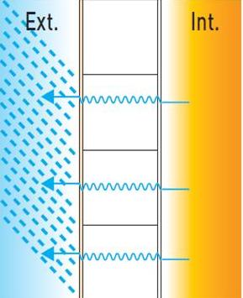
The walls, however, have a coeficient of very low water absorption, or in other words are walls with a high degree of tightness. This is because the concrete pores are closed and cell interconnect. The material can only absorb water by capillary action through the solid part, which we know only occupies 20% of the volume.
7.2.3 Mechanical resistance
Load-bearing walls
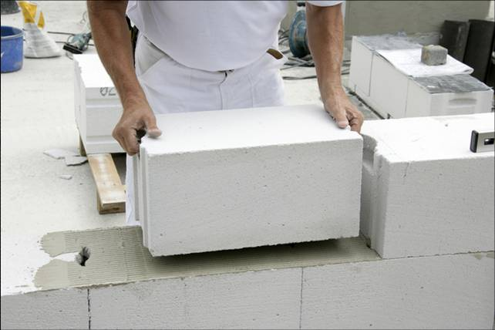
Aerated concrete is a material with high resistance to compression, which varies depending on the density of the material.
Table:
Density (kg/m3) | Characteristic resistance (N/mm2)
350/400 | 3
500 | 4
Load-bearing walls are characterized by their homogeneity, which is due to the geometric precision of the blocks and the joint. The blocks are solid and the pores are evenly distributed throughout its volume.
The walls can withstand high loads, allowing a lot of floors in the construction.
Floors and roofs
The deck and slabs are manufactured as armed cell, able to with stand high loads without compression layer.
The lightness of the plate benefits the structural capacity, while reducing considerably the loads are transmitted to the walls and finally to the foundation.

Table of the weight of the floors:
Thickness 20 cm | Thickness 24 cm | Thickness 30 cm
144 kg/m² | 173 kg/m² | 216 kg/m²
The plates are manufactured in thicknesses from 10 to 30cm for roof and floor elements 20 to 30cm. The maximum light varies depending on the total overhead, and can reach a maximum of 6.60 m. It is also possible to place the plates with an overhang of up to 1.50 m.
The plates were placed directly on the walls. You only need to assemble and fill the horizontal joints between panels and frames to tie the perimeter hoops to ensure the rigidity of the floor or deck.
The plates can be loaded directly and do not require compression layer, allowing work to continue without interruption or obstructive items as props or forms.
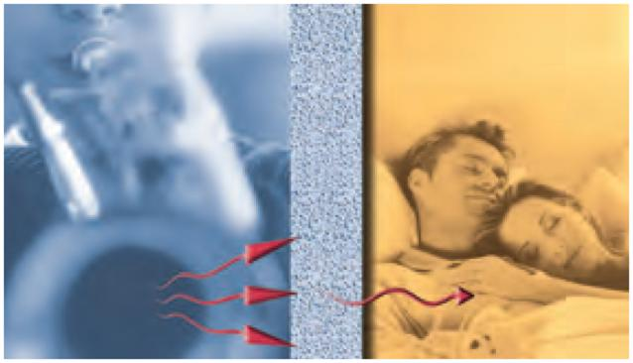
7.2.4 Sound proofing
The micro-alveolar structure of cellular concrete, with millions of pores embedded in closed air volume, contributes positively to satisfy the requirements of sound insulation regulations.

7.3 Geothermal Solar building
The low-temperature geothermal energy is a renewable, clean and available almost anywhere, based on exchanging the heat stored in the ground by solar radiation.Technology is successfully implemented in Europe and North America for several years begin to make themselves known in our territory.
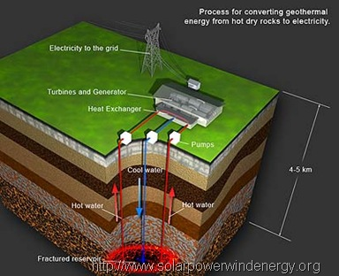
7.3.1 Taking advantage of the subsoil temperance
The sun heats the earth's crust, especially in summer. As the land has a high thermal inertia, is able to store this heat and maintain even seasonally. In the subsoil, from about 5 meters deep geological materials remain at a fairly constant temperature throughout the year. In the Spanish case, to a depth greater than 5 meters, the soil temperature, regardless of season or weather conditions, is around 15 degrees. Between 15 and 20 meters deep, the thermal stability is about 17 º C all year long depending on the location in each case.
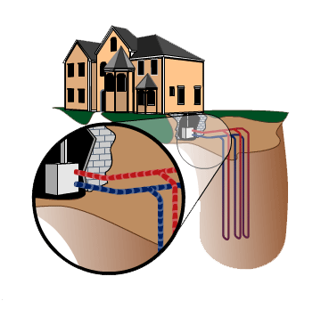
A geothermal system uses a solar heat pump and a system of holes in the ground to take this mild temperatures. The key to the efficiency of these heat pumps is the difference between the temperature to be achieved and the temperature at which the item is found to be heated. With a conventional heat pump air-air, in summer we intend to maintain a comfortable temperature of 25 ° when the outside air is 30 - 35 ° C. In winter, you want to keep the house at 21 º C when the outside temperature is below 10 ° C. Pass the air one temperature to another can only be achieved at the expense of considerable energy expenditure.
In the case of geothermal heat pumps (GHP), the temperature gradient that must be overcome is much lower. In winter, have a material 15 to 17 degrees can be considered a heat source. And in summer the ground is considerably cooler than the outside environment.
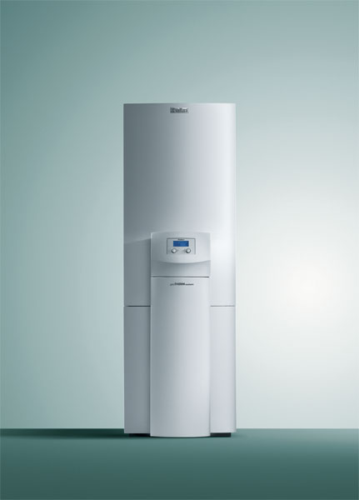
The exchange of heat with the ground, can provide the same comfort needs but with much lower power than a conventional heat pump.
7.3.2 An unbeatable efficiency
The COP (Coefficient of Performance) lets us know how efficient a heat pump. The COP of a geothermal heat pump is 4 to 6, ahead of more efficient heat pumps air to air, estimated between 2 and 3. This means that for every unit of energy used by the system you get 4 or more units of energy as heat or cold.
Note that the efficiency of a geothermal heat pump does not vary with the weather or seasonal, while in a conventional performance declines in the hottest summer and the coldest in winter, just when we need is your use.
Comfort without waste
If the distribution system by water, heat is transferred to the subsurface water flow. It usually feeds a system of low temperature radiators or underfloor heating, which can be complemented with an air cooling device. In the cooling mode, is an interesting effect called free cooling; depending on the weather of the place, or the beginning of the warm season,you can get cool to a high comfort level without the pump running, only taking advantage passively the freshness rise. When demand is greater, the pump is put into operation.
We see that the possibilities are varied, although it is noteworthy that the most efficient option is the distribution of heat through radiant floor or walls. In these systems it is enough that the outlet temperature of the heat pump is around 30 degrees, while in a hot air system or radiators high temperature is necessary to reach temperatures of about 50 degrees.
In summary, geothermal heating of cooling and solar energy can get hot water in homes and other buildings, but with performance unsurpassed by any other system. All this thanks to the system is not seen, which is under the ground.
7.3.3 Technology for Energy Efficiency
To take advantage of stable temperature in the subsurface is necessary to make a series of holes in the ground. The dimensions of these small wells of 10 to 15 centimeters in diameter depends on the dimensions of the place to air-condition, availability of land or geological conditions.
Inside each hole are placed pipes where there is heat exchange, consisting of a tube, usually made of polyethylene, full of fluid. Usually this circulating fluid is water or a saline solution with antifreeze to prevent the fluid solidifies when temperatures are low on the surface of the soil. This formula is safe for the environment, although it anyway in no time the fluid comes in contact with the soil as the tube is perfectly sealed.
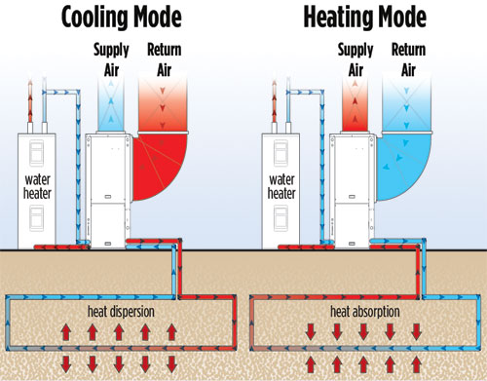
The liquid is continuously circulated through the closed circuit: down, heated (or cooled, if it is summer) and go up again, driven by a small pump. At this point, the circulating medium gives up its heat (or cold) to the refrigerant and then to the means used for heating (air or water).Then, the fluid back down through the circuit located in the holes of the ground for more heat. This system has high performance drilling because the exchange is made at a depth of between 50 and 100 m. An important part of economic cost is determined by drilling and these may not be feasible in some areas.
On the other hand, there are also horizontal circuits, in which the intake pipe is buried horizontally at a depth of 1.5 meters. In this case, you must have an area of land plot, that it is not asphalted or paved. Installation is easier and less cost, but we need to have a considerable floor space.
The circuit buried in the ground is chosen according to where is the building and the space available. With regard to the characteristics of the geothermal heat pump, there are different models to suit each case and each size of the houses.

7.3.4 An investment-saving
The main advantage of buying an efficient appliance or turning to renewable energy is that the investment is recovered relatively quickly. A solar geothermal installation can be amortized in five to ten years. This is possible because the GHP used between 25% and 40% less electricity than conventional heating or cooling, powered by natural gas, propane, diesel, or electric radiators. They also require little maintenance and have a long life. For example, the compressor heat pump, the element with greater wear, has a lifespan of about 16 years, and the interchange with the underground about 50.
This technology was developed initially in regions with very strong winters, they often want to savings of energy and money, which allows the low-temperature of geothermal energy for heating in cold countries (saving about 65 - 75% of heating costs). However, it is also true that in Spain is increasingly consumed more energy for cooling in summer, so that also in our territory profitability will be an advantage.
Other positive factor is the fact that they require no outside condensing unit, avoiding the problems of noise inside and outside the home.
7.3.5 Examples of geothermal energy in practice
The solar geothermal should not be confused with high-temperature geothermal systems, which are only possible in parts of the planet with special conditions of tectonic activity, which takes advantage of the residual energy inside the earth to generate electricity. On the other hand, solar geothermal can be exploited by almost everyone, provided that local ground conditions make it possible.
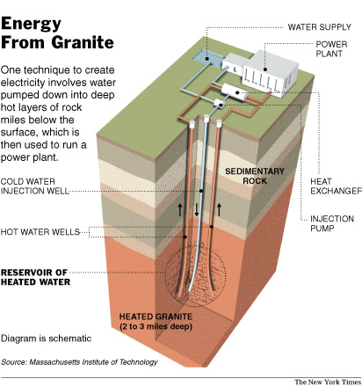
Facilities that have been made in our country include both single-family homes or cottages isolated as apartment buildings or offices in the heart of the city, farm or industrial premises. The holes range from several tubes of a few meters (6 holes 10 meters),to deeper wells. This diversity demonstrates the versatility of the geothermal systems. In the case of isolated houses, for example, usually has a large amount of soil that allows for a horizontal loop geothermal installation. Considering the expenses diesel or other fuels and transport to the house, the geothermal system, although an considerable initial investment in the medium term is really the cheapest option.
On the other hand, it is noteworthy that in multi-family buildings or public or commercial buildings in the urban environment, in many cases it is possible to drill vertical during the performance of the foundation, so that one of the major costs of the geothermal system is reduced or eliminated, by including it in the usual requirements of the building.
We also note that, given the low consumption makes the pump, this could be powered by photovoltaic solar panels, so that then the system becomes fully autonomous, efficient and renewable.

Geothermal and solar has come a long way. In 1950 in the United States first patented geothermal heat pump, and such systems are being used extensively in North America, Japan, Switzerland, Germany and Sweden for more than three decades. Some experts say may be the most efficient, ecological and economically viable to get comfortable in the home. What is certainly true that the air-conditioning heat pumps is a new opportunity to reduce energy consumption and CO2 emissions associated with houses.

7.4 Description of the construction

The construction of the passive house is located in Valencia, on the campus of the Universitat Politécnica de Valencia, the parcel is an irregular polygon with an area of XXXX m2, and the house is built in the north of the parcel to take advantage of the deciduous trees that we plant on the south and protect us the sun in the summer and in winter the sun will pass to take advantage of this energy.

The construction will take place on a layer of Foam glass of 27 cm thickness, Foam glass is an insulating material made from crushed glass and carbon; is totally inorganic and is not conducive to mold, fungi or microorganisms; and is the only insulation material completely sealed to all types of humidity, non-combustible and does not release toxic fumes or gases, is stable, its compressive strength is high and resist rot, insects, undesirable animals and the acid.

The foundation was made on a layer of lean concrete and the isolated footing type. The isolated footing is a superficial type of foundation that can be used in areas of good quality land when the eccentricity of the column load is small or moderate, this condition is best accomplished in the building perimeter abutments, consisting of concrete prism beneath the pillars of the structure; its function is to transmit the stresses to the land which is under the rest of the structure, the footings are joined together by beams. The correct sizing of the isolated footings involves checking the bearing capacity of collapse, checking the state of equilibrium (sliding, overturning) and its differential settlement in relation to the adjacent footings.

For the formation of the walls, we will use blocks of celular concrete, thanks to all the features explained before. After the sheet of celular concrete we place the insulation that in the case of the walls will be expanded polystyrene; we place this material because it has extraordinary qualities, the most significant are the thermal insulation and low weight, other important characteristics are mechanical strength, their proper behavior and resistance to water vapor diffusion compared with other materials, its versatility in shape and features that are specified in a wide range. The use of expanded polystyrene in the building also provides environmental benefits primarily due to its role of thermal insulation and the use of a material that implies a low energy consumption of material resources.

The last sheet will consist of facing bricks, these bricks are manufactured to be placed without covering both exterior and interior of the building. There are a variety of models, depending on the size, color ... and depending on the materials and additives,may also have a decorative function moreover of its structural function, but in our case will have,apart from the decorative function, the function of protecting isolation. This material is very resistant to the passage of time and very low maintenance, which in turn has thermal insulation and soundproofing. Current technology allows the manufacture of facing bricks of large dimensions that are used in their dual role of thermal and decorative facades.

The roof structure is also formed by celular concrete, in this case we use plates of 24cm thick. The roof insulation is extruded polystyrene that have similar characteristics of heat insulation and a little more mechanical resistence than expanded polystyrene. They are very similar materials as their chemical composition is identical: about 95% polystyrene and 5% of gas, the only difference is in the process of formation, but it is a crucial difference, because the polystyrene produces a bubble structure closed; the extruded polystyrene is the only insulation that is capable of getting wet without losing properties. The XPS has a typical thermal conductivity between 0.033 W / mK and 0.036 W / mK, although there polystyrenes with values up to 0.029 W / mK.

After placement of the insulation, we place the membrane impermeable across the deck, this sheets are called also fabrics asphalt. They are sheet products, whose base is of type bituminous waterproofing, bituminous materials are those containing natural asphalt, bitumen penetration of oxidation or tars. Can be found in several ways: self-protected (have an aluminum embossed or crushed slate on one side), without protection or reinforcement (mesh or felts are to be inserted into the sheet during manufacture, the Mayans are fiberglass, polyethylene or polyester), in our case we will use of non-protected, which will force us to protect them with a finish.

We will finish with a thin layer of concrete for the formation of slopes and pavement as well as inside the house will be ceramic tile.

The house will have some solar panels to feed power, photovoltaic modules or photovoltaic solar collectors consist of a set of cells (photovoltaic cells that produce electricity from light that strikes them) (solar electricity). The standardized parameter to classify its power is called the peak power and corresponds to the maximum power that can deliver under standardized conditions, which include radiation 1000 W/m2 and cell temperature of 25 º C, for example, a plate of 40 Wp, produce 40 Wh energy if you get radiation for one hour with standard conditions. The construction will also have a system for harnessing geothermal energy described above.

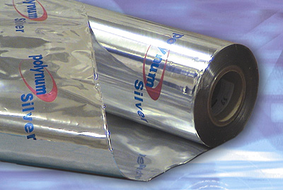
-Vapor barrier

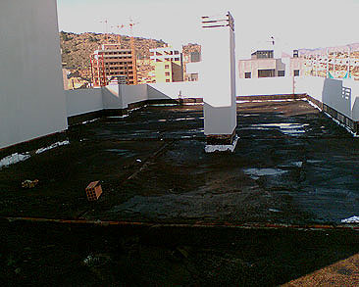

-Waterproof sheet

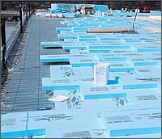
-Extuded polystyrene

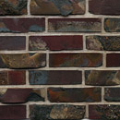

-Bricks facing ceramic

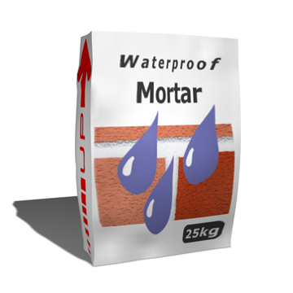
-Waterproof mortar

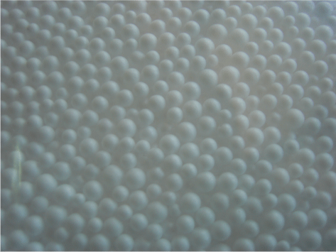
-Expanded polystyrene

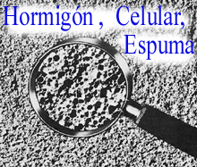

-Celular concrete

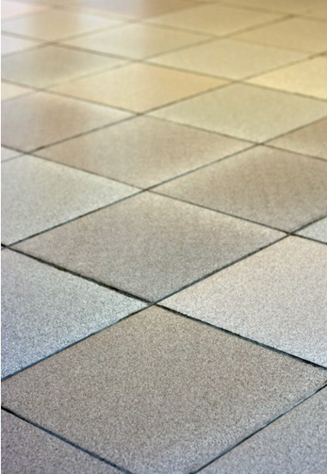

-Ceramic tiles

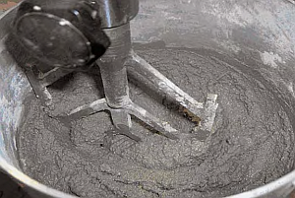
-Regulation mortar

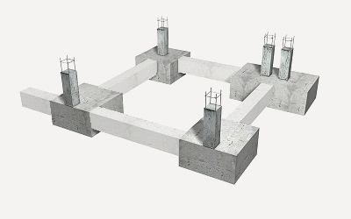

-Reinforced concrete

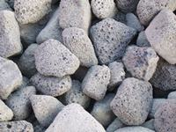

-Foam glass

7.5 Calculations.

We start to calculate the U-value of the Windows, facades, deck, floor and door. To calculate these values we used the program PHPP (Passive House Planning Package). This program takes the thickness and the lambda of the materials, and the thermal resistance of the exterior and the interior of the walls, windows, deck, floor and door. The transmittance coefficient (U-value) is determined by the following expression:

$$U=\frac{1}{Rse+\sum{\frac{e}{λ}+Rc+Rsi}}$$

U: Transmittance coefficient of the build element (W/m²K)
Rse: Thermal resistance of the external superficies (m²K/W)
Rc: Thermal resistance of the air chamber (m²K/W)
Rsi: Thermal resistance of the internal superficies (m²K/W)
E: Thickness of each material making up the layers of the sealing elements (m)
λ: Thermal conductivity of each of the materials comprising the layers of the construction element (W/mK)

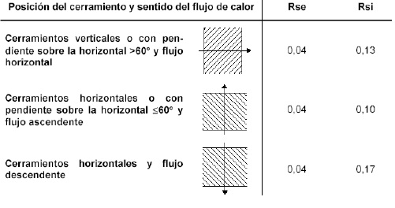

In the case of the windows must also take into account the orientation, the surface of the window and the frame surface, In this house we have chosen a crystal passive triple U = 0'49 (W/m2K) and a frame a U = 0'72 (W/m2K), these values of the window and frame are chosen in the options of the PHPP program, the case of the door will be the same system for calculating but we will catch the U-values of the wood frame and the wood of the door,the values are chosen in the PHPP; the frame has a U = 1.50 (W/m2K) and the door U = 0'70 (W/m2K).
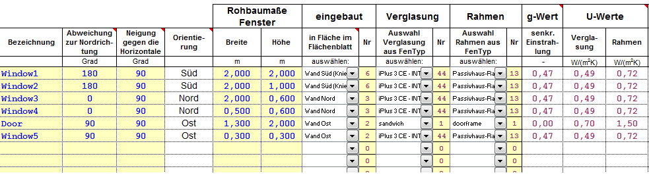
With these values, the surfaces of hollow frames and windows and the thermal bridge between the glass and frame, we calculate the U-value of all around.

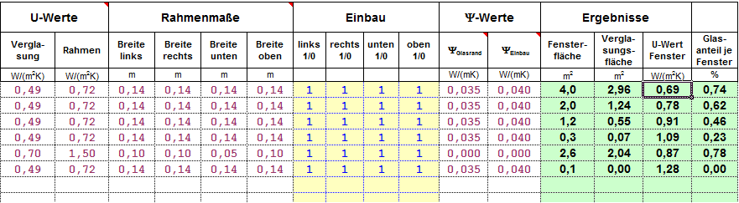

The total U-value:
Window1………………………………………………………………………………………. U-value= 0’69 (W/m2K)
Window2………………………………………………………………………………………. U-value= 0’78 (W/m2K)
Window3………………………………………………………………………………………. U-value= 0’91 (W/m2K)
Window4………………………………………………………………………………………. U-value= 1’09 (W/m2K)
Door……..………………………………………………………………………………………. U-value= 0’87 (W/m2K)
Window5………………………………………………………………………………………. U-value= 1’28 (W/m2K)

To calculate the facades, the deck and the floor we take the lambda and the thickness of each material and the correct thermal resistance in each case.

$$U=\frac{1}{Rse+\sum{\frac{e}{λ}+Rc+Rsi}}$$

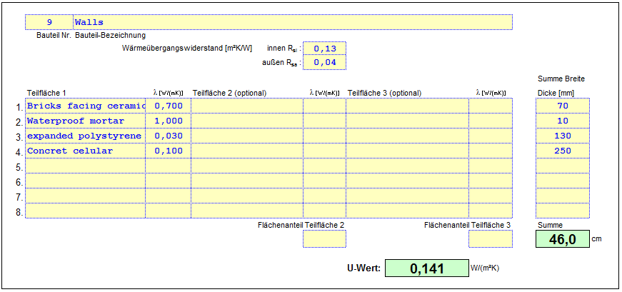
The values of the U calculation of the walls:

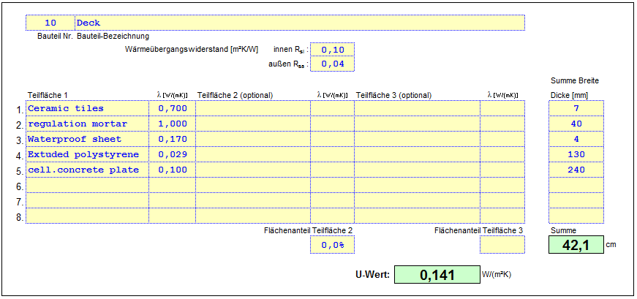
The values of the U calculation of the deck:

The values of the U calculation of the floor:
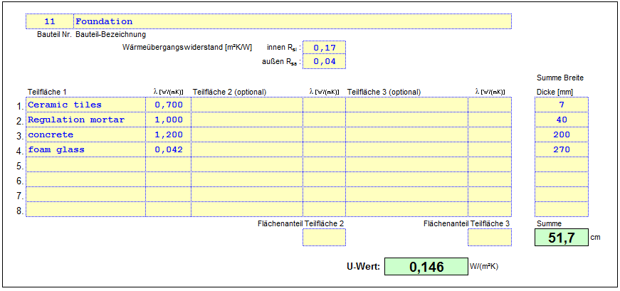

With the U-values and the area of each element we calculate the coefficient of heat transmission of the exterior environment.
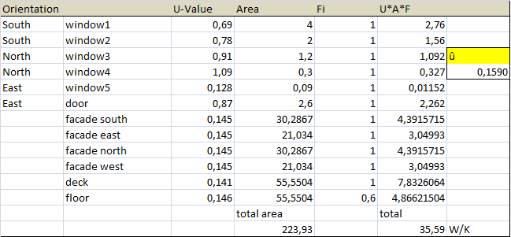
The average of the U-values of the construction is 0’159 W/K.

Let us calculate the total energy that we need for heating or cooling the building. We begin by calculating the power losses of transmitantion and ventilation and the power of cooling that we need, and after that we will calculate the sun, internal and the precooling power; with these factors we can calculate the total energy.

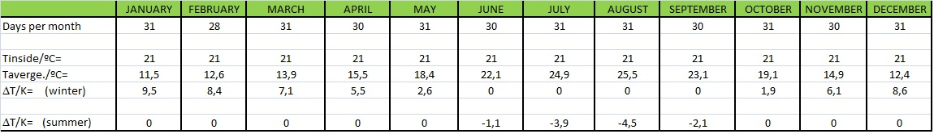
To calculate the power losses of transmitation we take the total of U*A*F= 35,59 W/K and we multiply by the difference of Temperature between the temperature inside and the average of temperature outside of each month. In summer we have negative differences in these cases we take 0 because these values we will take to calculate the power of cooling.

Power losses of transmitation:
January: 35,59 * 9’5 = 338 kWh
February: 35,59 * 8’4 = 299 kWh
March: 35,59 * 7’1 = 253 kWh
April: 35,59 * 5’5 = 196 kWh
May: 35,59 * 2,6 = 93 kWh
June: 35,59 * 0 = 0 kWh
July: 35,59 * 0 = 0 kWh
August: 35,59 * 0 = 0 kWh
September: 35,59 * 0 = 0 kWh
October: 35,59 * 1’9 = 68 kWh
November: 35,59 * 6,1 = 217 kWh
December: 35,59 * 8,6 = 306 kWh
Total power losses of transmitation= 1769 kWh

To calculate the losses of ventilation we need to know how many people are going to live or to stay in the house, in our case we choose 5 persons because or house is not too big. Each person need 20 (m3/h) air needed. The way to calculate is:

$$\frac{Persons*Air need*\left(r*c\right)*\left(1-recovery efficience\right)*difference of temperature}{3^{'''},6}$$

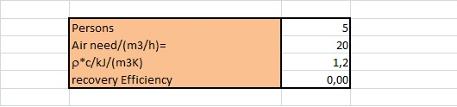
The difference of temperature (winter) is the same that we used in the power losses of transmition.

Power losses of ventilation:
January = 317 kWh
February = 280 kWh
March = 237 kWh
April = 183 kWh
May = 87 kWh
June = 0 kWh
July = 0 kWh
August = 0 kWh
September = 0 kWh
October = 63 kWh
November = 203 kWh
December = 287 kWh

Total power losses of ventilation = 1657 kWh

To calculate the power of cooling we take the total of U*A*F= 35,59 W/K and we multiply by the difference of Temperature between the temperature inside and the average of temperature outside of each month. In summer we have negative differences in these cases we take the absolute value because we need the power to change these difference of temperature.

Power cooling:
January: 35,59 * 0 = 0 kWh
February: 35,59 * 0 = 0 kWh
March: 35,59 * 0 = 0 kWh
April: 35,59 * 0 = 0 kWh
May: 35,59 * 0 = 0 kWh
June: 35,59 * 1’1 = 39 kWh
July: 35,59 * 3’9 = 139 kWh
August: 35,59 * 4’5 = 160 kWh
September: 35,59 * 2’1 = 75 kWh
October: 35,59 * 0 = 0 kWh
November: 35,59 * 0 = 0 kWh
December: 35,59 * 0 = 0 kWh
Total power cooling= 413 kWh

To calculate the power of the sun we used the area of the south window, the sunshine hours per month and the insensitive of the sun. We estimate that the insensitive of sun is 600 W/m2 for each month. The area of the south windows are 6 m².

Formula:
$$\frac{Sun shine time*Sun intensitive*Area south window}{1000}$$

 | Sun shine hours per month | Power Sun
January | 169 | 608’4
February | 169 | 608’4
March | 212 | 763’2
April | 229 | 824’4
May | 256 | 921’6
June | 271 | 975’6
July | 314 | 1130’4
August | 285 | 1026
September | 237 | 853’2
October | 201 | 723’6
November | 167 | 601’2
December | 150 | 540

Total Power Sun = 9576 kWh

To calculate the internal power we supposed that are 5 persons and we estimate that each person produce 100 W.
$$Pint=Persons*Pperson$$
Every month we produced 500 W. And to know how much kWh we multiply per the hours of each month.

$$Power internal=Power produced per person*Hours per month$$

 | Hours per month | Power internal
January | 744 | 372
February | 672 | 336
March | 744 | 372
April | 720 | 360
May | 744 | 372
June | 720 | 360
July | 744 | 372
August | 744 | 372
September | 720 | 360
October | 744 | 372
November | 720 | 360
December | 744 | 372

Total Power internal = 4380 kWh

To know the total power we use this equation:

$$Power total=Power losses by transmitation+Power losses by ventialtion+Power cooling-Power Sun-Power Internal$$

Month per Month:
 | Jan. | Feb. | Mar. | Apr. | May | June | July | Aug. | Sep. | Oct. | Nov. | Dec. | Tot.
Ptra | 338 | 299 | 253 | 196 | 93 | 0 | 0 | 0 | 0 | 68 | 217 | 306 | 1769
Pvnt | 317 | 280 | 237 | 183 | 87 | 0 | 0 | 0 | 0 | 63 | 203 | 287 | 1657
Pcool | 0 | 0 | 0 | 0 | 0 | 39 | 139 | 160 | 75 | 0 | 0 | 0 | 413
Psun | 608 | 608 | 763 | 824 | 921 | 975 | 1130 | 1026 | 853 | 723 | 601 | 540 | 9576
Pint | 372 | 336 | 372 | 360 | 372 | 360 | 372 | 372 | 360 | 372 | 360 | 372 | 4380
Ptot | 454 | 529 | 774 | 945 | 1242 | 1515 | 1769 | 1686 | 1428 | 1093 | 681 | 447 | 12563

Power total = 10.943 kWh

We have a additional system of precooling and preheating, but let’s focus with the precooling because in Spain in the passive house is more important the cooling. If you prepare the house to the high temperatures, this house will work good in winter too.
We take the values of the temperature average and we add the difference of the temperatures of hot hours, this difference we estimate that is about 9 degrees. We are going to said that the higher temperature outside is the:

$$T air outside=Taverage+T diff of hot hours$$
The Higher temperature of each month are:
 | Jan. | Feb. | Mar. | Apr. | May | June | July | Aug. | Sep. | Oct. | Nov. | Dec.
T air outside | 20,5 | 21,6 | 22,9 | 24,5 | 27,4 | 31,1 | 33,9 | 34,5 | 32,1 | 28,1 | 23,9 | 21,4

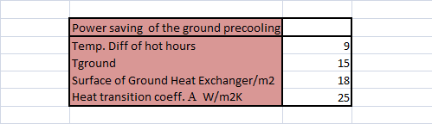
With this and the values of the ground pipe we calculate the Power precooling.
The values of the ground pipe are:

The equation of the Power precooling:

$$Power precooling=\left(\left(\frac{Tair outside+T inside}{2}\right)-Tground\right)*Surface*Heat Tran. coeff$$

Power precooling month per month:
January = 2587’5 W
February = 2835 W
March = 3127’5 W
April = 3487’5 W
May= 4140 W
June= 4972’5 W
July= 5602’5 W
August = 5737’5 W
September = 5197’5 W
October = 4297’5 W
November = 3352’5 W
December = 2790 W

To know the energy that we take by the precooling we have to multiply for the sun shine hours per month, and divide by 1000 to change the unit because we calculated the power precooling in Watts.

$$Energy precooling=\frac{Power precooling*Sun Shine time}{1000}$$

The energy precooling of each month:

Jan. | Feb. | Mar. | Apr. | May | June | July | Aug. | Sep. | Oct. | Nov. | Dec.
473’3 | 479’1 | 663 | 798’6 | 1059’8 | 1347’4 | 1759’2 | 1635’2 | 1231’8 | 863’8 | 559’9 | 418’5

Total Energy precooling = 11.253’8 kWh

To calculate the needed energy, we take the month that need power to cooling and after that we take the total power minus the energy of precooling and both divided per COP, the capacity of power of the cooler.
$$Needed energy=\frac{Total power-enery of precooling}{COP}$$

The needed energy month per month is:

January: 0 kWh
February: 0 kWh
March: 0 kWh
April: 0 kWh
May: 0 kWh
June: 9’1 kWh
July: 39’3 kWh
August: 25’7 kWh
September: 18’7 kWh
October: 0 kWh
November: 0 kWh
December: 0 kWh

The total needed energy is 87’4 kWh
We have enough with the thermal energy, we don’t need air condition, cooler or heaters.

Energy used by the building:

The estimate calculates of the energy of electrical appliances month per month:

January: Total electrical energy = 68’82 kWh
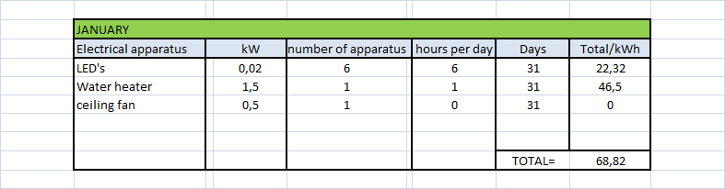

February: Total electrical energy = 62’16 kWh
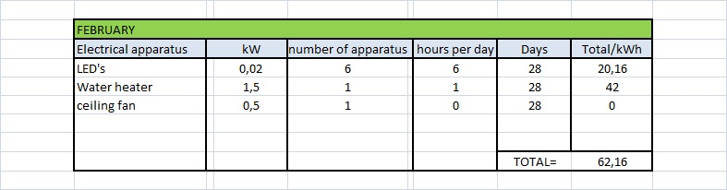

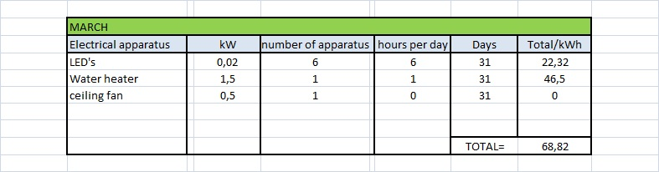
March: Total electrical energy = 68’82 kWh

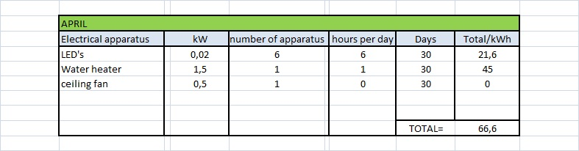
April: Total electrical energy = 66’6 kWh

May: Total electrical energy = 61’07 kWh
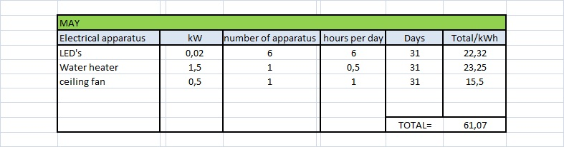

June: Total electrical energy = 74’01 kWh
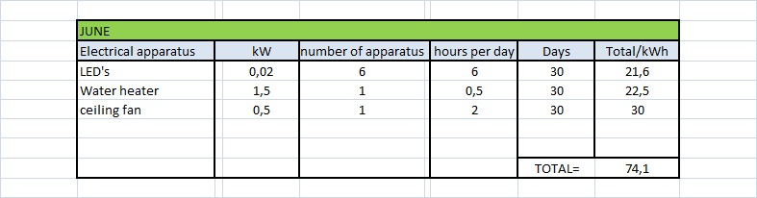

July: Total electrical energy = 64’94 kWh
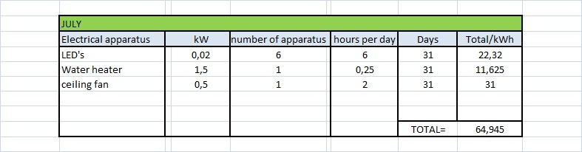

August: Total electrical energy = 64’94 kWh
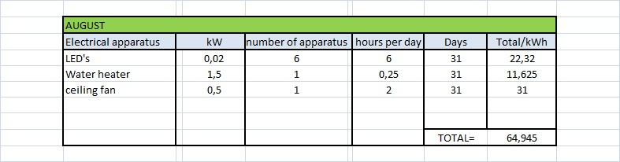
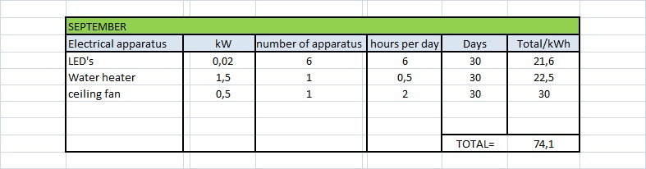
September: Total electrical energy = 74’1 kWh

October: Total electrical energy = 68’82 kWh
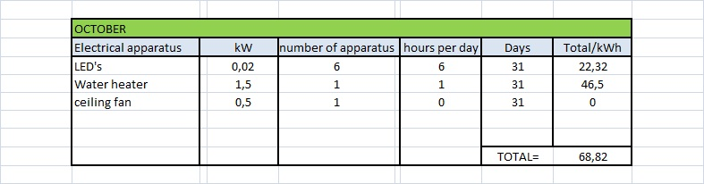

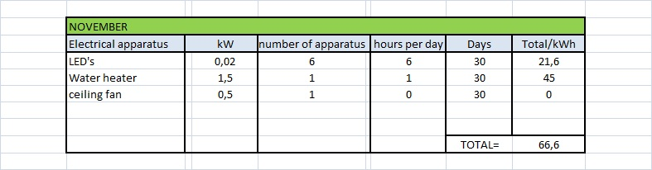
November: Total electrical energy = 66’6 kWh

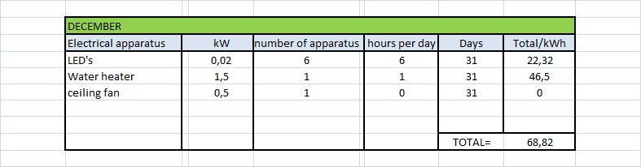
December: Total electrical energy = 68’82 kWh

The total of energy per year of the electrical apparatus is = 809’8 kWh

- Biobliography

-http://www.builditsolar.com/Projects/Cooling/passive_cooling.htm
-http://www.openengineering.talktalk.net/OeUni_Saving_es.html
-http://www.sto.de/88949_DE-Architekten-Konstruktionsdetails.htm?bereichId=16#
-http://www.passivhaus.de/index.php?id=95&L=1or
-http://www.passivehouse.us/passiveHouse/PassiveHouseInfo.html
-http://www.passiv.de/
-http://www.plataforma-pep.org/index.php?page=18
-http://www.passive-on.org/es/design_principles.php
-http://www.energieinstitut.at/Retrofit/
-http://www.panelagency.com/pdf/Steico_Technical_Guide_Nov07.pdf
-http://www.steico.com/anwenden/geschossdecke.html
-http://www.finnforest.de/Pages/Default.aspx
-http://www.azsolarcenter.org/
-http://www.unav.es/arquitectura/actualidad/noticias/not/0178/
-http://www.ytong.es/#_sub1544
-http://2010.sdeurope.org/
-http://www.sdeurope.org/
-http://www.celcon.cl/herramientas.php
-http://www.arquimaster.com.ar/articulos/articulo410.htm
-http://intranet.minem.gob.pe/AppWeb/DGE/CalculoConsumo
-http://www.vaillant.de/
-http://www.terra.org/articulos/art01221.html
-http://www.prosolda.com/alumbrado_industrial_leds.htm

