Received 00th January 20xx,
Instituto de Tecnología Química (UPV-CSIC), Universitat Politècnica de València, Consejo Superior de Investigaciones Científicas, Valencia, 46022, Spain. E-mail: acorma@itq.upv.es, mmoliner@itq.upv.es.
† Electronic Supplementary Information (ESI) available: Synthesis and catalytic experimental details, chemical analysis, SEM image, XRD patterns and N₂ adsorption measurements of aged samples. See DOI: 10.1039/x0xx00000x
Accepted 00th January 20xx
DOI: 10.1039/x0xx00000x
www.rsc.org/
Nanosized MCM-22 zeolite using simple non-surfactant organic growth modifiers: synthesis and catalytic application
Eva M. Gallego, Cecilia Paris, Cristina Martínez, Manuel Moliner,* Avelino Corma*
Non-surfactant cyclic alkylammonium can selectivelly decresae the rate of crystal growth along the x-y crystal axes during the synthesis of MWW zeolite. This results in a ∼60 nm nanocrystalline zeolite that shows remarkable catalytic properties for the production of cumene.
The search for effective methodologies to synthesize nanosized zeolitic materials with crystal sizes below 100 nm has supposed an important challenge in the last twenty years.¹ Along these two decades, many post-synthetic or one-pot methods have been described in the literature,¹ showing their effective application in diverse areas, such as medicine, electronics or catalysis, among others.²
Regarding catalysis, the synthesis of zeolites in the nanometer scale remarkably decreases diffusion paths, not only favouring the accessibility of the reactants to the active sites, but also preventing undesired by-reactions of the formed products.³ Among the different techniques that can be found in the literature describing the crystallization of nanosized zeolites,¹⁻⁴ the use of bulky organic structure-directing agents (OSDAs) with long aliphatic chains is one of the preferred methodologies, since, in general, it allows obtaining high solid yields and well-controlled chemical compositions.⁴ However, the cost associated to the nanozeolite manufacture is probably the most critical factor for its industrial implementation, and consequently, current research efforts must focus on the design of direct and inexpensive procedures that permit an efficient control of the kinetic crystal growth during the crystallization process.⁵
Among the 235 zeolites recognized by the International Zeolite Association (IZA),⁶ the MCM-22 zeolite (MWW structure) is one of the very few zeolites that currently are in commercial application.⁷ The MWW structure is formed by two independent pore systems: one is composed by 12-ring cages connected by 10-ring apertures, and the other one is defined by a 10-ring circular channel.⁸ The external surface of the MCM-22 crystals exposes half of these 12-ring cages,⁸ leading to external “cups” with accessible acid sites, which have been described as active sites for selective aromatic alkylation reactions, such as the benzene alkylation with propylene to obtain cumene.⁹
Two different post-synthetic treatments on the as-prepared layered MCM-22 precursor were first described for increasing the exposed fraction of the external cups, pillarization of the MCM-22 precursor to MCM-36,¹⁰ or its delamination with surfactants to obtain the single-MWW layer, named ITQ-2 zeolite.¹¹ More recently, new one-pot strategies based on the use of bifunctional surfactant-type cations presenting long alkyl-aliphatic chains, alone or in combination with the traditional MCM-22 OSDA, have been described as efficient methods to obtain highly-delaminated MWW materials (MIT-1 and DS-ITQ-2, respectively).¹² Nevertheless, these bulky OSDA molecules are costly and, as it has been stated above, the use of simpler organic molecules would be required to make the direct synthesis of the MWW with controlled particle sizes industrially attractive.
As an alternative to the use of surfactant-based molecules, the synthesis of the nanosized form of the MCM-22 has been described by using a cationic polymer, Poly(diallyldimethylammonium chloride), as protecting agent to prevent the synthesis colloids self-aggregation.¹³
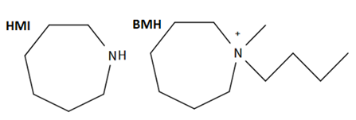
Fig. 1 Organic structure directing agents employed for the synthesis of MCM-22 materials

In addition, we have recently described a new methodology employing simple cycloalkyl-ammonium OSDA molecules to prepare Beta and ZSM-5 zeolites in their nanosized form.¹⁴ These simple OSDAs combine a cyclic part and a short alkyl-chain group (preferably C4, see for instance BMH in Fig. 1).
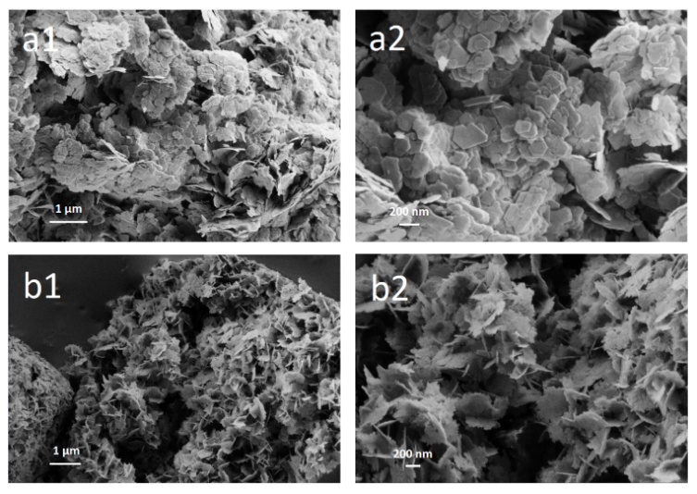
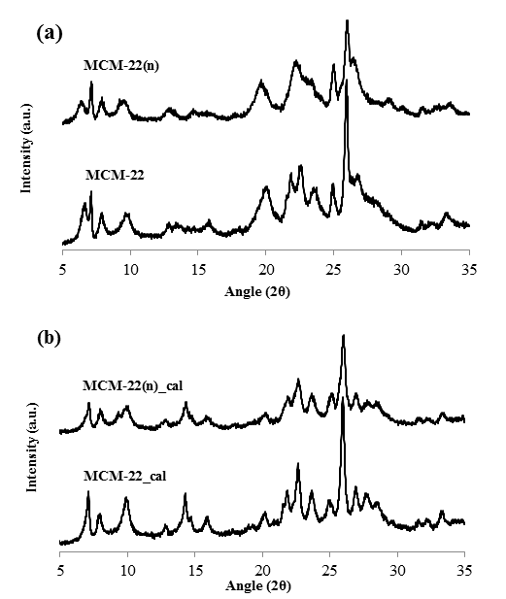
Thus, in order to control the particle size of the MCM-22, we have modified the conventional MCM-22 synthesis,¹⁵ replacing 20% of the former OSDA, hexamethyleneimine (HMI, see Fig. 1), by a related cyclic organic molecule but also containing a short alkyl-chain, N-butyl-N-methylhexamethyleneiminium (BMH, see Fig. 1). The overall synthesis conditions for the conventional MCM-22 zeolites were: SiO₂/0.042 Al₂O₃/0.3 NaOH/0.5 HMI/40 H₂O, whereas those for the modified MCM-22 were: SiO₂/0.042 Al₂O₃/0.3 NaOH/0.1 BMH/0.4 HMI/40 H₂O. The gels were introduced under tumbling conditions at 423 K for 10 days. After that period, the resultant solids were filtered and washed with abundant deionized water, and dried at 363 K overnight [more details can be found in the Electronic Supplementary Information (ESI†)].
Fig. 2 PXRD patterns of the as-prepared (a) and calcined (b) MCM-22 samples

The PXRD patterns of both as-prepared solids reveal the crystallization of the MWW structure (see Fig. 2a). However, when the intensity of the diffraction peaks are compared, it can be observed that the one synthesized in presence of the zeolite growth modifier BMH, shows lower intensities and broader diffraction peaks (see MCM-22(n) in Fig.2a), which could imply smaller crystal sizes. FE-SEM microscopy images show that both MWW zeolites exhibit similar platelet crystal morphology (see Fig. 3), although a noteworthy reduction of the crystal size for the MCM-22(n) can be observed (see Fig.3b). TEM microscopy confirms that the average particle diameter for the MCM-22(n) is remarkably lower (below 60 nm, see Fig. 4b) than for the conventional MCM-22 zeolite (∼200-250 nm, see Fig. 4a), but deeper inspections on the platelets thickness by TEM do not reveal appreciable differences between both MWW zeolites [see Fig. S1 and Fig.S2 in (ESI†)].
Fig. 3 FE-SEM images of the conventional MCM-22 zeolite (a), and modified MCM-22(n) zeolite (b).
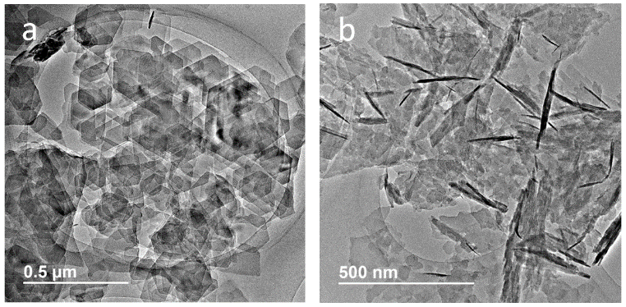
Fig. 4 TEM images of the conventional MCM-22 zeolite (a), and modified MCM-22(n) zeolite (b).

These results clearly suggest that the BMH molecule added to the synthesis media is acting as a Zeolite Growth Modifier (ZGM). We have found that the use of BMH cation as co-OSDA does not preclude the crystal growth along the z-axis, forcing the crystallization of very thin MWW zeolites with one or very few layers but, in contrast, prevent the crystal growth along the x and y-axes, resulting in small hexagonal platelets of 0.05-0.1 µm.¹² This fact would allow to expose more pore mouth corresponding to the circular 10-ring channels, as well as decreasing the mean path through the layer formed by 12-ring cavities. All that should improve diffusion molecules trough the two layers, i.e. the one formed by 12-ring cavities connected by 10-ring windows, and the one formed by circular 10-ring channels with many openings at the x- and y-axes.
The role of the BMH cations on the control of crystal growth along the x and y-axes cannot be precisely described at the moment but, according to the previous works by Rimer et al.,¹⁶ this type of cationic molecules could present particular interactions with the pre-zeolite nuclei, influencing the aspect ratio (diameter/width) of the resultant zeolite crystals. In this sense, the inclusion of BMH molecules in the synthesis media modifies the aspect ratio of the MWW crystals, as it can be clearly determined by comparison with the conventional MWW zeolite and the surfactant-modified MWW nanosheets.¹²
The textural properties of the MWW samples have been measured by N₂ adsorption after the calcination treatments. As it could be expected from its smaller crystal size, the nanosized MCM-22(n) sample shows higher BET and external surface area than conventional MCM-22 (482.7-124.4 and 457.3-83.8 m²/g respectively, see Table 1).
Regarding the chemical composition, ICP analyses reveal similar Si/Al molar ratios in the final MWW solids (∼11, see Table 1). Interestingly, the amount of aluminum species in tetrahedral coordination is also comparable for both MWW zeolites, remaining ∼77-80% of the Al species in framework positions after the calcination treatments [see ²⁷Al MAS NMR spectra in Fig. S3 in (ESI†)].
Table. 1 Physico-chemical properties of the synthesized MWW materials

Sample | Si/Al)_{ICP} | Crystal size (nm) | Area BET (m²/g) | Ext. Surf. area (m²/g) | Microp. area (m²/g)
MCM-22 | 10.6 | ∼200 | 457.3 | 83.8 | 373.5
MCM-22(n) | 11.1 | ∼50-60 | 482.7 | 124.4 | 358.3

MWW-related materials are often described as efficient catalysts for industrially-relevant reactions that mainly require external surface acid sites.^{3a,9,11,17} Thus, to evaluate the accessibility to the acid sites of the synthesized MWW samples and their acid strength, we have adsorbed two probe molecules with different sizes, pyridine and ditertbutyl pyridine (DTBP), and measured their desorption at different temperatures by FT-IR spectroscopy. As it can be seen in Fig. S4a in (ESI†), the IR bands at 1545 cm⁻¹ after the desorption treatment at 150°C, which can be assigned to the pyridinium ions retained on the Brønsted acid sites, are analogous for both MWW materials. This fact suggests that the two synthesized MWW-materials present similar amount of acid sites accessible to pyridine, has been adsorbed [see Table S1 in (ESI†)]. However, when a larger probe molecule, as DTBP, is adsorbed, the intensity of the 3360 cm⁻¹ band associated with protonated DTBP is remarkably higher for the nanosized MCM-22(n) compared to the conventional MCM-22 [see Fig. S4b and Table S1 in (ESI†)]. These results indicate that the nanosized MWW zeolite presents a higher amount of acid sites accessible to the larger molecule DTBP, owing to its larger external surface area, which exposes a larger number of pore mouth channels (see Table 1). This should have an important impact on reactions in where there are diffusion limitations either for reactants and products.
The synthesis of cumene is a key petrochemical reaction because is considered as chemical precursor of phenol and acetone.¹⁸ Despite MWW and Beta zeolites are well-known industrial catalysts for liquid phase alkylation of benzene with propylene,¹⁸ it has been described that the ability to design these catalysts in their nanocrystalline form results in a remarkable increase of the catalyst lifetime.^{12b,14} This is not surprising if one takes into account that a larger diffusion limitation for the reaction products, i.e. cumene, will drive into a higher extension of consecutive reactions, as for instance the formation of dialkylated products and oligomerized products that, if build within the 12-ring cavities, and pores, will lead to a deactivation of the catalyst with time on stream. On the other hand, if the dialkylbenzenes are formed at the external surface of the zeolite they can still be desorbed. Following the above, we can expect that a nanosized MWW with much external surface area and lower diffusional problems should give higher conversion, more diisopropylbenzene, but lower rate of catalyst deactivation.
Indeed, the nanosized MCM-22(n) zeolite shows a remarkably higher propylene conversion compared to the conventional MCM-22 zeolite, presenting a negligible deactivation with time-on-stream (see Fig. 5), even working at very low contact times. In addition, the product yield towards cumene is substantially higher for the nanosized MCM-22(n) catalyst, achieving continuous values of ∼80% with TOS (see Fig. S5a in (ESI†)]. These catalytic improvements observed for the MCM-22(n) zeolite compared to the conventional MCM-22 zeolite could be ascribed to the nanocrystalline nature of the former.
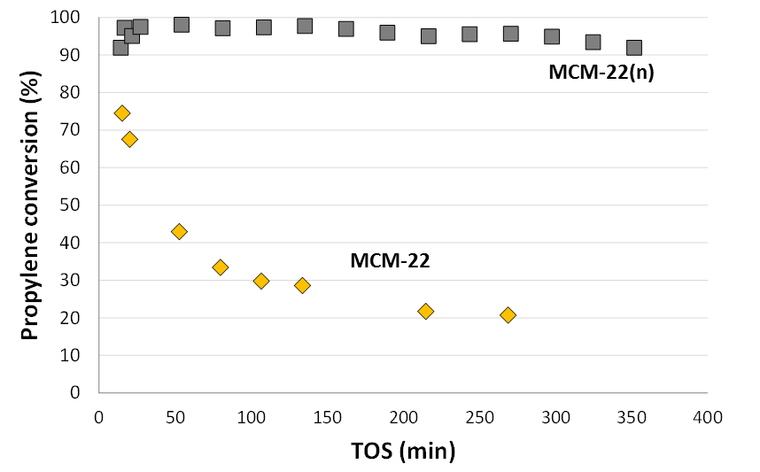
Fig. 5 Propylene conversion with TOS for the liquid phase alkylation of benzene with propylene using the synthesized MWW catalysts (reaction conditions: T=125°C, P=3.5 MPa, benzene/propene=3:1 mol/mol, τ=10⁻² h).

In conclusion, we have prepared a nanosized MCM-22 zeolite with average particle sizes of ∼60 nm, which is remarkably smaller than the particle sizes of conventional MCM-22 zeolite. The crystal size control has been achieved by selectively decreasing the rate of crystal growth along the x- and y-axes. This has been accomplished by including a simple non-surfactant cyclic alkyl-ammonium molecule, which acts as a zeolite growth modifier. The resultant nanosized MCM-22 zeolite shows improved catalytic activity and stability for the industrially-relevant liquid-phase benzene alkylation with propylene to synthesize cumene as compared to conventional MCM-22 zeolite. These results allows envisioning that the controlled addition of simple non-surfactant alkyl-substituted cyclic cations to the synthesis media as zeolite growth modifiers, could be extended to the synthesis of other relevant zeolites in order to improve their physico-chemical properties and to enhance their catalytic performance for target reactions.

This work has been supported by the European Union through ERC-AdG-2014-671093 (SynCatMatch), by the Spanish Government-MINECO through ‘‘Severo Ochoa” (SEV 2016-0683), MAT2015-71261-R and CTQ2015-70126-R, and by the Fundación Ramón Areces through a research contract of the “Life and Materials Science” program. The Electron Microscopy Service of the Universitat Politècnica de València (UPV) is acknowledged for their help in sample characterization. E.M.G. acknowledges “La Caixa - Severo Ochoa” International PhD Fellowships (call 2015). We thank V. J. Margarit for helpful discussions and B. Esparcia for technical assistance.
Conflicts of interest
There are no conflicts to declare.
Notes and references
- S. Mintova, J. P. Gilson and V. Valtchev, Nanoscale, 2013, 5, 6693-6703.
- (a) A. T. Bell, Science, 2003, 299, 1688-1691; (b) S. Mintova, M. Jaber and V. Valtchev, Chem. Soc. Rev., 2015, 44, 7207-7233.
- (a) A. Corma, U. Diaz, V. Fornes, J. M. Guil, J. Martinez-Triguero and E. J. Creyghton, J. Catal., 2000, 191, 218-224; (b) M. R. Díaz-Rey, C. Paris, R. Martínez-Franco, M. Moliner, C. Martínez and A. Corma, ACS Catal., 2017, 7, 6170-6178; (c) N. Martin, Z. Li, J. Martinez-Triguero, J. Yu, M. Moliner and A. Corma, Chem. Commun., 2016, 52, 6072-6075.
- (a) M. Choi, K. Na, J. Kim, Y. Sakamoto, O. Terasaki and R. Ryoo, Nature, 2009, 461, 246-249; (b) K. Na, C. Jo, J. Kim, K. Cho, J. Jung, Y. Seo, R. J. Messinger, B. F. Chmelka and R. Ryoo, Science, 2011, 333, 328-332; (c) H. Y. Luo, L. Bui, W. R. Gunther, E. Min and Y. Román-Leshkov, ACS Catal., 2012, 2, 2695-2699; (d) L. Meng, X. Zhu and E. J. M. Hensen, ACS Catal., 2017, 7, 2709-2719; (e) V. J. Margarit, M. R. Díaz‐Rey, M. T. Navarro, C. Martínez and A. Corma, Angew. Chem. Int. Ed., 2018, 57, 3459-3463.
- J. Grand, H. Awala and S. Mintova, CrystEngComm, 2016, 18, 650-664.
- www.iza-online.org
- S. I. Zones, Micropor. Mesopor. Mater., 2011, 144, 1-8.
- M. E. Leonowicz, J. A. Lawton, S. L. Lawton and M. K. Rubin, Science, 1994, 264, 1910-1913.
- G. Sastre, C. R. A. Catlow and A. Corma, J. Phys. Chem. B, 1999, 103, 5187-5196.
- W. J.Roth, C. T. Kresge, J. C. Vartuli, M. E. Leonowicz, A. S. Fung, S. B. McCullen, Stud. Surf. Sci. Catal., 1995, 94, 301-308.
- A. Corma, V. Fornes, S. B. Pergher, Th. L. M. Maesen and J. G. Buglass, Nature, 1998, 396, 353–356.
- (a) H. Y. Luo, V. K. Michaelis, S. Hodges, R. G. Griffin and Y. Román-Leshkov, Chem. Sci., 2015, 6, 6320-6324; (b) V. J. Margarit, M. E. Martínez-Armero, M. T. Navarro, C. Martínez and A. Corma, Angew. Chem. Int. Ed., 2015, 54, 13724-13728.
- X. Yin, N. Chu, J. Yang, J. Wang, Z. Li, Catal. Commun., 2014, 43, 218-222.
- E. M. Gallego, C. París, M. R. Díaz-Rey, M. E. Martínez-Armero, J. Martínez-Triguero, C. Martínez, M. Moliner and A. Corma, Chem. Sci., 2017, 8, 8138-8149.
- A. Corma, C. Corell and J. Pérez-Pariente, Zeolites, 1995, 15, 2-8.
- (a) A. I. Lupulescu, M. Kumar and J. D. Rimer, J. Am. Chem. Soc., 2013, 135, 6608-6617; (b) K. N. Olafson, R. Li, B. G. Alamani and J. D. Rimer, Chem. Mater., 2016, 28, 8453-8465.
- E. M. Gallego, M. T. Portilla, C. Paris, A. León-Escamilla, M. Boronat, M. Moliner, A. Corma, Science, 2017, 355, 1051-1054.
- W. Vermeiren and J. P. Gilson, Top. Catal., 2009, 52, 1131-1161.

