MOF-on-MOF composites with UiO-66-based materials as photocatalysts for the overall water splitting under sunlight irradiation

Arianna Melillo,$ María Cabrero-Antonino,$ Belén Ferrer, Amarajothi Dhakshinamoorthy, Herme G. Baldoví,* Sergio Navalón*
Departamento de Química, Universitat Politècnica de València, C/Camino de Vera, s/n, 46022, Valencia, Spain
Emails: hergarba@cam.upv.es; sernaol@doctor.upv.es
Abstract
There is a large interest for the sustainable conversion of H₂O into H₂ and O₂ assisted by sunlight. In recent times, metal-organic frameworks (MOFs) have evolved as promising photocatalysts for this reaction. In the present study, a number of novel MOF-on-MOF composites possessing UiO-66 topologies, namely UiO-66(Ce), UiO-66(Zr)-NH₂, UiO-66(Zr)-NH₂@UiO-66(Ce) and UiO-66(Ce)@UiO-66(Zr)-NH₂ are prepared, and their photocatalytic activity is examined in the overall water splitting under simulated sunlight irradiation. Among these photocatalysts, the promising activity is observed with UiO-66(Zr)-NH₂@UiO-66(Ce) photocatalyst exhibiting 708 and 320 μmol g⁻¹ at 22 h for H₂ and O₂, respectively. This enhanced photocatalytic activity of UiO-66(Zr)-NH₂@UiO-66(Ce) associated to its adequate energy band diagram and ability of photoinduced charge separation as revealed by several spectroscopic measurements such as photoluminescence and transient absorption spectroscopies together with specific photocatalytic measurements. This study is an illustrative investigation showing the photocatalytic activity of MOF-on-MOF composites for the overall water splitting under simulated sunlight irradiation.
Keywords: heterogeneous photocatalysis; MOF-on-MOF composites; UiO-66; overall water splitting; sunlight irradiation.
$ Both are considered as first authors

1. Introduction
Currently, fossil fuels are believed to be the primary energy source to cover the increasing worldwide demand.¹⁻³ One of the main disadvantages of during the combustion of fossil fuels is the generation of greenhouse gases that include CO₂ as well as highly poisonous polluting gases like NO_{x} and SO_{x} showing adverse negative impacts on human health and to the environment. In this context, hydrogen is considered as the ideal energy vector to afford clean energy source.⁴ In fact, hydrogen is expected to be an ideal main energy vector in those countries that expect to have zero emissions.⁴ In this perspective, there is a great demand to develop new technologies for the sustainable production of hydrogen. Currently, the production of hydrogen is achieved by high-temperature steam reforming of natural gas by employing fossil fuels as the secondary energy which is highly unsustainable.^{4, 5} To overcome these issues, one of the most convincing alternative strategies to generate hydrogen is the development of heterogeneous photocatalysts from H₂O in the presence of solar energy.⁶⁻⁸ In one of the seminal contributions, Fujishima and Honda in 1972 have employed TiO₂ photoelectrodes to obtain H₂ from H₂O.⁹ Since this discovery, the subsequent studies mainly interested to exploit the use inorganic semiconductors as photocatalysts for the water splitting to hydrogen.¹⁰⁻¹² Unfortunately, the relatively low tunable behavior of inorganic semiconductors hampered their use in large extent in this field. Therefore, there is a continuous interest in the development of new and efficient heterogeneous photocatalysts for the splitting of water to hydrogen.
In respect to conventional inorganic semiconductors, metal-organic frameworks (MOFs) have emerged as efficient photocatalysts due to their fascinating physical and chemical properties.¹³⁻¹⁵ MOFs are a class of crystalline porous materials whose crystal lattice is composed by the strong coordination bonds between the multitopic organic ligands and metal ions/metal oxo-clusters/ metal-oxo chains.¹⁶⁻²¹ Interestingly, MOFs have been reported as one of the suitable (photo)catalysts²²⁻²⁵ and materials for other applications,²⁶ due to their tunability in the physico-chemical and optoelectronic properties. Thus, the possibility of employing MOFs as photocatalysts has significantly accelerated in the hydrogen evolution reaction (HER) using triethanolamine (TEOA) or methanol as sacrificial electron donors.^{13, 27} Recently, Kampouri and coworkers have reported MOF-on-MOF composite based on MIL-167(Ti)@MIL-125(Ti)-NH₂ for the HER in the presence of methanol as sacrificial agent.²⁸ Some of the reasons for this enhanced activity that include appropriate band alignment of the MOFs, enhancement of visible light absorption and increase of photoinduced charge separation. Regardless of the advances made in employing MOFs as photocatalysts for HER, the utility of sacrificial electron donors like TEOA or MeOH for the sake of applicability, it would be desirable for the development of MOF-based materials for the solar-driven overall water splitting (OWS) into H₂ and O₂. In this aspect, a pioneering work from Liu and co-workers was reported by employing Ni²⁺/MIL-53(Al)-NH₂ as heterogeneous photocatalyst without the requirement sacrificial agent for the OWS reaction.²⁹ Later, other studies have also reported wide range of MOF-based photocatalysts like UiO-66^{30, 31} or MIL-125³² for this reaction³³⁻³⁵ although their activities are still limited.
In the present study, we report the preparation of novel MOF-on-MOF composites consisting of UiO-66 topology and their use as active photocatalysts for the OWS under simulated sunlight irradiation. The detailed characterization shows that the enhanced photocatalytic activity of an UiO-66(Zr)-NH₂@UiO-66(Ce) composite is associated to a combination of factors that include enhancement of visible light absorption, appropriate band alignment and efficient photoinduced charge separation respect to its individual counterparts. The achieved results are expected to open new avenues for the development of efficient MOF-based photocatalysts for the OWS into H₂ and O₂ under photocatalytic conditions with solar irradiation.

2. Experimental Section
Preparation of various solids like UiO-66-(Zr)-NH₂, UiO-66(Zr)-NH₂-200@UiO-66(Ce), UiO-66(Zr)-NH₂-25@UiO-66(Ce), UiO-66(Ce)-200@UiO-66(Zr)-NH₂ and UiO-66(Ce) was provided in the supporting information file. UiO-66(Zr)-NH₂-25@UiO-66(Ce) and UiO-66(Ce)-200@UiO-66(Zr)-NH₂ solids refer to those samples prepared using preformed UiO-66(Zr)-NH₂ (200 or 25 mg) and the formation of UiO-66(Ce) from its precursors. Replacement of zirconium by cerium was not observed during the synthesis of these two samples as revealed by ICP-AES analyses. Similarly, UiO-66(Ce)-200@UiO-66(Zr)-NH₂ solid refers to the sample prepared using preformed UiO-66(Ce) (200 mg) and the formation of UiO-66(Zr)-NH₂ from its precursors. On the other hand, detailed experimental procedures for the OWS and HER/oxygen evolution reaction (OER) were given in the supporting information file. In addition, this section placed at the supporting information provides materials employed for this study and various instrumentation details employed in this work.
3. Results and discussion
3.1. Material preparation and characterization
The as-prepared MOFs and MOF-on-MOF composites based on UiO-66 topologies (See SI file) were characterized to ascertain their structural characteristic properties. Powder X-ray diffraction (PXRD) measurements of UiO-66(Zr)-NH₂ and UiO-66(Ce) solids confirm the expected UiO-66 topology (Figure 1) as previously reported.^{30, 36-39} Furthermore, the diffractions appeared at 2θ values around 4 and 6° are due to the 100 and 110 reflections of the reo topology of UiO-66,^{40, 41} thus indicating the formation of UiO-66 framework with ordered structure containing missing cluster defects.⁴⁰ These reflections evidence that the reo nano regions are homogeneously distributed with a long-range order, and the formed UiO-66 structure is close to the reo topology. The low-angle diffraction peak of UiO-66(Ce) solid is shifted to 7.2 º respect to UiO-66(Zr)-NH₂ appears at 7.4 º. This observation is due to the higher ionic radius of Ce⁴⁺ respect to Zr⁴⁺ at the metal nodes that causes an expansion of the unit cell volume. PXRD of the synthetized UiO-66 composites show that they also exhibit UiO-66 topologies (Figure 1). UiO-66(Zr)-NH₂-200@UiO-66(Ce) sample is characterized by a main low-angle diffraction peak at about 7.4 º as in the case of the pure UiO-66(Zr)-NH₂ solid. On the other hand, UiO-66(Zr)-NH₂-25@UiO-66(Ce) sample exhibits two diffraction peaks appearing at about 7.2 and 7.4 º and attributed to the UiO-66(Ce) and UiO-66(Zr)-NH₂, respectively. The peak at 7.2 º is broadened with more intensity in UiO-66(Zr)-NH₂-25@UiO-66(Ce) solid respect to its analogous UiO-66(Zr)-NH₂-200@UiO-66(Ce) sample. This observation is attributed to a larger amount of UiO-66(Zr)-NH₂ in UiO-66(Zr)-NH₂-200@UiO-66(Ce) sample that can mask the signals of UiO-66(Ce).

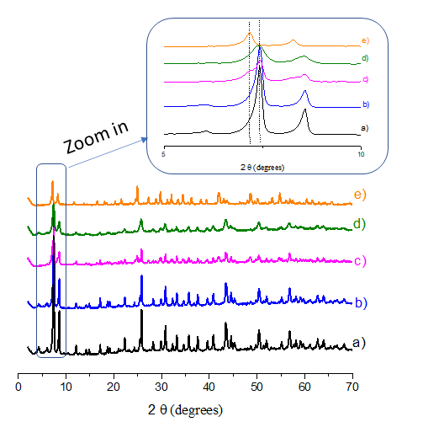
Figure 1: PXRD of UiO-66-(Zr)-NH₂ (a), UiO-66(Zr)-NH₂-200@UiO-66(Ce) (b), UiO-66(Zr)-NH₂-25@UiO-66(Ce) (c), UiO-66(Ce)-200@UiO-66(Zr)-NH₂ (d) and UiO-66(Ce) (e). The inset shows a zoon in in the low angle region.
Isothermal N₂ adsorption experiments were performed for UiO-66(Zr)-NH₂ and UiO-66(Ce) solids and their BET surface area values are 923 and 906 m²/g (Figures S1 and S2), respectively. These data are in good agreement with previous studies.^{30, 36} Further, UiO-66(Zr)-NH₂-200@UiO-66(Ce) and UiO-66(Zr)-NH₂-25@UiO-66(Ce) samples exhibited BET surface area values of 841 and 783 m²/g, respectively (Figures S3 and S4). Attempts to prepare a UiO-66(Ce)@UiO-66(Zr)-NH₂ composite using 200 mg of preformed UiO-66(Ce) resulted in a crystalline solid (Figure 1d) with a BET surface area of only 600 m²/g (Figure S5). This lower BET surface area may reflect that UiO-66(Ce) is not completely stable in the presence of the acidic ZrCl₄ reagent during the preparation of the UiO-66(Ce)@UiO-66(Zr)-NH₂ solid. In fact, this sample exhibited poor photocatalytic results for the OWS compared with the other two composites (data not shown). Therefore, we decided to continue the present study with UiO-66(Zr)-NH₂@UiO-66(Ce) samples.
HRSEM analysis of the UiO-66 samples under study revealed that UiO-66(Zr)-NH₂ (Figure S6) and UiO-66(Ce) (Figure S7) exhibited an average particle size with standard deviation of 133 ± 45 and 112 ± 46 nm, respectively. The preparation of UiO-66(Zr)-NH₂-200@UiO-66(Ce) and UiO-66(Zr)-NH₂-25@UiO-66(Ce) samples from the preformed UiO-66(Zr)-NH₂ (133 ± 45 nm) resulted in an increase of average particle size to 161 ± 80 and 142 ± 44 nm (Figures S8 and S9), respectively. The increase of particle size in the UiO-66 composites might be associated with the growth of UiO-66(Ce) over the external part of the preformed UiO-66(Zr)-NH₂ solid. In good agreement with these observations, ICP-AES analyses of the acid-digested composites revealed that the weight percentage of cerium respect to the total metal contents (Zr+Ce) in UiO-66(Zr)-NH₂-25@UiO-66(Ce) is 28.6 wt% that is higher compared to UiO-66(Zr)-NH₂-200@UiO-66(Ce) (11.5 %). Furthermore, UiO-66 samples were also analyzed by EDX mapping (S10-S13), point analyses (Figures S13-S16) and observing the presence of all the expected elements in the sample.
To gain more information about the structure of the prepared MOF-on-MOF materials, we further characterized these solids by STEM analyses. At the same time, to obtain some evidences over the oxidation and reduction sites in these materials, photodeposition tecnique was employed. This technique consists in the irradiation of a photocatalyst suspension in water in the presence of H₂PtCl₆ and Pb(NO₃)₂. Thus, Pt and PbO_{x} NPs are deposited in the reduction and oxidation sites of the photocatalyst, respectively.⁴² Figure 2 shows a representative STEM-EDX mapping analysis with the presence of the expected elements in the UiO-66(Zr)-25@UiO-66(Ce) sample together with Pt and Pb species photodeposited within its network. Furthermore, these SEM-EDX images indicate that there is a preferential deposition of Pt and Pb species on the whole surface of the MOF-on-MOF sample as revealed by a more intense color corresponding to Pt and Pb species in the border of the image. Similarly, the analysis of the UiO-66(Zr)-NH₂-200@UiO-66(Ce) sample revealed a similar preferential deposition of the Pt and Pb species in the surface (Figure S17).
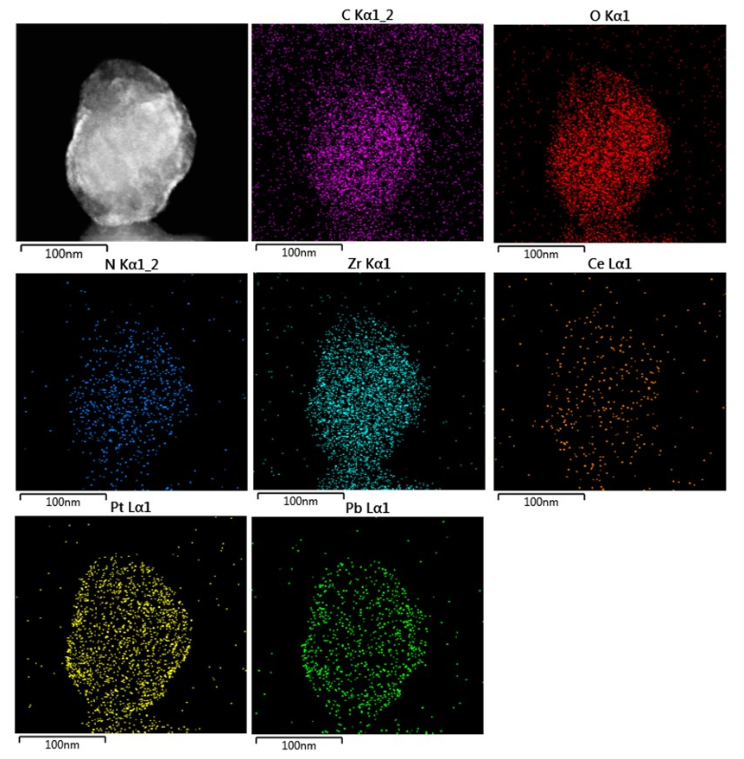
Figure 2. STEM image and elemental EDX mapping for UiO-66(Zr)-NH₂-25@UiO-66(Ce) supported Pt and PbO_{x} NPs.

To gain more information about the distribution of the elements in the UiO-66(Zr)-NH₂@UiO-66(Ce) solids supported with Pt and PbO_{x} NPs, EDX line scan analyses across the same particles analyzed by EDX mapping were carried out. Figure 3 shows the STEM image of UiO-66(Zr)-NH₂-25@UiO-66(Ce) solid together with the EDX scan line profiles. As it can be seen, the EDX line scan profiles of the elements shows that the ratio of Ce increases at both ends of the particle with a measured tichknesses of 4.6 and 3.9 nm respect to the Zr species (⁓140 nm of diameter). This measurement together with the previous information can be interpreted in the formation of a thin UiO-66(Ce) shell around UiO-66(Zr)-NH₂ particle. Similar conclusions can be obtained from the EDX line scan anlyses for the UiO-66(Zr)-NH₂-200@UiO-66(Ce) sample in where the analyzed particle exhibits a core of about 170 nm with shell thicknesses between 5.4 and 3.9 nm (Figure S18). Furthermore, Pt and Pb species accumulate predominantly in the UiO-66(Ce) shell and interface with UiO-66(Zr)-NH₂ domains in both composites.
Overall, these results can be interpreted considering the formation of a thin UiO-66(Ce) shell around the UiO-66(Zr)-NH₂ core. Analyses of the photodeposited Pt and Pb species along the MOF-on-MOF particles show preferential deposition and, therefore, the presence of redox sites on the shell and interface areas between both MOFs. However, the small thickness of the UiO-66(Ce) counterpart around the UiO-66(Zr)-NH₂ makes us difficult to identify separately oxidation and reduction domains in the MOF-on-MOF composite.

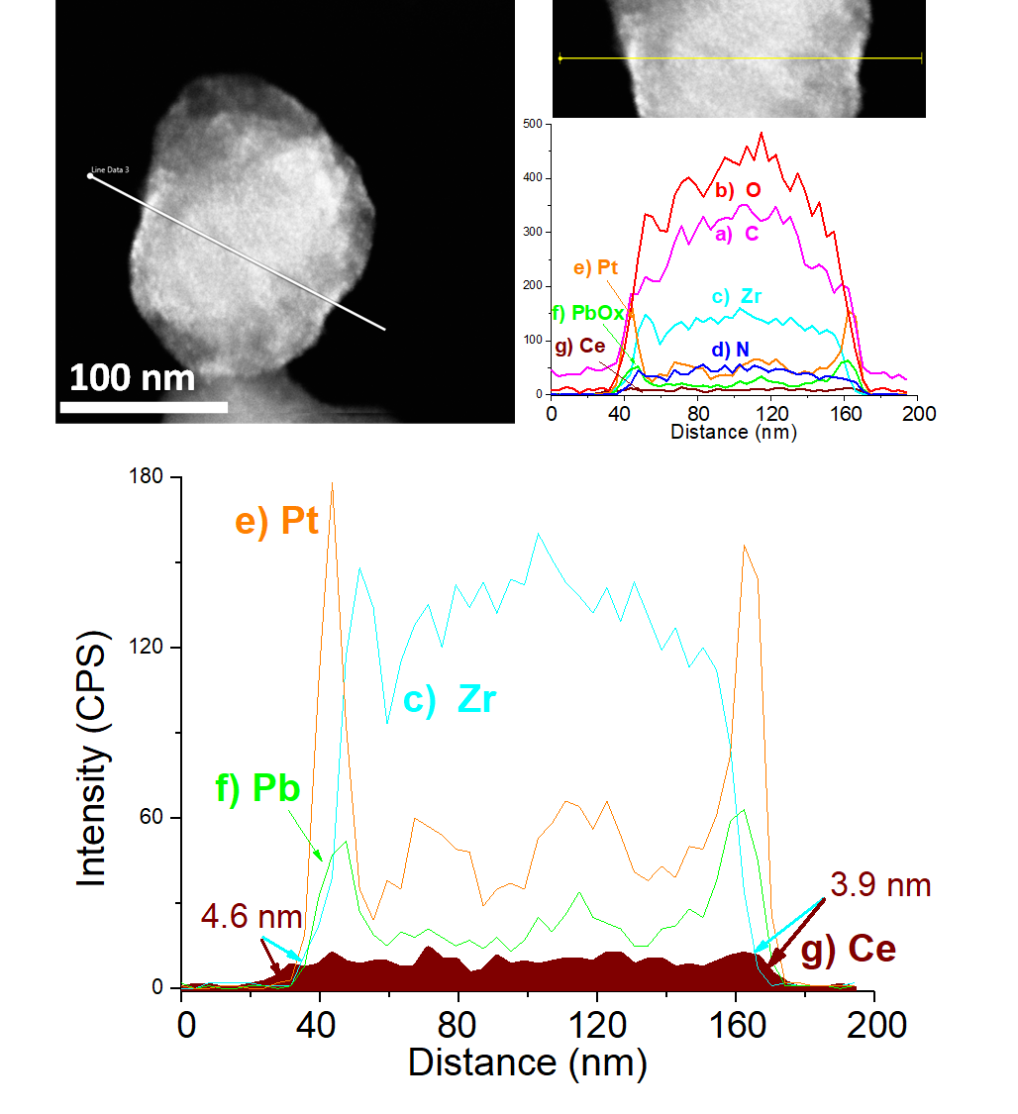
Figure 3. STEM image and line scan EDX analysis for UiO-66(Zr)-NH₂-25@UiO-66(Ce) supported Pt and PbO_{x} NPs along the path highlighed by the yellow line. The distribution of a) C, b) O, c) Zr, d) N, e) Pt, f) PbOx and g) Ce is presented on top image. Magnification of analysis for Zr, Ce, Pt and PbO_{x} is shows in the image in the down part. For clarity the area below the EDX line scan for Ce has been filled in brown color.

ATR-FT-IR spectroscopy was also employed to characterize the samples under study (Figure S19). The UiO-66(Zr)-NH₂ solid is characterized by the presence of carboxylate (υ_{asymm}1585 and υ_{symm} 1384 cm⁻¹) and amino ((υ_{asymm} 3482 cm⁻¹ and υ_{symm} 3386 cm⁻¹) functional groups together with the characteristic C-N stretching band (1595 cm⁻¹). The UiO-66(Ce) solid is also characterized by the vibrational bands of the carboxylate functional groups (υ_{asymm}1585 and υ_{symm} 1384 cm⁻¹).⁴³ These bands were also observed in the UiO-66 composites (Figure S19).
Thermogravimetric analyses show that UiO-66(Zr)-NH₂ and UiO-66-(Ce) solids are thermally stable up to about 300 ºC as previously reported (Figure S20). The combustion of the MOF organic ligand leads to a remaining weight that corresponds to the presence of metal oxides CeO₂ or ZrO₂. UiO-66(Zr)-NH₂ solid showed the experimental zirconium content of 32.8 wt% by TGA which is analogous to the ideal solid (31.2 %) with neutral formula Zr₆O₄(OH)₄(OOC-C₆H₃NH₂-COO)₆. Similarly, UiO-66(Ce) material also exhibited a quite good coincidence between the experimental cerium content as determined by TGA (42.9 wt%) and the cerium content (42.97 wt%) present in the ideal formula Ce₆O₄(OH)₄(OOC-C₆H₄-COO)₆. These small, but significant, differences between the experimental value afforded by TGA and the theoretical metal content of these two MOFs are an indication of the presence of structural defects.³⁰ Furthermore, UiO-66(Zr)-NH₂@UiO-66(Ce) composites exhibit a thermal stability intermediate between that of UiO-66(Ce) and UiO-66(Zr)-NH₂ solids.
UiO-66(Zr)-NH₂, UiO-66(Ce) and UiO-66(Zr)-NH₂@UiO-66(Ce) composites have also been characterized by XPS (Figure 4 and Figures S21-S23). C 1s spectrum shows the characteristic signals of the aromatic sp² carbons (284.4 eV) together with the C-N (286 eV) and carboxylate carbon atoms (288 eV) of the terephthalate ligands. The O 1s spectrum exhibits a main band at about 532 eV characteristic of the oxygen atoms present in the carboxylate groups. The N 1s spectrum is characteristic of the C-N of the amino group present in the UiO-66(Zr)-NH₂. The Zr 3d spectrum shows two bands attributable to the d_{5/2} (182.5 eV) and d_{3/2} (184.5 eV) characteristic of the Zr⁴⁺ ions present in the metal nodes of UiO-66(Zr)-NH₂. The Ce 3d spectrum reveals the presence of both Ce⁴⁺ and Ce³⁺ ions in the metal nodes of UiO-66(Ce) in agreement with previous reports.³⁰
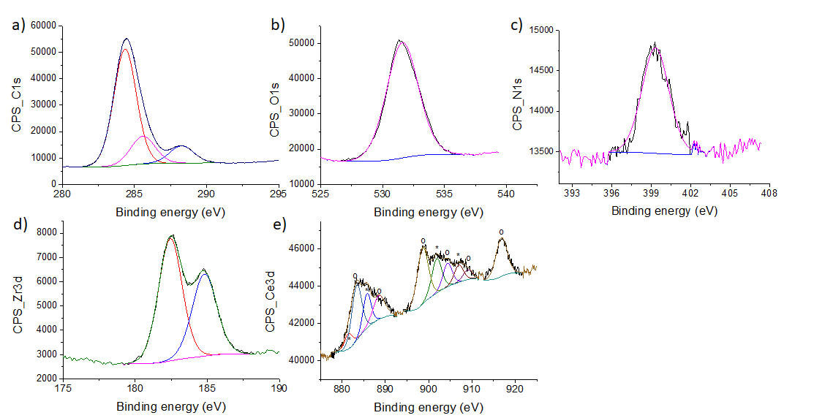
Figure 4. High resolution XPS peaks and the best deconvolution for the C 1s (a), O 1s (b), N1s (c), Zr 2p (d) and Ce 2d (e) signals recorded for the UiO-66(Zr)-NH₂-25@UiO-66(Ce) sample. Legend: Ce⁴⁺ (o), Ce³⁺ (*).

Another important feature of UiO-66 solids under study for their use as photocatalysts in the OWS is their energy level band diagram.⁴⁴ UV-Vis diffuse reflectance spectra of UiO-66 composites exhibit a characteristic shoulder band up to about 500 nm while UiO-66(Zr)-NH₂ and UiO-66(Ce) materials show absorption band up to 450 nm. From these UV-Vis spectra, the optical band gaps of the UiO-66 materials were determined by means of the Tauc plots (Figure S24). The estimated band gaps for UiO-66(Zr)-NH₂ and UiO-66(Ce) were 2.81 and 2.99 eV,^{36, 45} while slightly lower band gap values obtained for the UiO-66 composites. In addition, the energy level of the valence band maximum of these UiO-66 solids was estimated by XPS from the intersection of a linear fit to the linear portion of the electron emission edge and the background (Figure S25). The obtained value corresponds to the valence band maximum energy versus the Fermi level (E^{f}_{υ}). The valence band position vs the NHE (E_{υ}^{NHE}) can be obtained from the following equation: E_{υ}^{NHE} = E_{υ}^{f} + φ_{sp} -4.44 where φ_{sp} is the work function of the spectrometer with the value 4.244 eV. From this E_{υ}^{NHE} value and the band gap the conduction band energy minimum (E_{c}^{NHE}) can be determined. Figure 5 summarizes the energy level obtained for the UiO-66 composites and UiO-66(Zr)-NH₂ and UiO-66(Ce) samples. The results indicate that the UiO-66 samples meet the thermodynamic prerequisites to be used as photocatalysts for the OWS. As it can be seen in Figure 5, UiO-66 composites have slightly lower band gap and slightly positive lowest unoccupied crystal orbital (LUCO) values compared to UiO-66(Zr)-NH₂ and UiO-66(Ce) solids. One plausible explanation for these observations is the fact that the UiO-66(Ce) shell formed around the preformed UiO-66(Zr)-NH₂ core in both UiO-66(Zr)-NH₂-@UiO-66(Ce) composites differ in large extent respect to the as-prepared UiO-66(Ce) sample. As commented earlier, UiO-66(Ce) sample exhibits an average particle size with the standard deviation of 112 ± 46 nm, while the UiO-66(Ce) shell present in the composite has a thickness of only few nanometers (< 6 nm). In this context, previous studies in the area of photocatalysis using both inorganic semiconductors⁴⁶⁻⁴⁸ and MOFs^{49, 50} have shown that the size and shape of the particles determine their energy band diagram. Other factors including structural defects such oxygen-vacancies in inorganic semiconductors or missing linker or cluster in MOFs⁵⁰⁻⁵² also influences the resulting energy level band diagram of the solids. Therefore, these are possible explanations about the deviations of energy level diagrams between the UiO-66(Zr)-NH₂ or UiO-66(Ce) solids and the MOF-on-MOF composites.
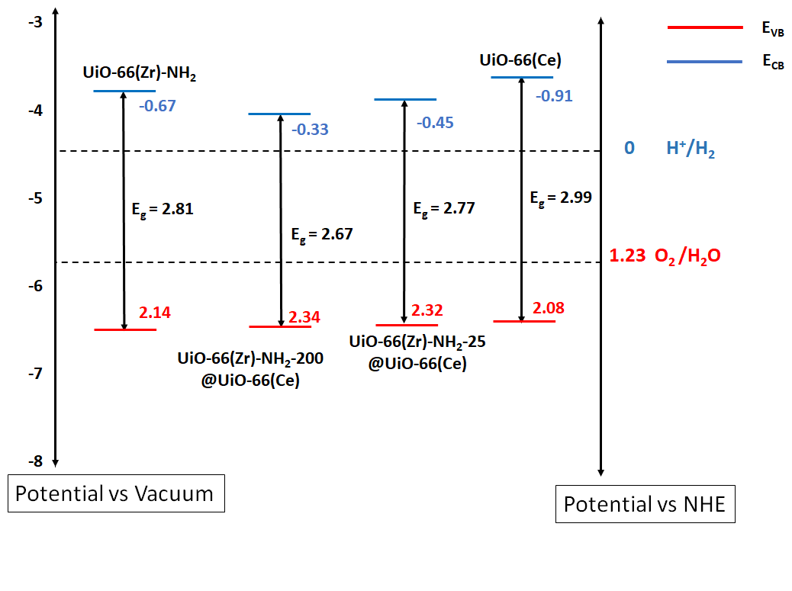
Figure 5. Energy band diagram of UiO-66(Zr)-NH₂, UiO-66(Zr)-NH₂-200@UiO-66(Ce), UiO-66(Zr)-NH₂-25@UiO-66(Ce) and UiO-66(Ce).
3.2. Photocatalytic results
The as-prepared series of UiO-66 samples were initially evaluated for the photocatalytic OWS. In good agreement with the energy band diagram of the UiO-66 solids shown in Figure 5, all the four samples were active for OWS reaction under both UV-Vis and simulated sunlight irradiation (Figure 6). Control experiments were carried out in the absence of photocatalyst and no formation of H₂ or O₂ is observed under the same reaction conditions. The somewhat lower oxygen content observed respect to the H₂O stoichiometry may be due to several reasons, including partial consumption of the photogenerated holes by spurious electron donor impurities or the in situ reaction of O₂ evolved during the photocatalytic reaction.³⁰ In fact, several previous studies of photocatalytic OWS using MOFs such as MIL-125(Ti)-NH₂,⁵¹ UiO-66(Zr/Ce/Ti),³⁰ UiO-66(Ce)-NH₂,⁵³ MIL-173(Zr/Ti),⁵⁰ IEF-11,³⁴ among other precedents,²⁵ have also reported H₂ to O₂ molar ratio higher than the theoretical value of 2 in OWS reaction. These observations can be related to several factors with different contributions that include H₂O oxidation to H₂O₂ that later could be decomposed to O₂. In this study, attempts to measure possible formation of H₂O₂ by titration with titanyl oxalate as previously reported,⁵⁴ do not reveal its formation during the photocatalytic OWS using UiO-66(Zr)-NH₂-25@UiO-66(Ce). Other factors such as the saturation of the MOF porosity network by O₂ that is more soluble than H₂ or the saturation of deareated water solution with O₂ (more water soluble than H₂) can justify to the observation of measured H₂ to O₂ ratio.⁵³ Interestingly, UiO-66(Zr)-NH₂@UiO-66(Ce) composites were more active compared to UiO-66(Zr)-NH₂ or UiO-66(Ce) solids for the OWS into H₂ and O₂ under both UV-Vis and simulated sunlight irradiation. Among the various solids tested, UiO-66(Zr)-NH₂-25@UiO-66(Ce) sample exhibited the highest activity of H₂ and O₂ production to 375 and 170 μmol g⁻¹ in 22 h under simulated sunlight irradiation (Figure 6). Additional experiments using exclusively visible light irradiation (λ > 420 nm) showed that a large part of the observed photocatalytic activity (277 μmol g⁻¹ H₂ and 79 μmol g⁻¹ of O₂ in 22 h) derives from its visible light response. Control experiments using a physical-mixture of UiO-66(Ce) and UiO-66(Zr)-NH₂ solids with the same proportions than in the UiO-66(Zr)-NH₂-25@UiO-66(Ce) composite resulted in a photocatalytic activity similar to that of UiO-66(Zr)-NH₂ or UiO-66(Ce) solids with the values of 154 and 77 μmol g⁻¹ for H₂ and O₂, respectively, in 22 h under simulated sunlight irradiation. This observation highlights the possibility of developing MOF-on-MOF composites with enhanced photocatalytic activity.
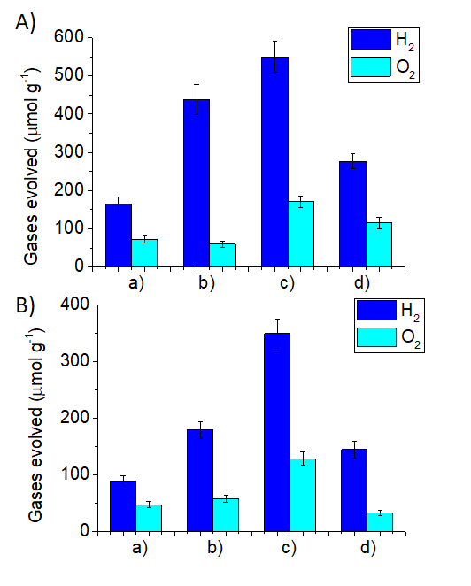
Figure 6. Photocatalytic OWS using UiO-66(Zr)-NH₂ (a), UiO-66(Zr)-NH₂-200@UiO-66(Ce) (b), UiO-66(Zr)-NH₂-25@UiO-66(Ce) (c) and UiO-66(Ce) (d) under UV-Vis (A) or simulated sunlight irradiation (B). Reaction conditions: photocatalyst (10 mg), H₂O (20 mL), UV-Vis (Hg-Xe lamp 150 W) (A) or simulated sunlight irradiation (B) (Hg-Xe lamp 150 W through an AM 1.5G filter), 35 °C.
It is important to note that the photocatalytic activity of UiO-66(Zr)-NH₂-25@UiO-66(Ce) (375 and 170 μmol g⁻¹ of H₂ and O₂ production, respectively, in 22 h under simulated sunlight irradiation) compares favorably with other MOF-based photocatalysts reported under similar conditions (Table S1).^{29-35, 55} More specifically, some of us have reported that a titanium (IV) squarate-MOF denoted as IEF-11 was one of the most active MOF photocatalysts for the OWS in the absence of any co-catalyst under simulated sunlight irradiation.³⁴ In particular, IEF-11 photocatalyst was efficient in splitting H₂O into H₂ and O₂ with the production rates of 260 and 107 μmol g⁻¹ h⁻¹ in 22 h, respectively, under identical photocatalytic conditions employed in this work (150 W Xe-He lamp, AM 1.5G filter, 10 mg of IEF-11, 20 mL H₂O, 35 ºC) and the same photoreactor.³⁴ Under identical reaction conditions, the production rate of H₂ and O₂ was enhanced to 540 and 267 μmol g⁻¹ at 22 h, respectively with 5 mg of IEF-11.³⁴ In this work, the activity of UiO-66(Zr)-NH₂-25@UiO-66(Ce) photocatalyst (5 mg) was notably higher with the production rates of H₂ and O₂ to 708 and 320 μmol g⁻¹, respectively after 22 h. The estimated apparent quantum yield (AQY) using UiO-66(Zr)-NH₂-25@UiO-66(Ce) as photocatalyst for the OWS is 0.034 % at 400 nm. For comparison, a mixed-metal Zr/Ti-MIL-173 porphyrin-based MOF exhibited an AQY of 0.11 % at 450 nm.⁵⁰ Overall, this study shows the possibility of preparing MOF-on-MOF composites based on UiO-66 solids to develop active photocatalysts for the OWS under simulated sunlight irradiation.
The stability of the most active UiO-66(Zr)-NH₂-25@UiO-66(Ce) sample was assessed by performing several consecutive reuses. Figure 7 shows that the photocatalyst retains its initial photocatalytic activity after six consecutive uses. The PXRD of the six-times used sample reveals that the solid maintains most of its initial crystallinity. ICP-AES analysis of the liquid phase after one use reveals that the absence of zirconium leaching while about 6 wt% of the initial cerium is leached to the solution. Thus, the partial cerium leaching may be one of the reasons of the observed decrease of activity.

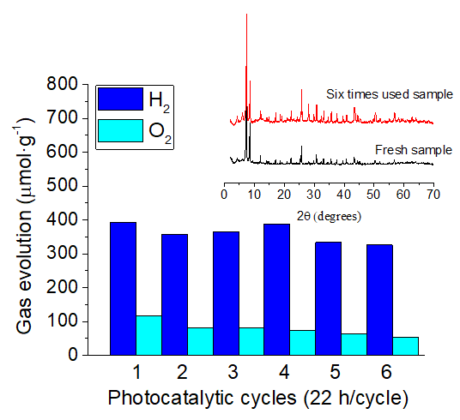
Figure 7. Photocatalytic OWS for six consecutive cycles using UiO-66(Zr)-NH₂-25@UiO-66(Ce) under simulated sunlight irradiation. The inset shows the PXRD patterns of the fresh and six-times used sample. Reaction conditions: photocatalyst (10 mg), H₂O (20 mL), simulated sunlight irradiation (Hg-Xe lamp 150 W through an AM 1.5G filter), 35 °C.

3.3. Reaction mechanism
To gain some insights on the high photocatalytic activity of UiO-66(Zr)-NH₂-25@UiO-66-(Ce) for the OWS, additional experiments were carried out. Initially, the photocatalytic H₂O oxidation to O₂ was confirmed by using isotopically labelled H₂¹⁸O and observing the formation of a m/z 36 associated to the formation of ¹⁸O_{2’} by GC-MS analysis of the headspace of the reactor after 22 h irradiation (Figure S26). In other control experiment, the possibility of cerium species that did not fully grow may behave as co-catalyst was evaluated. For this purpose, the most active UiO-66(Zr)-NH₂-25@UiO-66-(Ce) solid was modified in purpose with an additional amount of Ce⁴⁺ ions as described in the experimental section. Figure S27 shows that the resulting solid maintains its crystallinity as revealed by PXRD measurements while ICP-AES analysis of acid-digested sample confirms an additional cerium content of this sample respect to the parent solid with 3 wt%. The use of this sample as photocatalyst resulted in about a 10 % increase of H₂ production respect to the photocatalyst without additional Ce⁴⁺ ions. More significantly H₂:O₂ molar ratio was observed to be about 2.3 that is in contrast with the ratio of 3.35 value achieved with the sample without additional Ce⁴⁺ ions. This significant increase of the O₂ production due to the presence of additional amount of Ce⁴⁺ ions within the UiO-66(Zr)-NH₂-25@UiO-66-(Ce) solid can be attributed to the well-known role of Ce⁴⁺ as electron acceptor during OER in such a way that favors the generation of molecular O_{2.}^{32, 56} Therefore, these results suggest that Ce⁴⁺ ions that did not fully grow on UiO-66(Zr)-NH₂-25@UiO-66-(Ce) solid are not a determinant factor of the observed activity.
Additionally, the photocatalytic HER and OER in the presence of methanol or persulfate as sacrificial hole or electron scavengers, respectively, were performed. Figures 8a and 8b show that the order of activity for both photocatalytic HER or OER, respectively, is the same as that observed for the OWS (Figure 6). The most active photocatalyst for both processes are the UiO-66(Zr)-NH₂-25@UiO-66(Ce) composite. The observed order of photocatalytic activity for both HER and OER processes deserves some comments. The UiO-66(Zr)-NH₂ (-0.67 V) and UiO-66(Ce) (-0.91V) have more negative LUCO values than UiO-66(Zr)-NH₂-25@UiO-66(Ce) (-0.45 V), but all of them meet the thermodynamic reduction potential required for the HER. In this case, the higher photocatalytic activity of UiO-66(Zr)-NH₂-25@UiO-66(Ce) may be at least attributed to higher visible light harvesting due to the differences in UV-Vis absorption spectra. At the same time, UiO-66(Zr)-NH₂-25@UiO-66(Ce) sample with the higher band gap (2.77 eV) than to UiO-66(Zr)-NH₂-200@UiO-66(Ce) (2.67 eV) is also more active. In this case, the higher activity of UiO-66(Zr)-NH₂-25@UiO-66(Ce) respect to UiO-66(Zr)-NH₂-200@UiO-66(Ce) could be associated the more negative LUCO value of the former (-0.45 vs -0.33 V). In the case of the photocatalytic OER, the composites exhibit somewhat more positive HOCO (highest occupied crystal orbital) values than UiO-66(Zr)-NH₂ and UiO-66(Ce) together with lower band gap values and these might be the reasons of their higher photocatalytic activity during the OER. Regardless to these comments, the relatively higher activity of UiO-66(Zr)-NH₂-25@UiO-66(Ce) respect to UiO-66(Zr)-NH₂-200@UiO-66(Ce) sample for the OER cannot be simply explained based on their energy band diagram and other reasons should also be considered to explain this behavior.
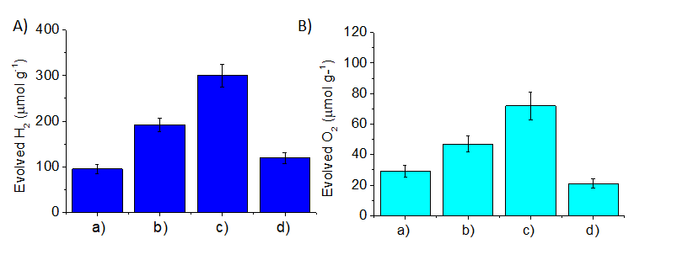
Figure 8. Photocatalytic H₂ (A) or O₂ (B) evolution reactions using UiO-66(Zr)-NH₂ (a), UiO-66(Zr)-NH₂-200@UiO-66(Ce) (b), UiO-66(Zr)-NH₂-25@UiO-66(Ce) (c) and UiO-66(Ce) (d) under simulated sunlight irradiation. Reaction conditions for panel A: photocatalyst (10 mg), H₂O (16 mL), MeOH (4 mL) simulated sunlight irradiation (Hg-Xe lamp 150 W through an AM 1.5G filter), 35 °C, reaction time 1 h. Reaction conditions for panel B: photocatalyst (10 mg), H₂O (20 mL), Na₂S₂O₈ (700 mg), simulated sunlight irradiation (Hg-Xe lamp 150 W through an AM 1.5G filter), 35 °C, reaction time 3 h.
To further evaluate the possible origin of the high photocatalytic activity of UiO-66(Zr)-NH₂-25@UiO-66(Ce) composite, a comparative photoluminescence emission spectroscopy was carried out for all the materials under study. Photoluminescence spectroscopy is a useful technique to provide some insights about the occurrence of photoexcited charge transfer and recombination in photoresponsive MOFs.⁵⁷ It is worth commenting that the emission intensity of a specific sample after photoexcitation is associated to its relatively inefficient charge separation. As it will be shown later, the photoexcitation of the UiO-66 materials results in the occurrence of photogenerated electron and hole pairs. Thus, the observed fluorescence emission of the UiO-66 samples is attributed to the emission of photons due to the inefficient photoinduced charge charrier separation. Figure 9 shows the photoluminescence spectrum of the UiO-66 series in acetonitrile suspension (about 0.1 mg mL⁻¹) after excitation at 266 nm. The emission spectrum of UiO-66(Zr)-NH₂ upon 266 nm irradiation is dominated by two main bands centered at around 360 and 448 nm. In contrast, negligible photoluminescence (PL) was recorded for UiO-66(Ce). Interestingly the PL emission of the UiO-66(Zr)-NH₂-200@UiO-66(Ce) sample resembles to that of UiO-66(Zr)-NH₂ in the region around 448 nm. UiO-66(Zr)-NH₂-25@UiO-66(Ce) sample showed much lower PL intensity compared to UiO-66(Zr)-NH₂-200@UiO-66(Ce) or UiO-66(Zr)-NH₂ indicating a more efficient charge separation process.

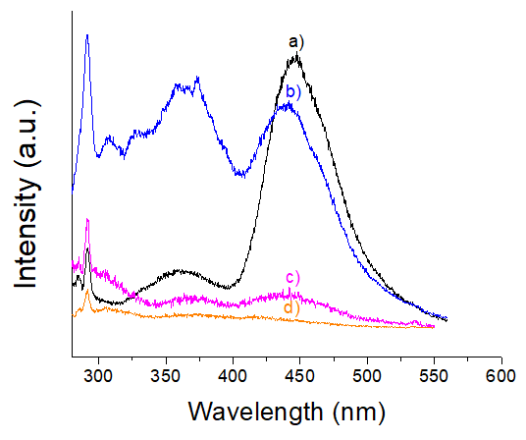
Figure 9 Emission spectra of acetonitrile suspension of a) UiO-66(Zr)-NH₂; b) UiO-66(Zr)-NH₂ 200@UiO-66 (Ce); c) UiO-66(Zr)-NH₂-25@UiO-66(Ce); d) UiO-66(Ce) recorded at λ_{exc}= 266 nm.
Other important aspect from the PL study (Figure 9) is the observation that the emission of the UiO-66(Zr)-NH₂-25@UiO-66(Ce) sample is much lower than that observed with the other composite UiO-66(Zr)-NH₂-200@UiO-66(Ce) indicating a better charge separation of the former. Thus, the good photocatalytic activity of UiO-66(Zr)-NH₂-25@UiO-66(Ce) sample respect to the other solids UiO-66(Zr)-NH₂-200@UiO-66(Ce) or UiO-66(Zr)-NH₂ can be associated to the better photoinduced charge separation. AlthoughUiO-66(Ce) sample shows similar emission intensities at 266 nm respect to UiO-66(Zr)-NH₂-25@UiO-66(Ce) sample, the lower photocatalytic activity of the former can be attributed at least partially to its lower ability to absorb visible light irradiation.
One common strategy to confirm the occurrence of photoinduced charge separation is the use of probe molecules that react with electrons or holes resulting in the formation of colored species. Among them, methyl viologen (MV²⁺) is one of the preferred molecules employed as one-electron acceptor leading to the formation of a visually observable blue colored radical cation (MV^{·+}) under inert atmosphere.⁵⁸ Similarly, N,N,N',N'-tetramethyl-p-phenylenediamine (TMPD) is commonly employed as one electron donor molecule rendering under inert atmosphere a visually observable blue-violet colored radical cation (TMPD^{·+}). In this study, it was observed that all the UiO-66 samples promote the photocatalytic one electron MV²⁺ reduction to MV^{·+} as well as the TMPD oxidation to TMPD^{·+} (Figure 10). Furthermore, it is interesting to note that the order of photocatalytic activity of the UiO-66 samples for these two processes is same for OWS, HER and OER reactions: UiO-66(Zr)-NH₂-25@UiO-66(Ce) > UiO-66(Zr)-NH₂-200@UiO-66(Ce) > UiO-66(Zr)-NH₂ > UiO-66(Ce).
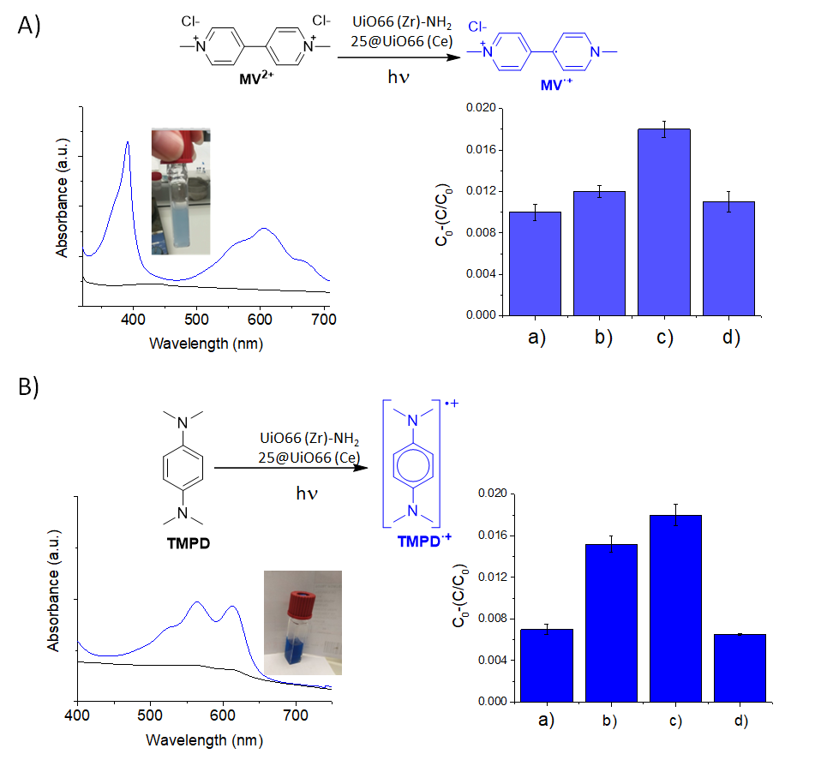
Figure 10. A) Photocatalytic one electron MV²⁺ reduction to MV^{·+} using UiO-66(Zr)-NH₂-25@UiO-66(Ce) and its UV-vis spectra before (black line) and after (blue line) irradiation of an acetonitrile MV²⁺ solution under Ar atmosphere. Right bar diagram shows the photocatalytic activity for MV²⁺ reduction to MV^{·+} using (a) UiO-66(Zr), (b) UiO-66(Zr)-NH₂-200@UiO-66(Ce), (c) UiO-66(Zr)-NH₂-25@UiO-66(Ce) and (d) UiO-66(Ce). B) Schematic illustration of the photocatalytic one electron TMPD oxidation to TMPD^{·+} using UiO-66(Zr)-NH₂-25@UiO-66(Ce) and its UV-vis spectra before (black line) and after (blue line) irradiation in acetonitrile solution under Ar. Right bar diagram shows the photocatalytic activity for TMPD to TMPD^{·+} under Ar atmosphere using (a) UiO-66(Zr), (b) UiO-66(Zr)-NH₂-200@UiO-66(Ce), (c) UiO-66(Zr)-NH₂-25@UiO-66(Ce) and (d) UiO-66(Ce).
To gain better insights into the observed photocatalytic activity and the occurrence of photoinduced charge separation observed by using probe molecules, the UiO-66 samples were further studied by means of microsecond transient absorption spectroscopy (TAS). For this purpose, optically matched (absorbance 0.3) acetonitrile suspensions of the four UiO-66 samples were prepared. Figure 11 shows the temporal profiles obtained for the UiO-66 samples upon laser excitation at 355 nm under Ar atmosphere and monitored at 340 nm. This selected wavelength can promote electrons from the HOCO to the LUCO of the UiO-66 materials. From the best fit of these temporal profiles to a monoexponential decay kinetics, lifetimes in the order of nanoseconds were obtained. Besides, all the transient signals shown in Figure 11 decay to the ground state in the time scale available for the measurement, indicating that no photoproducts are formed and the system decays to the initial ground state. Previous studies using defective UiO-66(Zr)-NH₂ samples as photocatalysts have described that the average decay lifetime obtained from femtosecond TAS can be used as indicator to evaluate the charge separation efficiency. The somewhat faster decay lifetime obtained for the UiO-66(Zr)-NH₂-25@UiO-66(Ce) composite respect to UiO-66(Zr)-NH₂-200@UiO-66(Ce), UiO-66(Zr)-NH₂ and UiO-66(Ce) can be attributed to the more efficient photoinduced electron-hole separation.

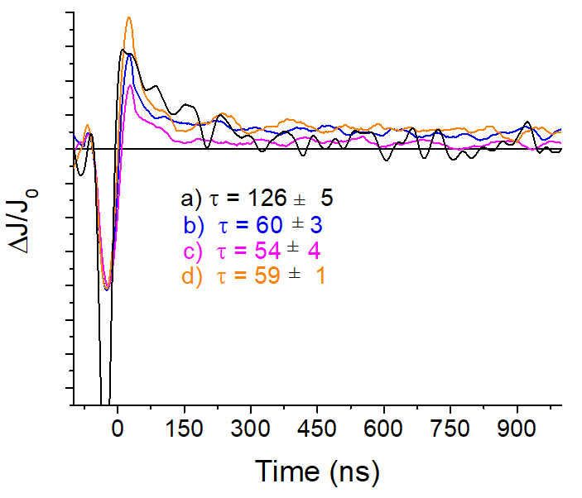
Figure 11: Temporal profiles of the transient signals monitored at 340 nm upon 355 nm laser excitation under argon atmosphere for a) UiO-66(Zr)-NH₂; b) UiO-66(Zr)-NH₂-200@UiO-66(Ce); c) UiO-66(Zr)-NH₂-25@UiO-66(Ce); d) UiO-66(Ce).

In the case of the most active UiO-66(Zr)-NH₂-25@UiO-66(Ce) sample the nature of the photogenerated species was further evaluated by microsecond TAS performing selective electron or hole quenching experiments. N₂O was employed as electron quencher, while methanol was used as hole quencher. Figure 12 shows that the presence of both N₂O or MeOH quenches the transient signals monitored at 340 nm upon excitation at 355 nm. These observations agree that the nature of the photogenerated transient species as being a contribution of electrons and holes. Figure 12 also shows that the presence of N₂O or MeOH quenches different regions of the transient absorption spectrum recorded under Argon. Electrons have a larger contribution to the absorption from 300 to 700 nm, while positive holes are responsible in a larger proportion for the absorption between 260-575 nm. Overall, this behavior indicates that the species responsible for the absorption signal in the transient spectrum correspond to photogenerated electrons and holes.
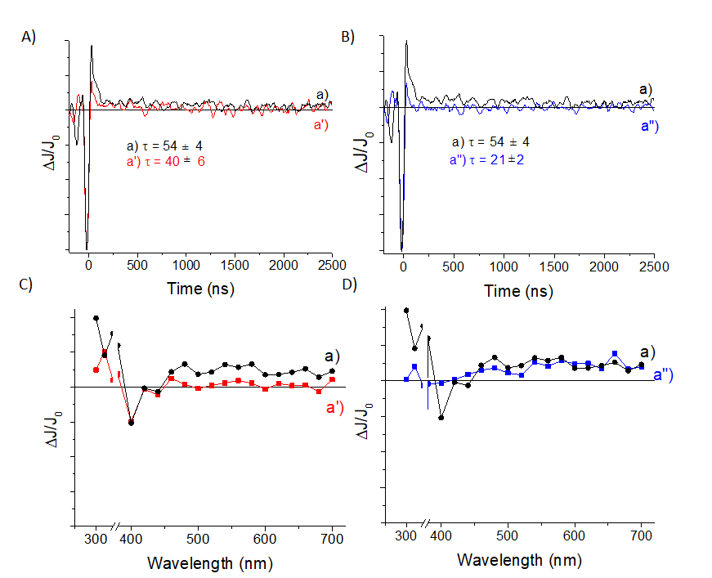
Figure 12. Temporal profile of the transient signals monitored at 340 nm recorded upon 355 nm laser excitation for UiO-66(Zr)-NH₂-25@UiO-66(Ce) sample (A, B) under argon atmosphere (a), N₂O atmosphere (a’) and in the presence of methanol (a’’). Transmission transient absorption spectra of UiO66 (Zr)-NH₂-25@UiO-66(Ce) sample (C, D) recorded at 10 ns after 355 nm laser excitation under argon atmosphere (a) or after the addition of 300 mL of dichloromethane (a’) or methanol (a’’) for optically matched (absorbance 0.2) suspensions of the composites in acetonitrile.
Overall, the present results indicate that the UiO-66(Zr)-NH₂@UiO-66(Ce) composites showed enhanced visible light absorption, photoinduced charge separation and photocatalytic activity for the HER and OWS compared to UiO-66(Zr)-NH₂ and UiO-66(Ce) solids.
4. Conclusions
This work shows the feasibility of developing active MOF-on-MOF composites based UiO-66 topology for the photocatalytic OWS under simulated sunlight irradiation. Out of the different solids tested, the activity of UiO-66(Zr)-NH₂-25@UiO-66(Ce) solid exhibited three times higher activity compared to UiO-66(Zr)-NH₂ or UiO-66(Ce) solids in HER, OER and OWS under simulated sunlight irradiation. The achieved photoactivity performance of UiO-66(Zr)-NH₂-25@UiO-66(Ce) in the OWS to H₂ (708 μmol g⁻¹) and O₂ (320 μmol g⁻¹) without any co-catalyst under simulated sunlight irradiation after 22 h compares favorably with previous MOF-based photocatalysts from the litearture. The good performance of UiO-66(Zr)-NH₂-25@UiO-66(Ce) solid in OWS reaction is associated due to its adequate energy band diagram (band gap, HOCO and LUCO values) and favorable photoinduced charge separation.
The authors of this investigation believe that this study will help to the development of other MOF-based photocatalsts for the solar-driven photocatalytic OWS in the near future.

Supporting Information
This section provides intrumentation details, photocatalytic and control experiments. Laser-flash photolysis measurements, isothermal gas adsorption-desorption measurements, HRSEM images, SEM-EDX images. SEM-EDX mapping, STEM image with elemental mapping, FT-IR spectra, TGA curves, XPS deconvolution peaks, UV-Vis diffuse reflectance, mass spectrum with labelled water experiment and powder XRD for the as-prepared solids in this work.

Acknowledgements
S.N. is gracious for the financial support from Grant PID2021-123856OB-I00 funded by MCIN/AEI/10.13039/501100011033 and by “ERDF A way of making Europe. A.D. thanks the Spanish Ministry of Science and Education for a Maria Zambrano contract.

Conflict of Interest
The authors declare no conflict of interest.

Data Availability Statement
The data that support the findings of this study are available from the corresponding author upon request.

References
1. Li, X.; Yu, J.; Jaroniec, M.; Chen, X., Cocatalysts for selective photoreduction of CO₂ into solar fuels. Chem. Rev. 2019, 119, 3962−4179.
2. Brockway, P. E.; Sorrell, S.; Semieniuk, G.; Heun, M. K.; Court, V., Energy efficiency and economy-wide rebound effects: A review of the evidence and its implications. Renewable and Sustainable Energy Rev. 2021, 141, 110781.
3. Shafiee, S.; Topal, E., When will fossil fuel reserves be diminished? Energy Policy 2009, 37, 181-189.
4. Rissman, J.; Bataille, C.; Masanet, E.; Adene, N.; Morrow III, W. R.; Zhou, N.; Elliott, N.; Dell, R.; Heeren, N.; Huckestein, B. et al., Technologies and policies to decarbonize global industry: Review and assessment of mitigation drivers through 2070. Appl. Energ. 2020 266, 114848.
5. Qian, J. X.; Chen, T. W.; Enakonda, L. R.; Liu, D. B.; Basset, J.-M.; Zhou, L., Methane decomposition to pure hydrogen and carbon nano materials: State-of-the-art and future perspectives. Int. J. Hydrog. Energ. 2020, 45, 15721-15743.
6. Kim, J.; Hansora, D.; Sharma, P.; Jang, J.-W.; Lee, J. S., Toward practical solar hydrogen production – an artificial photosynthetic leaf-to-farm challenge. Chem. Soc. Rev. 2019, 48, 1908-1971.
7. Lewis, N. S., Introduction: Solar energy conversion. Chem. Rev. 2015, 115, 12631-12632.
8. Lewis, N. S., Research opportunities to advance solar energy utilization. Science 2016, 351, 1920.
9. Fujishima, A.; Honda, K., Electrochemical photolysis of water at a semiconductor electrode. Nature 1972, 238, 37-38.
10. Hisatomi, T.; Domen, K., Reaction systems for solar hydrogen production via water splitting with particulate semiconductor photocatalyst. Nat. Catal. 2019, 2, 387–399.
11. Wang, Q.; Domen, K., Particulate photocatalysts for light-driven water splitting: Mechanisms, challenges, and design strategies. Chem. Rev. 2020, 120, 919-985.
12. Wang, Z.; Li, C.; Domen, K., Recent developments in heterogeneous photocatalysts for solar-driven overall water splitting. Chem. Soc. Rev. 2019, 2109-2125.
13. Dhakshinamoorthy, A.; Asiri, A. M.; García, H., Metal-organic framework (MOF) compounds: Photocatalysts for redox reactions and solar fuel production. Angew. Chem. Int. Ed. 2016, 55, 5414-5445.
14. Nasalevich, M. A.; Van Der Veen, M.; Kapteijn, F.; Gascon, J., Metal-organic frameworks as heterogeneous photocatalysts: Advantages and challenges. CrystEngComm 2014, 16, 4919-4926.
15. Qian, Y.; Zhang, F.; Pang, H., A review of MOFs and their composites-based photocatalysts: Synthesis and applications. Adv. Func. Mater. 2021, 31, 2104231.
16. Li, H.; Eddaoudi, M.; O'Keeffe, M.; Yaghi, O. M., Design and synthesis of an exceptionally stable and highly porous metal- organic framework. Nature 1999, 402, 276-279.
17. Férey, G., Hybrid porous solids: past, present, future. Chem. Soc. Rev. 2008, 37, 191-214.
18. Férey, G.; Mellot-Draznieks, C.; Serre, C.; Millange, F.; Dutour, J.; Surblé, S.; Margiolaki, I., A chromium terephthalate-based solid with unusually large pore volumes and surface area. Science 2005, 23, 2040-2042.
19. Kitagawa, S.; Kitaura, R.; Noro, S.-I., Functional porous coordination polymers. Angew. Chem. Int. Ed. 2004, 43, 2334-2375.
20. Furukawa, H.; Cordova, K. E.; O'Keeffe, M.; Yaghi, O. M., The chemistry and applications of metal-organic frameworks. Science 2013, 341, 1230444.
21. Gropp, C.; Canossa, S.; Wuttke, S.; Gándara, F.; Li, Q.; Gagliardi, L.; Yaghi, O. M., Standard practices of reticular chemistry. ACS Central Science 2020, 6, 1255-1273.
22. Akbarian, M.; Sanchooli, E.; Oveisi, A. R.; Daliran, S., Choline chloride-coated UiO-66-Urea MOF: A novel multifunctional heterogeneous catalyst for efficient one-pot three-component synthesis of 2-amino-4H-chromenes. . J. Mol. Liq. 2021, 325, 115228.
23. Azarifar, D.; Ghorbani-Vaghei, R.; Daliran, S.; Oveisi, A. R., A multifunctional zirconium-based metal–organic framework for the one-pot tandem photooxidative passerini three-component reaction of alcohols. ChemCatChem 2017, 9, 1992-2000.
24. Bavykina, A.; Kolobov, N.; Khan, S.; Bau, J. A.; Ramirez, A.; Gascon, J., Metal−organic frameworks in heterogeneous catalysis: Recent progress, new trends, and future perspectives. Chem. Rev. 2020.
25. Navalón, S.; Dhakshinamoorthy, A.; lvaro, M.; Ferrer, B.; García, H., Metal–organic frameworks as photocatalysts for solar-driven overall water splitting. Chem. Rev. 2023, 123, 445-490.
26. Daliran, S.; Ghazagh-Miri, M.; Oveisi, A. R.; Khajeh, M.; Navalón, S.; Álvaro, M.; Ghaffari-Moghaddam, M.; Delarami, H. S.; García, H., A Pyridyltriazol functionalized zirconium metal-organic framework for selective and highly efficient adsorption of palladium. . ACS Appl Mater Interfaces 2020, 12, 25221-25232.
27. Nguyen, H. L., Metal–organic frameworks for photocatalytic water splitting Solar RRL 2021, 5, 2100198.
28. Kampouri, S.; Ebrahim, F. M.; Fumanal, M.; Nord, M.; Schouwink, P. A.; Elzein, R.; Addou, R.; Herman, G. S.; Smit, B.; Ireland, C. P. et al., Enhanced visible-light-driven hydrogen production through MOF/ MOF heterojunctions. ACS Appl. Mater. Interfaces 2021, 13, 14239−14247.
29. An, Y.; Liu, Y.; An, P.; Dong, J.; Xu, B.; Dai, Y.; Qin, X.; Zhang, X.; Whangbo, M.-H.; Huang, B., Ni^{II} coordination to Al-based metal–organic framework made from 2-aminoterephthalate for photocatalytic overall water splitting. Angew. Chem. Int. Ed. 2017, 56, 3036 –3040.
30. Melillo, A.; Cabrero-Antonino, M.; Navalón, S.; Alvaro, M.; Ferrer, B.; García, H., Enhancing visible light photocatalytic activity for overall water splitting in UiO-66 by controlling metal node composition. Appl. Catal. B. Environ. 2020, 278, 119345.
31. Zhang, J.; Bai, T.; Huang, H.; Yu, M.-H.; Fan, X.; Chang, Z.; Bu, X.-H., Metal–organic-framework-based photocatalysts optimized by spatially separated cocatalysts for overall water splitting. Adv. Mater. 2020, 32, 2004747.
32. Remiro-Buenamañana, S.; Cabrero-Antonino, M.; Martínez-Guanter, M.; Álvaro, M.; Navalón, S.; García, H., Influence of co-catalysts on the photocatalytic activity of MIL-125(Ti)-NH2 in the overall water splitting Appl. Catal. B. Environ. 2019, 677-684.
33. Salcedo-Abraira, P.; Vilela, S. M. F.; Babaryk, A. A.; Cabrero-Antonino, M.; Gregorio, P.; Salles, F.; Navalón, S.; García, H.; Horcajada, P., Nickel phosphonate MOF as efficient water splitting photocatalyst. Nano Res. 2021, 14, 450–457.
34. Salcedo-Abraira, P.; Babaryk, A. A.; Montero-Lanzuela, E.; Contreras-Almengor, O. R.; Cabrero-Antonino, M.; Grape, E. S.; Willhammar, T.; Navalón, S.; Elkäim, E.; García, H.et al., A novel porous Ti-squarate as efficient photocatalyst in the overall water splitting reaction under simulated sunlight irradiation. Adv. Mater. 2021, 33, 2106627.
35. Hu, H.; Wang, Z.; Cao, L.; Zeng, L.; Zhang, C.; Lin, W.; Wang, C., Metal-organic frameworks embedded in a liposome facilitate overall photocatalytic water splitting. Nat. Chem. 2021, 13, 358-366.
36. Melillo, A.; García-Vallés, C.; Ferrer, B.; Álvaro, M.; Navalón, S.; García, H., Bifunctional metal-organic frameworks for hydrogenation of nitrophenol using methanol as hydrogen source. Org. Biomol. Chem. 2020, 19, 794-800.
37. Lammert, M.; Glißmann, C.; Stock, N., Tuning the stability of bimetallic Ce(IV)/Zr(IV)-based MOFs with UiO-66 and MOF-808 structures. Dalton Trans. 2017, 46, 2425-2429.
38. Sun, D.; Liu, W.; Qiu, M.; Zhang, Y.; Li, Z., Introduction of a mediator for enhancing photocatalytic performance via post-synthetic metal exchange in metal–organic frameworks (MOFs). Chem. Commun. 2015, 51, 2056-2059.
39. Sun, D.; Fu, Y.; Liu, W.; Ye, L.; Wang, D.; Yang, L.; Fu, X.; Li, Z., Studies on photocatalytic CO₂ reduction over NH₂-UiO-66(Zr) and its derivatives: Towards a better understanding of photocatalysis on metal–organic frameworks Chem. Eur. J. 2013, 19, 14279-14285.
40. Cliffe, M. J.; Wan, W.; Zou, X.; Chater, P. A.; Kleppe, A. K.; Tucker, M. G.; Wilhelm, H.; Funnell, N. P.; Coudert, F. X.; Goodwin, A. L., Correlated defect nanoregions in a metal-organic framework. Nat. Commun. 2014, 5, 4176.
41. Shearer, G. C.; Chavan, S.; Bordiga, S.; Svelle, S.; Olsbye, U.; Lillerud, K. P., Defect engineering: tuning the porosity and composition of the metal−organic framework UiO-66 via modulated synthesis. Chem. Mater. 2016, 28, 3749−3761.
42. Wenderich, K.; Mul, G., Methods, mechanism, and applications of photodeposition in photocatalysis: A review. . Chem. Rev. 2016, 116, 14587−14619.
43. Nagarjun, N.; Concepcion, P.; Dhakshinamoorthy, P., Influence of oxophilic behavior of UiO-66(Ce) metal–organic framework with superior catalytic performance in Friedel-Crafts alkylation reaction. Appl. Organometal. Chem. 2020, 34, 5578.
44. Peng, Y.; Rendón-Patiño, A.; Franconetti, A.; Albero, J.; Primo, A.; García, H., Photocatalytic overall water splitting activity of templateless structured graphitic nanoparticles obtained from cyclodextrins. ACS Appl. Energy Mater. 2020, 3, 6623-6632.
45. Qiu, X.; Zhu, Y.; Zhang, X.; Zhang, Y.; Menisa, L. T.; Xia, C.; Liu, S.; Tang, Z., Cerium-based metal–organic frameworks with UiO architecture for visible light-induced aerobic oxidation of benzyl alcohol. Sol. RRL 2019, 1900449.
46. Liberto, G. D.; Cipriano, L. A.; Tosoni, S.; Pacchioni, G., Rational design of semiconductor heterojunctions for photocatalysis. Chem. Eur. J. 2021, 27, 13306-13317.
47. Lin, H.; Huang, C. P.; Li, W.; Ni, C.; Ismat Shah, S.; Tseng, Y.-H., Size dependency of nanocrystalline TiO2 on its optical property and photocatalytic reactivity exemplified by 2-chlorophenol. . Appl. Catal. B.-Environ. 2006, 68 1-11.
48. Ong, W.-J.; Tan, L.-L.; Chai, S.-P.; Yong, S.-T.; Mohamed, A. R., Facet-dependent photocatalytic properties of TiO₂-based composites for energy conversion and environmental remediation. ChemSusChem 2014, 7, 690 – 719.
49. Cheng, X.-M.; Dao, X.-Y.; Wang, S.-Q.; Zhao, J.; Sun, W.-Y., Enhanced photocatalytic CO₂ reduction activity over NH₂-MIL-125(Ti) by facet regulation. ACS Catal. 2021, 11, 650–658.
50. Gikonyo, B.; Montero-Lanzuela, E.; G. Baldovi, H. G.; De, S.; Journet, C.; Devic, T.; Guillou, N.; Tiana, D.; Navalon, S.; Fateeva, A., Mixed-metal Zr/Ti MIL-173 porphyrinic metal–organic frameworks as efficient photocatalysts towards solar-driven overall water splitting. J. Mater. Chem. A 2022, 10, 24938-24950.
51. Cabrero-Antonino, M.; Albero, J.; García-Vallés, C.; Álvaro, M.; Navalón, S.; García, H., Plasma-induced defects enhance the visible-light photocatalytic activity of MIL-125(Ti)-NH2 for overall water splitting. Chem. Eur. J. 2020, 26, 15682 - 15689.
52. Xu, J.; Lu, L.; Zhu, C.; Fang, Q.; Liu, R.; Wang, D.; He, Z.; Song, S.; Shen, Y., Insights into conduction band flexibility induced by spin polarization in titanium-based metal–organic frameworks for photocatalytic water splitting and pollutants degradation. J. Colloid. Inter. Sci. 2023, 430-442.
53. Dai, S.; Montero-Lanzuela, E.; Tissot, A.; Baldoví, H. G.; García, H.; Navalón, S.; Serre, C., Room Temperature design of Ce(IV)-MOFs: from photocatalytic HER and OER to overall water splitting under simulated sunlight irradiation. Chem. Sci. 2023, DOI: 10.1039/D2SC05161C.
54. Manickam-Periyaraman, P.; Espinosa, J. C.; Ferrer, B.; Subramanian, S.; Álvaro, M.; García, H.; Navalón, S., Bimetallic iron-copper oxide nanoparticles supported on nanometric diamond as efficient and stable sunlight-assisted Fenton photocatalyst. Chem. Eng. J. 2020, 393, 124770.
55. Semerci, T. G.; Melillo, A.; Mutlu, Y. C.; Garcia, H., Band alignment of PCN-222 via selection of the metal porphyrin linker for sunlight driven photocatalytic overall water splitting. . Catal. Today 2022.
56. Bamwenda, G. R.; Uesigi, T.; Abe, Y.; Sayama, K.; Arakawa, H., The photocatalytic oxidation of water to O₂ over pure CeO₂, WO₃, and TiO₂ using Fe₃C and Ce₄C as electron acceptors. Appl Catal. A Gen. 2001, 205, 117-128.
57. Xiao, J.-D.; Shang, Q.; Xiong, Y.; Zhang, Q.; Luo, Y.; Yu, S.-H.; Jiang, H.-L., Boosting photocatalytic hydrogen production of a metal–organic framework decorated with platinum nanoparticles: The platinum location matters. Angew. Chem. Int. Ed. 2016, 55, 9389 –9393.
58. Striepe, L.; Baumgartner, T., Viologens and their application as functional materials. Chem. Eur. J. 2017, 23, 16924 – 16940.

