generation of a neural stem progenitor cell line, transfected with green fluorescent protein for in VIVO MONITORING

CRISTINA RUBIO RAMÓN
Tutor UPV: Francisco Jiménez Marco
Cotutor: Francisco Javier Rodríguez Jiménez
Cotutor colaborador: Ángel Vilches García

TRABAJO FINAL DE GRADO
CURSO 2014/15
Valencia, Julio 2015

UNIVERSITAT POLITÈCNICA DE VALÈNCIA
ESCOLA TÈCNICA SUPERIOR D´ENGINYERIA AGRONÒMICA I DEL MEDI NATURAL

Generación de una línea de progenitores neurales (NPSCs), transfectadas con el gen de la proteína fluorescente verde (GFP) para monitorización in vivo

La presencia de células madre en el tejido medular de individuos adultos (progenitores neurales o epSPCs) abre un abanico de posibilidades en lo que se refiere al tratamiento de lesión medular. No sólo supone un avance en terapia celular sino también en la estimulación del potencial endógeno regenerador del sistema nervioso. Estos últimos años se han llevado a cabo variedad de estudios en los que se pretendía estudiar el comportamiento de estas células madre o progenitores neurales en homeostasis o tras una lesión. En ellos se utilizan técnicas como la farmacología, el silenciamiento con RNAi o sobreexpresión con vectores de expresión en mamíferos para potenciar o deprimir cascadas de señalización celular que aumentan ese potencial endógeno regenerador.
La terapia celular con estos progenitores también es importante ya que ayuda a los mecanismos internos en su función de reparar el daño y proteger las neuronas dañadas tras la lesión medular. Para su estudio es necesario, por tanto, marcar estas células, que van a ser trasplantadas, con una señal fluorescente estable como por ejemplo GFP. De esta manera se podrá hacer un seguimiento de la migración de las células diferenciadas in vivo. En primer lugar para observar la migración desde el lugar de inyección hasta el lugar de la lesión, y en segundo lugar para comprobar que se incorporan a la estructura tisular de la misma manera que lo harían de forma natural y no formando estructuras indeseadas.

Palabras clave: lesión medular, terapia celular, progenitores neurales (epSPCs)

Autora: Cristina Rubio Ramón
Valencia, Julio 2015
Tutor UPV: Francisco Jiménez Marco
Cotutor: Francisco Javier Rodríguez Jiménez
Cotutor colaborador: Ángel Vilches García

Generation of a neural stem progenitor cell lines (NPSCs), transfected with Green Fluorescent Protein (GFP) for in vivo monitoring

The presence of stem cells in the adult spinal cord (neural progenitor or epSPCs) entails an important progress in spinal cord injury treatment. This progress is not only related to cell therapy but also to enhance the endogenous regenerative potential of the nervous system. In the last few decades, the attention has been focused on studying the behavior of this stem cells or epSPCs in homeostasis or after the injury. Pharmacological studies, silencing with RNAi and overexpressing analysis with expression vectors in mammals are currently an excellent tool in order to increase or decrease cellular signaling pathways which upgrade this endogenous regeneration potential.
Neural progenitors or epSPCs have an important role on cell therapy. Those stem cells help endogenous mechanism related to damage repairing and neural protection after spinal cord injury. It is, indeed, needed to insert a stable fluorescent marker, GFP for example, to these cells in order to study and monitor in vivo differentiated stem cells when transplanted. In first place, to observe the migration from the injection point to the lesion area and, in second place to check if cells incorporate themselves to the tissue structure in a natural way or if they form undesirable structures.

Key word: spinal cord injury, cell therapy, neural progenitor (epSPCs)

Author: Cristina Rubio Ramón
Valencia, July 2015
UPV tutor: Francisco Jiménez Marco
Co-tutor: Francisco Javier Rodríguez Jiménez
Co-tutor contributor: Ángel Vilches García

ACKNOWLEDGEMENTS
I thank our colleagues from Regenerative medicine groups, headed by Dr. Slaven Erceg and Dr. Victoria Moreno Manzano, from the Foundation Prince Felipe Research Center who provided insight and expertise that greatly assisted the research.
In addition, I would like to thank Dr. Francisco Marco Jiménez for his advice during the writing of this report.

LIST OF FIGURES
Figure 1. Overview of pathophysiology and stem cell treatment for SCI. 1
Figure 2. Mus musculus 3
Figure 3. The Relative Contribution of Ependymal Cells, Astrocytes, and Oligodendrocyte Progenitors to New Glial Cells in the Adult. 4
Figure 4. Schematic representation of approaches used to establish adult spinal cord stem cell proliferation, self-renewal and expansion, and production of neurons, astrocytes, and oligodendrocytes. The experimental approaches to demonstrating self-renewal and expansion of stem cells in response to EGF+bFGF are shown. When primary, dissociated adult cells are exposed to EGF+bFGF, spheres of undifferentiated cells are generated. 5
Figure 5. Different protocols to induce pluripotency related to their clinical use 7
Figure 6. Steps followed in order to use ihPSCs for transplantation 8
Figure 7. Mice placed at their cage with food and water access 11
Figure 8. pMXIE. Plasmid containing the GFP gen. 12
Figure 9. pHCMV-AmphoEnv. Plasmid containing retrovirus envelope or capside. 13
Figure 10. Clean culture of neurospheres (10X) 15
Figure 11. Infected neurosphere with GFP via retroviral vector (1). 16
Figure 12. Infected neurosphere with GFP via retroviral vector (2). 16
Figure 13. Infected neurosphere with GFP via retroviral vector (3). 17

LIST OF TABLES
Table 1. Overview of major cell sources employed in the cell-based applications for SCI 2
Table 2. Pros and cons of NSPCs transplantation 5
Table 3. Techniques of mammalian cell transfection 9
Table 4. Mice strains 11
Table 5.Complete medium. Supplementation of neurosphere culture medium 12
Table 6. Hormone Mix 100X 12
Table 7. Efficiency of viral transfection of epSPCs 15

LIST OF ABBREVIATIONS
SCI
CNS
GFAP
SC
OPC
hESCs
NSPCs
ihPSCs
OECs
MSCs
hUCB
BMSCs
GCV
epSPCs
CSPG
mRNA
iPS-NPs

EAEC

CEBA
BOE
HSV-TK
ULA-6MW
pMXIE
GFP
pHCMV-AmphoEnv
HEK 293
FBS
HEPES

Spinal Cord Injury
Central Nervous System
Glial fibrillary acidic protein
Stem Cell
Oligodendrocytes Precursor Cells
Human Embryonic Stem Cells
Neural Stem Progenitor Cells
Induced human Pluripotent Stem Cells
Olfactory Ensheatihng Cells
Mesenquimal Stem Cells
Human Umbilical Cord Blood
Bone Marrow Stem Cells
Ganciclovir
Ependymal Stem Progenitor Cells
Chondroitin sulphate proteoglycans
Messenger RNA
Induced Pluripotent Stem-Neural Progenitor Cells
Ethics Committee for Animal Experimentation
Ethical Committee for Animal Welfare
Official Spanish State Gazette
Herpes simplex virus-thymidine kinase
Ultra-Low Attach 6 Multi Well plate
pMX-IRES-EGFP
Green Fluorescent Protein
Amphotropic: capside retrovirus
Human Embryonary Kidney 293
Fetal Bovine Serum
4-(2-hydroxyethyl)-1-piperazineethanesulfonic acid
INDEX
1. INTRODUCTION 1
1.1. Stem Cells applied to spinal cord injury 1
1.2. Mouse as an animal model for SCI 3
1.3. Neural Stem Progenitor Cells 3
1.4. Induced human Pluripotent Stem Cells 6
1.5. Transfection methods 9
1.6. Objectives 10
2. MATERIALS AND METHODS 11
2.1. Animals 11
2.2. Neurospheres 11
2.3. Infection 13
2.4. Fluorescence assay 14
3. RESULTS 15
4. DISCUSSION 18
5. CONCLUSION 19
6. FUTURE PERSPECTIVES 20
7. LITERATURE 21

INTRODUCTION

Stem Cells applied to spinal cord injury
Spinal cord injury (SCI) is a condition which implies devastating physical as well as psychological consequences in the central nervous system (CNS) (Batista et al., 2014). It can be caused by contusion or compression (Rowaland et al., 2008). The cascade of reaction and events taking place after the damage should be introduce for a better understanding of the new approaches using different stem cells. The SCI pathophysiology can be summarized in two complex phases:
- Primary injury phase: appears when both type of lesion occur. After SCI the homeostasis is broken leading to altered ion balance (Young et al., 1986), lipid peroxidation (Braughler et al., 1985) and glutamate release (Rothman et al., 1986). Furthermore, local ischemia contributes to secondary degeneration (Balentin et al., 1978).
- Secondary injury phase: is focused on cellular events such as (a) massive cell death due to the host immune system responses to the injury, (b) secondary necrosis and/or apoptosis, (c) oxidative damages after SCI, (d) excitotoxicity, and (e) axonal damages (Ronaghi et al., 2010). At the end, the progression of the damage contributes to the formation of a scar with fibrotic and a glial compartment made of reactive astrocytes expressing glial fibrillary acidic protein (GFAP; Barnabé-heider et al., 2010; Stenudd et al., 2014).
The purpose of new stem cell (SC) therapies is to avoid the formation of that scar which is at the same time beneficial for re-establishment of physical and chemical integrity of the CNS but implies an important obstacle for neuroregeneration. Figure 1 shows a general approach of what has been doing until now regarding cell therapy (Ronaghi et al., 2010).
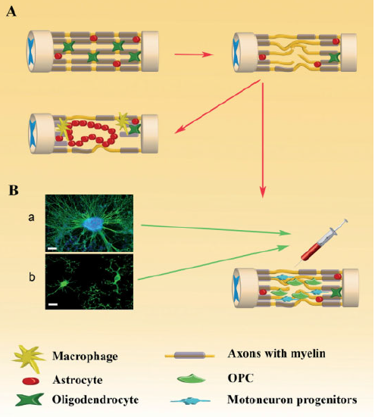
Oligodendrocyte
Astrocytes
Macrophage
Axons with myelin
OPC
Motoneuron progenitor
Figure 1. Overview of pathophysiology and stem cell treatment for SCI. (A): Following SCI the BBB is broken and the infiltrates cells from the blood invade the tissue, the astrocytes and glia are activates, and the glial scar and cysts form. (B): A proposed treatment for SCI using stem cells. Upper panel show motoneurons differentiated from human embryonic stem cells double-stained by β-tubulin type III (green) and 4’,6-diamidino-2-phenylindole (DAPI; blue). Lower panel show OPCs differentiated from neuronal stem cells that are stained by oligodendrocyte marker RIP (green). Bars=16µm (upper panel) and 50 µm (lower panel). Abbreviations: OPC, oligodendrocytes precursor cells (from Ronaghi et al., 2010).
The cell loss occurring in SCI points the cell therapy as an effective treatment for axonal regeneration and neural protection (Lukovic et al., 2012). Hence, different SCs have been studied for their application in SCI. Some of them are (Volarevic et al., 2013; Dedeepiya et al., 2014):
- Human Embryonic Stem Cells (hESCs)
- Neural Stem Progenitor Cells (NSPCs)
- Induced human Pluripotent Stem Cells (ihPSCs)
- Olfactory Ensheatihng Cells (OECs)
- Mesenquimal Stem Cells (MSCs)
- Human Umbilical Cord Blood (hUCB)
- Bone Marrow Stem Cells (BMSCs)
However, none of these therapies is completely perfect (Ronaghi et al., 2010; Dedeepiya et al., 2014). Although the drawbacks exist, animal and clinical studies are in progress (Dedeepiya et al., 2014). Advantages and disadvantages related to them are briefly shown in Table 1.
Table 1. Overview of major cell sources employed in the cell-based applications for SCI (Dedeepiya et al., 2014)
Type of cell source | Advantages | Disadvantages
hESC | Ability to differentiate into various cell linages, ability to proliferate over several passages | Immunorejection (need for immunosuppression) ethical issues, risk of teratoma
hUCB | Ease of accessibility | Need for HLA-matched donors, immunosuppression
OECs | Ability to support neurogenesis, reduced risk of hypertrophy of the CNS astrocytes, autologous transplantation possible (no graft rejection and no need for immunosuppression), easy accessibility | Differentiation potential is limited when compared with hESC, inadequate cell source particularly in autologous transplants, cell purification difficult
BMSCs | Option of using autologous  stem cells and hence lesser  chance of immunorejection | Purification is difficult,  differentiation potential limited
NSPCs | Tissue of origin similar and  hence differentiation potential  to neurons is relatively high | Isolation and directed  differentiation difficult
ihPSCs | Personalized cell therapy  possible, differentiation potential  similar to ESCs | Immunogenicity, high levels of  genomic instability

Mouse as an animal model for SCI
Mouse, Mus musculus, is a powerful system for mammalian genetic and biomedical research. (Figure 2). Mice provide effective models due to the physiology shared with humans (Nei et al., 2001; Nguyen and Xu, 2008). It is an ideal model for modeling complex human diseases and drug efficacy testing. Hypertension, diabetes, osteoporosis, glaucoma, neurological and neuromuscular disorders as well as cancer and other rare diseases are some of the conditions for what mice are in used (Paigen and Eppig, 2000).
Figure 2. Mus musculus (extracted from The Jackson Laboratories©)
Some advantages of the mouse as a model organism are (Nguyen and Xu, 2008):
- Genetic manipulation of the mouse genome
- Identification of causative mutations in the mouse genome
- Characterization of genetic background effects
- Value for inbred strains and strain panels
Regarding spinal cord injury, an elegant model was developed by Sofroniew (Faulkner et al., 2004) that allows conditional ablation of GFAP using herpex simplex virus type 1-thymidine kinase (HSV-TK; suicide gene) that is under control of mouse GFAP promoter (Faulkner et al., 2004). This model allows temporary ablation of dividing scar-forming reactive astrocytes using antiviral drug ganciclovir (GCV) in combination with different types of injury (Bush et al. 1999; Faulkner et al., 2004; Voskuhl et al. 2009).
The creation of this model arises from the controversy of the protective role of scar-formation reactive astrocytes (Sofroniew et al., 2005 and 2009; Faulkner et al., 2004), especially in synergism with transplanted cells (Lukovic et al., 2013). This mouse has been already used in SCI model (Faulkner et al., 2004) proving that reactive astrocytes are essential in tissue and neuron protection as well as damage repair. Thus, there are particular interests on the potential of transplanted cells in this model (Erceg et al., 2010).

Neural Stem Progenitor Cells
Over the past few decades, there were findings of endogenous SCs on specialized niches of the CNS (Agrawal and Schaffer, 2005; Conti and Cattaneo, 2008), presenting morphological and functional heterogeneity in each of the different microenvironments (Qin et al., 2015). These cells are called Neural Stem Progenitor Cells (NSPCs) and have the capacity of giving rise to differentiated neurons (Weiss et al., 1996; Horner et al., 2000; Shihabuddin, 2008). It implies the formation of new circuits contributing to a partial, or even a full, functional recovery after neurological damages (Yamashita et al., 2006). The molecular mechanisms underlying neurogenesis remains elusive but their future discovery will lead to alternative strategies to cell transplantation: in situ modulation after injury (Qin et al. 2015).
The endogenous SCs lining the central canal of the spinal cord are the ependymal Stem Progenitor Cells (epSPCs; Meletis et al., 2008; Barnabé-Heider et al., 2010). In homeostasis, its self-renewal capacity is diminished (Johansson et al., 1999). Exclusively, those epSPCs expressing nestin and Sox2 can differentiate into neurons (including GABAergic), astrocytes and oligodendrocytes (Weiss et al., 1996; Gage, 2000; Meletis et al., 2008; Hamilton et al., 2009). Furthermore, under homeostatic conditions, oligodendrocytes maintain self-renewal activity and can give rise to mature oligodendrocytes while astrocytes and epSPCs has limited self-duplication capacity (Johansson et al., 1999; Xu et al., 2006; Meletis et al., 2008). However, after SCI they started to migrate even outside the ependymal layer differentiating themselves into astrocytes and lesser into oligodendrocytes (Figure 3; Meletis et al., 2008; Bernabé-Heider et al., 2010). Both cell types help to protect the neural environment and to restore demyelination, respectively (Okano et al. 2003; reviewed in Ronaghi et al., 2010). Neurons do not proliferate because of the presence of Notch ligand inhibitors (Okano et al., 2003) and Chondroitin sulphate proteoglycans (CSPG; Meletis et al., 2008) from reactive astrocytes (Lukovic et al., 2012)
Distribution uninjured

Generation uninjured (4months)
Net addition injured (4months)
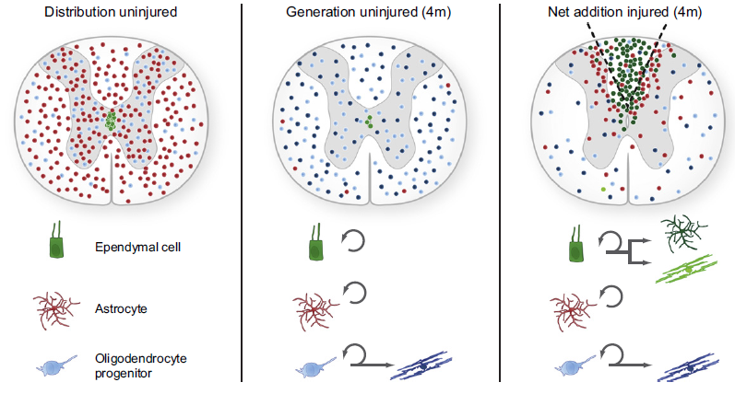
Ependymal cells
Astrocytes
Oligodendrocytes
progenitor
Figure 3. The Relative Contribution of Ependymal Cells, Astrocytes, and Oligodendrocyte Progenitors to New Glial Cells in the Adult. The distribution of ependymal cells (green), astrocytes (red), and oligodendrocyte progenitors (blue) and their progeny are shown at 50% of their estimated number. Note that the right panel depicts the net addition of new cells after injury, and that the addition of the left and right panels gives the full picture of all cells present after the lesion. (extracted from Barnabé-Heider et al., 2010)
Weiss et al. (1996) were the first to describe neurosphere culture and to demonstrate the self-renewal and differentiation capacity of epSPCs in vitro (Figure 4). Suspension culture keep intact the self-renewal ability and monolayer culture promotes the differentiation into astrocytes, oligodendrocytes and neurons (Okano et al., 2003; Coutts and Keirstead, 2008). They can be extracted from adult brain, spinal cord and optic nerve of cadavers (Coutts and Keirstead, 2008). In addition, they can be differentiated from ESCs or ihPSCs (Okano et al., 2003; Iwanami et al., 2005; Ronaghi et al., 2010).
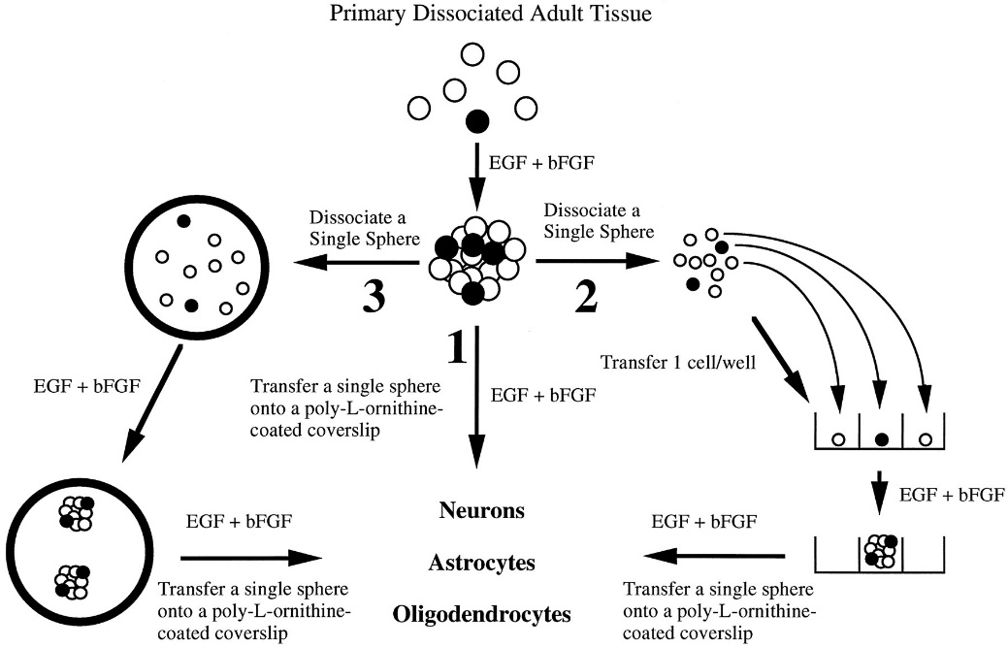
Figure 4. Schematic representation of approaches used to establish adult spinal cord stem cell proliferation, self-renewal and expansion, and production of neurons, astrocytes, and oligodendrocytes. The experimental approaches to demonstrating self-renewal and expansion of stem cells in response to EGF+bFGF are shown. When primary, dissociated adult cells are exposed to EGF+bFGF, spheres of undifferentiated cells are generated. (1) Differentiation of single primary spheres results in the production of neurons, astrocytes, and oligodendrocytes. (2) Dissociation of single primary spheres into single cells, which are plated after serial dilution as 1 cell/well, generates clonally derived secondary spheres. Differentiation of single secondary spheres results in the production of neurons, astrocytes, and oligodendrocytes. (3) Dissociation of single primary spheres into single cells, all of which are plated into one well, results in more than one secondary sphere. Once again, differentiation of these single secondary spheres results in the production of neurons, astrocytes, and oligodendrocytes (extracted from Weiss et al., 1996)
According to previous statements, two different therapeutic approaches have been studyed: recruitment of endogenous NSPCs (Meletis et al., 2008; Moreno-Manzano et al., 2008) or their transplantation (Okano et al. 2003; Ronaghi et al., 2010). In both cases, inhibition of neuronal growth must be taken into account (Okano et al. 2003). Besides, in transplantation, the time at which it is performed plays an important role in functional recovery. Okano et al. (2003), Nakamura and Toyama (2003) and Iwanami et al. (2005) agree in day 9 after injury. In that way, astrocytes and oligodendrocytes have time to form the scar and restore the blood brain barrier (Faulkner et al., 2004; Okada et al., 2006). Table 2 will show a list of pros and cons regarding NSPCs transplants (Coutts and Keirstead, 2008; Ronaghi et al., 2010).
Table 2. Pros and cons of NSPCs transplantation
Pros | Cons
Safer than ESCs | Hard to obtain a pure population of differentiated cells
No tumorigenic potential | Inefficient tracking system
 | Moderate cell survival after transplantation
 | Other obstacles regarding axonal regeneration and cell replacement

Ependymal Stem Progenitor Cells open a new window in SCI treatment (Barnabé-Heider and Frisén, 2008). In comparison with cell therapy, stimulation of endogenous epSPCs is a non-invasive procedure and it avoids immunosuppression (Meletis et al., 2008). However, the natural recruitment of epSPCs after injury does not follow a functional recovery. Therefore, it is still unknown if this kind of therapy could be beneficial or could cause even more damage contributing to the scar formation. Further studies are necessary for a better understanding of their function and their molecular regulation (Barnabé-Heider et al., 2008).

Induced human Pluripotent Stem Cells
Induced human Pluripotent Stem Cells (ihPSCs) rise as an alternative to hESC. Extracting cells from embryos or fetus leads to ethical issues hard to overcome. Furthermore, high tumorigenic and immunogenic activities are two powerful reasons to find a new approach for cell therapy. The ihPSCs offer the option of autologous transplantation avoiding host rejection (Salewski et al., 2010; Tsuji et al., 2010; Nori et al., 2011; Lucovik et al., 2012).
The ihPSCs come from differentiated tissue reprogrammed by transcription factors so that they create or simulate an embryonic-like state (morphology and differentiation potential). Differences between both cell types, embryonic and induced pluripotent cells, are epigenetic marks (methylation and global expression levels; Salewski et al., 2010; Lucovik et al., 2012) conferring some advantages. The reprogramming issue involves viral vector so that you can introduce those transcription factor genes (Oct4, Sox2, Klf4 and c-Myc; Salewski et al., 2010; Nakamura et al., 2013) in order to confer pluripotency. In other words, resulting cells will exhibit proliferative and differentiation capacity (Nakamura et al., 2013).
The creation of ihPSCs lines increases the risk of tumorigenesis which may be related to foreign provenance of inserted genes or to an incomplete reprogramming (Nakamura et al., 2013). Although the risk exists there are not much studies in which tumor proliferation appears. Using in vitro pre-differentiation lines the risk decreases (Romanyuk et al., 2014).
Viral infection and tumorigenesis are the main problems regarding ihPSCs therapy. Hence, several solution have been proposed already applied (Figure 5; Robinton and Daley, 2012; Kramer et al., 2013; Nakamura et al., 2013):
- Transient gene expression (e.g. episomal plasmids, mRNA, Sendai virus…)
- Introducing proteins
- Using drugs instead of genes
- Using minicircle vectors controlling its long-term expression
- Replacing c-Myc and Klf4 oncogenes with NANOG and LIN28 (Yu et al, 2007)
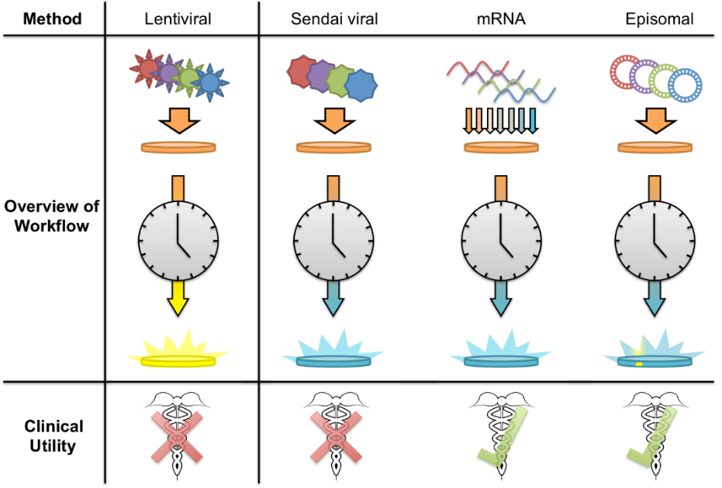
Method
Overview of workflow
Clinical utility
Lentiviral
Sendai viral
mRNA
Episomal
Figure 5. Different protocols to induce pluripotency related to their clinical use (DeVine, 2015)
Regarding the concerns previously mention, each ihPSCs line must be evaluated before clinical application (transplantation). In the case of SCI, ihPSCs will be differentiated into NSPCs (Tsuji et al., 2010; Nori et al., 2011 Lucovik et al., 2012; Nakamura et al., 2013; Romanyuk et al., 2014). Hence, the potential to generate neural cells compared with ESCs must be evaluated.
The evaluation of the efficacy constitutes an important step in ihPSCs transplantation. For SCI treatment, this type of cell line derives into a neural precursor line (iPS-NPs) capable of differentiate into the three main neural linages: astrocytes, neurons and oligodendrocytes (Tsuji et al., 2010; Nori et al., 2011; Lucovik et al., 2012; Nakamura et al., 2013; Romanyuk et al., 2014). In that way, the transplanted cells will be able to migrate, survive and communicate with the host tissue. As a consequence, somatosensory and motor deficits will be reversed. Thus, the evaluation will be focused on axonal regrowth, fulfill lesion cavity and trophic support without tumor formation (Romanyuk et al., 2014).
Romanyuk et al. (2014) as well as Hodgetts et al. (2015) reviewed several cases in which motor and sensorial loss is recovered. However, some other studies failed the purpose of improving this aspect for what Hodgetts et al. (2015) give some reasons: type of injury, rate of maturation of donor cells, inadequate myelination, undesirable ectopic projections and insufficient expression of neurotransmitters.
Summarizing, the next scheme (Figure 6), extracted from Kramer et al. (2013), shows the steps followed in order to use ihPSCs for transplantation.
Low reprogramming efficiency |  | High reprogramming efficiency
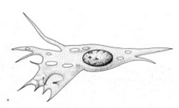 |  | 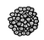
Fibroblasts |  | Neural stem cells

Cell type
e.g. Oct-4, c-myc*, klg-4*, sox-2, Nanog, lin28  (*increased tumurogenecity) |  | Alternatives  Enhancers  Substitutions  Omissions

Transcription factors
Genomic Integrations  Exision Systems  Transient Methods |  | Risk vs. efficiency vs. labor intensity vs. clinical application

Mode of Delivery
Feeder-based |  | Feeder-free |  | Xeno-free
Efficient platform, proven effective with most cell types, species & reprogramming methods |  | Important for clinical application e.g. mTesR (Stemcell Technologies) Usually requires matrix (e.g. Matrigel or Geltrex) |  | Few studies:  - Stemcell Technologies (mTesR2)  - Invitrogen (CellStart)  - Millipore (JEScGRO)

Culture Platform
Human Cell Lines |  | Non-Human Cell Lines
- Morphology  - Plutipotent Markers: IHC, PCR ¬gene arrays  - Telomerase, Alkaline Phosphatase activity  - Teratoma formation |  | - Same as human with addition of:  - Chimera formation  - Tetraploid complementation

Authentication of Pluripotency
Optimal Cell Type? |  | Non-Human Cell Lines
Astrocytes  Neurospheres  Oligo Precursor Cells |  | - Differentiation efficiency/propensity  - Purity of population – tumor concerns  - Markers (GFP, other?)

Desired Differentiation Phenotype

Figure 6. Steps followed in order to use ihPSCs for transplantation (extracted from Kramer et al., 2013)

Transfection methods
Transfection is a common tool to analyze the characteristics of cloning genes, analyze gene expression, etc. There are numerous techniques in order to introduce a particular gene inside a mammalian cell (Table 3; Washbourne and McAllister, 2002; Kingston, 2003; Karra and Dahm, 2010; Kaestner et al., 2015).
Table 3. Techniques of mammalian cell transfection (Karra and Dahm, 2010; Kaestner et al., 2015)
Classification 1 | Classification 2 | Techniques
Recombinant virus-based technologies |  | Herpes simplex virus
 |  | Adenovirus
 |  | Adeno-associated virus
 |  | Vaccinia virus
 |  | Lentivirus
 |  | Semliki-Forest virus
 |  | Retrovirus
Non-viral transfection methods | Chemical transfection | Calcium phosphate coprecipitation
 |  | Liposomes
 |  | Dendrimers
 | Physical transfection | Microinjection
 |  | Biolistics
 | Electrical Transfection | Electroporation
 |  | Nucleofection

Focusing now on viral transfection, it must be said that it is commonly used for in vivo assays because its cell specificity capacity (Kingston et al., 2003) but also for in vitro experiments like stable genomic integration and inducible expression of transgenes. Choosing a specific virus depends on the gene of interest, the target cell type and the experimental application (Karra and Dahm, 2010). Moreover, five purposes must be accomplished (Washbourne and McAllister, 2002):
- High efficiency in transfecting the desired cell line
- Constructs of varying size, including multiple constructs, should be capable of being transfected
- Limited cellular toxicity
- Easy and safe to perform
- Specifically for SCs, a high titration is required (Pears et al., 1993)
Lentiviral and retroviral vectors belong to the genera of the retroviridae. They are among the most powerful techniques for gene delivery into mammalian cells. (Romano et al., 2000; Tonini et al., 2004). Production system of both vectors is fast, reliable and safe (Pear et al, 1993; Soneoka et al., 1995; Romano et al., 2000).
On the one hand, retroviruses have kept the attention of scientific community due to its biological features. Retroviral genome is relatively simple and infect specifically diving cells. As a delivery system they are interesting because they need relatively high titer, have a broad cell tropism, lead to a stable gene expression due to viral genome integration into cell chromosomes, have a no toxic effect on infected cells and the total insert capacity is around 10kb. However, some possible adverse effect could occur as random insertion of viral genome, which may possibly results in mutagenesis and replication competent virus formation by homologous recombination.
On the other hand, lentiviruses can also infect non dividing cells which is a clear advantage for slow or non-replicative cells. The rest of the characteristics are similar to those of retroviral vectors (Romano et al., 2000; Yin et al., 2015).

Objectives
- Obtaining a clean culture of epSPCs.
- Knowing the transfection capacity of epSPCs when using a retroviral vector.

MATERIALS AND METHODS

Animals
Mice were bought to JAX® Mice (The Jackson Laboratories©; Figure 7). They are used in order to extract their spinal cord. Middle age mice (2 months) were selected for this purpose. The Ethics Committee for Animal Experimentation (EAEC) from the Foundation Prince Felipe Research Center approved this study. Moreover, the Ethical Committee for Animal Welfare (CEBA) evaluated the project assigning the number 14016. All animals were handled according to the principles of animal care published by Spanish Royal Decree 53/2013 (BOE, 2013).
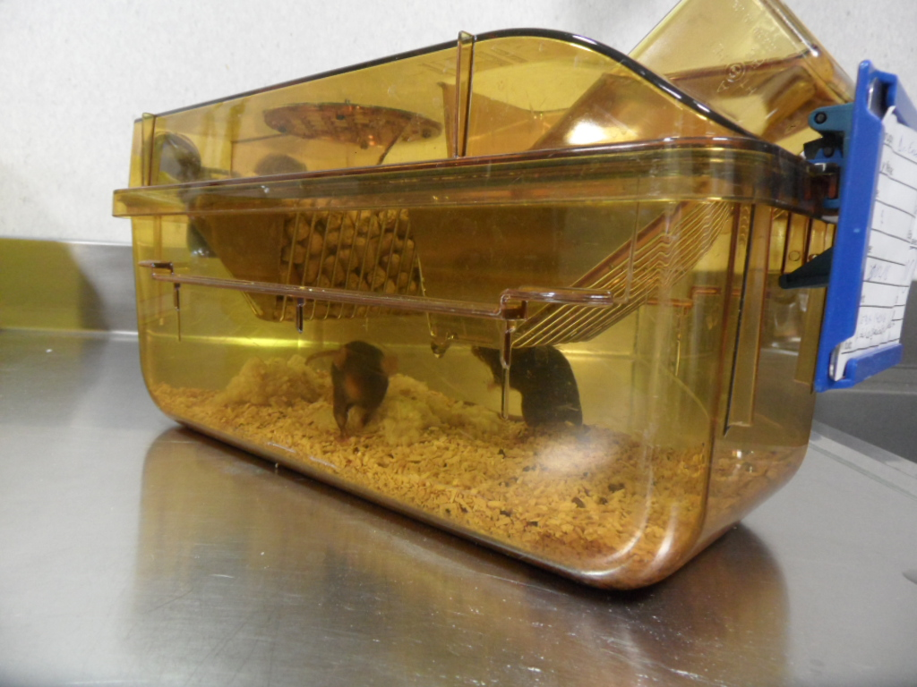
Figure 7. Mice placed at their cage with food and water access
In this study, there are two separate mouse strains: a transgenic and a wild type (the control group) (Table 4). The transgenic strain is hemizygous for the insert: HSV-TK. Cells that express HSV-TK will metabolize GCV to toxic nucleotide analogues and undergo cell death. Transgene-derived HSV-TK is present exclusively in cells expressing endogenous GFAP, for example, brain astrocytes or neural stem cells.
Table 4. Mice strains
Mice type | Strain name | Stock number
Transgenic | B6.Gg-Tg(Gfap-TK)7.1Mvs/J | 005698
Control | C57BL/6J | 000664

Neurospheres

Spinal cord extraction and primary culture
In order to obtain a primary culture of epSPCs in the form of neurospheres we follow the procedure previously described by Reynolds et al. (2005), the first step is extracting the spinal cord from our animal model. The spinal cord must be carefully extracted so that no hair is adhered to it. Hair can cause bacterial or fungal contamination. Furthermore, several cleaning steps must be perform to reduce contamination risk.
Once the spinal cord is extracted, the three layer of meninges are removed to avoid crossed contamination. The next step is the mechanic digestion of the clean spinal cord. The homogenized solution is centrifuged for 5 minutes at 1200rpm and resuspended in new complete medium (Table5 and 6) with mitogen agents. Then it is placed in a 60mm plate for 5-7 days.
Table 5. Complete medium. Supplementation of neurosphere culture medium
Products | Final concentration
DMEM/F12 (gibcoTM)
Hepes 1M (Fisher Scientific) | 5mM
NaHCO₃ 7,5% (Fisher Scientific) | 0,1%
Glucose 30% (Fisher Scientific) | 0,6%
P/S 100X (gibcoTM) | 1X
Fungizone (gibcoTM) | 250µg/mL
L-Glutamine 100X | 1X
Hormone Mix 100X (Table 6) | 10%
Insulin 10mg/µL (Sigma-Aldrich©) | 0,02mg/mL
BSA 2g/10mL (BDH Prolabo®) | 4 mg/mL
Heparine 375U/mL (Hosporina) | 0,7U/mL
EGF (gibcoTM) | 0,0004%
FGF (gibcoTM) | 0,0006%
Gentamycine (gibcoTM) | 0,001%

Table 6. Hormone Mix 100X
Products | Final concentration
DMEM/F12 (gibcoTM)
Hepes 1M (Fisher Scientific) | 4mM
NaHCO₃ 7,5% (Fisher Scientific) | 0,09%
Glucosa 30% (Fisher Scientific) | 0,5%
Progesterona 2mM (EMD Millipore) | 0,16nM
Selenio Sódico 1mM (Fisher Scientific) | 240nM
Holo-Transferrina (Sigma-Aldrich©) | 0,8mg/mL
Putrescina 0,5M (Sigma-Aldrich ©) | 90µg/mL

After 5-7 days of the primary culture neurospheres start to form and the complete medium must be changed. Neurospheres are grown in the complete medium so the way to clean the culture is collecting that medium and centrifuging it for 5 minutes at 1200rpm. The resulting pellet is resuspended in complete medium and seeded in an Ultra-Low Attach 6 Multi Well plate (ULA-6MW); 3 wells per spinal cord. The same procedure is performed each 2 or 3 days until the culture is completely clean or you want to start the infection experiment.

Infection
In order to perform the infection of epSPCs three main aspect are described: plasmid construction, plasmid purification and infection.

Plasmids
- pMX-IRES-EGFP (pMXIE)
IRES
GFP
3’ LTR
5’ LTR
ψ
Amp^{R}
pUC ori
MCS
pMXIE
7.2 kb
Figure 8. pMXIE. Plasmid containing the GFP gen.
- Amphotropic: capside retrovirus. pHCMV-AmphoEnv
pHCMV-AmphoEnv
6804 bp

Amp^{R}

MLV Amphotropic
CMV
Figure 9. pHCMV-AmphoEnv. Plasmid containing retrovirus envelope or capside.

Plasmid purification
Two different cultures are performed in order to grow bacteria containing plasmids. They are purified using the Genopure Plasmid Maxi kit® (Roche©), high-copy number plasmid protocol. Briefly, bacterial culture is centrifuged and cells are lysated. The suspension is cleared by filtration or centrifugation. The plasmid is purified thanks to a column through which the clear solution is passed. Then, DNA is isolated by isopropanol and ethanol steps.

Transfection of HEK 293 cell line, virus collection and infection of epSPCs
The method chosen to transfect HEK 293 cell line with both plasmids was a chemical transfection with liposomes. The resulted cells become a virus factory. The second transfection, infection, will be done to epSPCs with the retroviruses previously collected.
Firstly, a culture of 3x10⁶ HEK 293 cells is seeded in a 100mm plate. The next day, 20 minutes before transfection, this culture must be exposed to a free-antibiotics complete medium (DMEM High glucose (gibcoTM), 3% FBS (biowest) and 1% Penicillin/Streptomycin (gibcoTM)). The transfection solution contains OPTIMEM®, lipofectamine 2000 (InvitrogenTM) and both plasmid in a 1:1 proportion. The mixture is incubated at room temperature for 20 minutes and then is added to the plate drop-wise. After 24 hours, the medium is replaced by the complete medium of the cells you want to transfect. Next day, the supernatant of HEK 293 is collected and replaced by fresh medium. To collect the viruses the supernatant is centrifuged for 5 minutes at 3000rpm. Again, the supernatant must be took out carefully in order to not disrupting the pellet of HEK 293 cells. A mixture of the supernatant, HEPES 1M and polybrene solution 1mg/mL must be done and added to epSPCs. Infection is repeated three times in the next two days.
The same procedure is done with a second virus factory, starting one day later.

Fluorescence assay
Viral transfection efficiency is evaluated under the fluorescence microscope (blue filter, Ph1, 5X). The number of total neurospheres and the green ones are counted. Then, the percentage of transfected neurosphere is estimated.
.

RESULTS
The first objective has been overcome. Clean neurospheres were perfectly isolated from mouse spinal cord after three months of growing the baby mice, extract the spinal cord and pass the culture. Figure 10 shows the aspect of the clean culture of neurospheres.
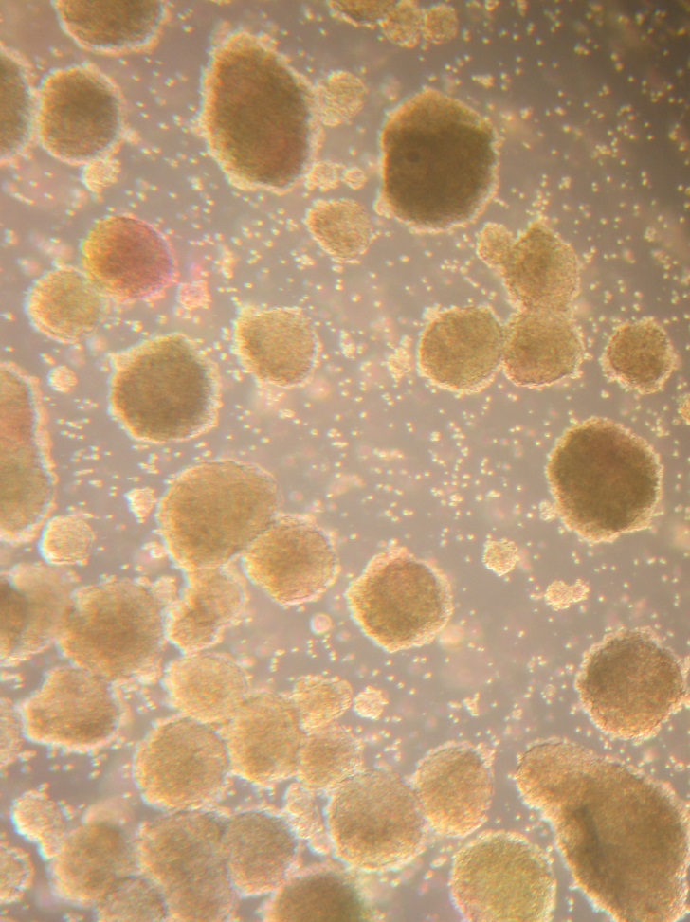
Figure 10. Clean culture of neurosphere (5X)
The viral transfection of epSPCs was performed with a total of four individuals. One of them was wild type and the other three were transgenic (HSV-TK). There is no difference between both types until ganciclovir is not administered. So we consider all experiments will behave the same way. The efficiency reach regarding the four experiment already mentioned has an average value of 41.9% ± 7.9% (Table 7).
Table 7. Efficiency of viral transfection of epSPCs
Experiment/Counting | 1 | 2 | 3 | 4
Total | 405 | 311 | 101 | 130
Infected | 183 | 160 | 33 | 53
Percentage | 45,2% | 51,4% | 32,7% | 40,8%
Media |  |  |  | 41,9%
Standard deviation |  |  |  | 7,9%

Figures 11, 12 and 13 show some of the neurospheres, either wild type or transgenic, transfected by the retrovirus.
Figure 11. Infected neurosphere with GFP via retroviral vector (1). Among all neurosphere in the captured area those ones presenting green point of fluorescence have been successfully infected. Picture was taken at zoom 5X.

Figure 12. Infected neurosphere with GFP via retroviral vector (2). Among all neurosphere in the captured area those ones presenting green point of fluorescence have been successfully infected. Picture was taken at zoom 5X.

Figure 13. Infected neurosphere with GFP via retroviral vector (3). Here we can see how this two big neurosphere are greatly infected. Picture was taken at zoom 5X.

DISCUSSION
Gene transfer via viral infection is a powerful tool for long lasting expression (Kingston, 2003; Karra and Dahm, 2010). In particular, it is used in neurosphere in order to elucidate molecular pathways related to regeneration, study gene expression or evaluate the behavior under certain circumstances (Bartrem et al., 2010; Serrano-Pérez et al., 2015). In this particular case, we are inserting a sequence which encodes the GFP because the aim of the project is creating a cell line of green NSPCs usable for monitoring in vivo the migration, differentiation and integration of those cells. For that reasons, pluripotency and differentiation capacities should be maintained after infection as it is proved by Bartrem et al. (2010). This line will be a potent tool for further studies of CNS regeneration.
Different viral vector have been used for gene delivery into neurospheres, some examples are adenovirus (Fu et al., 2008; Bartrem et al., 2010), lentivirus (Suzuki et al., 2002; Zhou et al., 2015) or retrovirus (Yamamoto et al., 2001). Hence, different efficiencies were achieved. Bartrem et al (2015) conclude that for a good infection the viral titration must not interfere neither in cell viability nor neurosphere reconstitution. Then, correct efficiency was a 50%. Furthermore, they also postulate that dissociation of neurospheres increase the efficiency so the viral titration may be reduced. Suzuki et al. (2002) and Zhou et al. (2015) reach around an 80% of efficiency with a lentivirus while Yamamoto et al. (2001) poorly get a 10% of infection employing a retrovirus. In comparison, we reach a 41.9% of infection, much higher than the obtained in Yamamoto et al. (2001) experiments. However, lentiviral transfection probably could achieved a higher efficiency because they not only infect dividing cells but also non-dividing ones (Romano et al., 2000; Yin et al., 2015).
As previously mention, neurosphere dissociation increases efficiency of infection so it is reasonable to think that the efficiency was dependent on the size of the neurospheres, in other words, virus penetration capacity is limited (Bartrem et al., 2010). Besides, this might be the explanation to the fact that the majority of neurospheres are not completely green but they only present green point inside them.

CONCLUSION
Neurospheres was successfully isolated from our animal model, allowing their transfection.
Employing this methodology, around a 40% of epSPCs are infected with GFP. It provides a potent tool for further studies in differentiation, migration and integration of epSPCs directly related with regeneration and replacement therapies.

FUTURE PERSPECTIVES
After transfecting epSPCs with GFP there are some other issues that must be done to continue the project. On the one hand, neurosphere would be used for cellular transplantation in order to see the migration of differentiated cells in vivo. For that purpose green and non-green cell populations are separated by sorting.
On the other hand, ihPSCs would be transfected to repeat the process we followed using epSPCs: in vivo monitoring of those cells. GFP transfection must be fine tunning because nobody else has transfected them before with a viral vector. The way researchers have accomplished this goal was by inserting GFP sequence in the same construction of pluripotency transcription factors when reprogramming somatic cells (Stadtfeld et al., 2008; Kim et al., 2012) or by nucleation and liposome as Chartterjee et al. (2011) did.

LITERATURE
Addgene. pHCMV-AmphoEnv. Last seen: June 12, 2015. Available in: http://www.addgene.org/15799/
Addgene. pMX-IRES-GFP. Last seen: June 12, 2015. Available in: https://www.addgene.org/vector-database/3673/
Agrawal S, Schaffer D. 2005. In situ stem cell therapy: novel targets, familiar chanllenges. Trends Biotechnol 23:78-83
Balentine JD. Pathology of experimental spinal cord trauma, I: the necrotic lesion as a function of vascular injury. Lab Invest 1978;39: 236–253.
Barnabé-Heider F, Frisén J. Stem cells for spinal cord repair. Cell Stem Cell. 2008 Jul 3;3(1):16-24. doi: 10.1016/j.stem.2008.06.011. Review. PubMed PMID: 18593555.
Barnabé-Heider F, Göritz C, Sabelström H, Takebayashi H, Pfrieger FW, Meletis K, Frisén J. Origin of new glial cells in intact and injured adult spinal cord. Cell Stem Cell. 2010 Oct 8;7(4):470-82. doi: 10.1016/j.stem.2010.07.014. PubMed PMID: 20887953.
Batista CE, Mariano ED, Marie SK, Teixeira MJ, Morgalla M, Tatagiba M, Li J, Lepski G. Stem cells in neurology--current perspectives. Arq Neuropsiquiatr. 2014Jun;72(6):457-65. Review. PubMed PMID: 24964114.
Bertram CM, Hawes SM, Egli S, Peh SL, Dottori M, Kees UR, Dallas PB. Effective adenovirus-mediated gene transfer into neural stem cells derived from human embryonic stem cells. Stem Cells Dev. 2010 Apr;19(4):569-78. doi: 10.1089/scd.2009.0183. PubMed PMID: 19594361.
Braughler JM, Duncan LA, Chase RL. Interaction of lipid peroxidation and calcium in the pathogenesis of neuronal injury. Cent Nerv Syst Trauma 1985;2:269–283.
Bush TG, Puvanachandra N, Horner CH, Polito A, Ostenfeld T, Svendsen CN, et al. Leukocyte infiltration, neuronal degeneration, and neurite outgrowth after ablation of scar-forming, reactive astrocytes in adult transgenic mice. Neuron 1999;23(2):297-308.
Chatterjee P, Cheung Y, Liew C. Transfecting and Nucleofecting Human Induced Pluripotent Stem Cells. Journal of Visualized Experiments : JoVE. 2011;(56):3110. doi:10.3791/3110.
ContiL, Cattaneo E. 2008. Novel and immortalization-based protocols for the generation of neural CNS stem cell lines for gene therap approaches. Methods Mol Bio 438:319-932
Coutts, M., & Keirstead, H. S. (2008). Stem cells for the treatment of spinal cord injury. Experimental neurology, 209(2), 368-377.
Dedeepiya VD, William JB, Parthiban JK, Chidambaram R, Balamurugan M, Kuroda S, Iwasaki M, Preethy S, Abraham SJ. The known-unknowns in spinal cord injury, with emphasis on cell-based therapies - a review with suggestive arenas for research. Expert Opin Biol Ther. 2014 May;14(5):617-34. doi:10.1517/14712598.2014.889676. Epub 2014 Mar 24. Review. PubMed PMID: 24660978.
DeVine, Alexandre. Boston Children’s Hospital’s science and clinical innovation blog. Induced pluripotent stem cells: Choosing a reprogramming method. February 12, 2015. Last visit: May 4, 2015. Available on: http://vector.childrenshospital.org/2015/02/induced-pluripotent-stem-cells-choosing-a-reprogramming-method/
Erceg S, Ronaghi M, Oria M, Rosello MG, Arago MA, Lopez MG, et al. Transplanted oligodendrocytes and motoneuron progenitors generated from human embryonic stem cells promote locomotor recovery after spinal cord transection. Stem Cells 2010;28(9):1541-9.
Faulkner JR, Herrmann JE, Woo MJ, Tansey KE, Doan NB, Sofroniew MV. Reactive astrocytes protect tissue and preserve function after spinal cord injury. J Neurosci 2004;24(9):2143-55.
Fred H. Gage. Mammalian Neural Stem Cells. Science 25 February 2000: 287 (5457), 1433-1438. [DOI:10.1126/science.287.5457.1433]
Hamilton LK, Truong MK, Bednarczyk MR, Aumont A, Fernandes KJ. 2009. Cellular organization of the central canal ependymal zone, a niche of latent neural stem cells in the adult mammalian spinal cord. Nueroscience 164:1044-1056
Hodgetts, Stuart I., Michael Edel, and Alan R. Harvey. The State of Play with iPSCs and Spinal Cord Injury Models. Journal of Clinical Medicine 4.1 (2015): 193-203.
Horner P, Power A, Kempermann G, Kuhn H, Palmer T, WinklerJ, Thal L, Gage F. 2000. Proliferation and differentiation of progenitor cells throughout the intact adult spinal cord. J Neurosci 20:2228-2228
Hu BY, Weick JP, Yu J, Ma LX, Zhang XQ, Thomson JA, Zhang SC. Neural differentiation of human induced pluripotent stem cells follows developmental principles but with variable potency. Proc Natl Acad Sci U S A. 2010 Mar 2;107(9):4335-40. doi: 10.1073/pnas.0910012107. Epub 2010 Feb 16. PubMed PMID: 20160098; PubMed Central PMCID: PMC2840097.
Iwanami A, Kaneko S, Nakamura M, Kanemura Y, Mori H, Kobayashi S, Yamasaki M, Momoshima S, Ishii H, Ando K, Tanioka Y, Tamaoki N, Nomura T, Toyama Y, Okano H. Transplantation of human neural stem cells for spinal cord injury in primates. J Neurosci Res. 2005 Apr 15;80(2):182-90. PubMed PMID: 15772979.
Johansson CB, Momma S, Clarke DL, Risling M, Lendahl U, et al. (1999) Identification of a neural stem cell in the adult mammalian central nervous system. Cell 96: 25–34.
Kaestner L, Scholz A, Lipp P. Conceptual and technical aspects of transfection and gene delivery. Bioorg Med Chem Lett. 2015 Mar 15;25(6):1171-6. doi: 10.1016/j.bmcl.2015.01.018. Epub 2015 Jan 28. Review. PubMed PMID: 25677659.
Karra D, Dahm R. Transfection techniques for neuronal cells. J Neurosci. 2010 May 5;30(18):6171-7. doi: 10.1523/JNEUROSCI.0183-10.2010. Review. PubMed PMID: 20445041.
Kingston, R. E. 2003. Introduction of DNA into Mammalian Cells. Current Protocols in Molecular Biology. 64:9.0:9.0.1–9.0.5.
Kramer AS, Harvey AR, Plant GW, Hodgetts SI. Systematic review of induced pluripotent stem cell technology as a potential clinical therapy for spinal cord injury. Cell Transplant. 2013;22(4):571-617. doi: 10.3727/096368912X655208. Epub 2012 Aug 27. Review. PubMed PMID: 22944020.
Lukovic D, Moreno Manzano V, Stojkovic M, Bhattacharya SS, Erceg S. Concise review: human pluripotent stem cells in the treatment of spinal cord injury. Stem Cells. 2012 Sep;30(9):1787-92. doi: 10.1002/stem.1159. Review. PubMed PMID:22736576.
Lukovic D, Valdes-Sanchez L, Sanchez-Vera I, Moreno-Manzano V, Stojkovic M, Bhattacharya SS, et al. Astrogliosis promotes functional recovery of completely transected spinal cord following transplantation of hESC-derived oligodendrocyte and motoneuron progenitors. Stem Cells 2013.
Miller, A. Dusty, and Guy J. Rosman. Improved Retroviral Vectors for Gene Transfer and Expression. BioTechniques 7.9 (1989): 980–990. Print.
Meletis K, Barnabé-Heider F, Carlén M, Evergren E, Tomilin N, Shupliakov O, Frisén J. Spinal cord injury reveals multilineage differentiation of ependymal cells. PLoS Biol. 2008 Jul 22;6(7):e182. doi: 10.1371/journal.pbio.0060182. PubMed PMID: 18651793; PubMed Central PMCID: PMC2475541.
Moreno-Manzano V, Rodríguez-Jiménez FJ, García-Roselló M, Laínez S, Erceg S, Calvo MT, Ronaghi M, Lloret M, Planells-Cases R, Sánchez-Puelles JM, Stojkovic M. Activated spinal cord ependymal stem cells rescue neurological function. Stem Cells. 2009 Mar;27(3):733-43. doi: 10.1002/stem.24. PubMed PMID: 19259940.
Nakamura M, Toyama Y. Transplantation of neural stem cells into spinal cord after injury. Nihon Rinsho. 2003 Mar;61(3):463-8. Review. Japanese. PubMed PMID: 12701174.
Nakamura M, Okano H. Cell transplantation therapies for spinal cord injury focusing on induced pluripotent stem cells. Cell Res. 2013 Jan;23(1):70-80. doi: 10.1038/cr.2012.171. Epub 2012 Dec 11. Review. PubMed PMID: 23229514; PubMed Central PMCID: PMC3541652.
Nei M., Xu P., Glazko G. (2001). Estimation of divergence times from multiprotein sequences for a few mammalian species and several distantly related organisms. Proc. Natl. Acad. Sci. USA 98, 2497–2502.
Nguyen D, Xu T. The expanding role of mouse genetics for understanding human biology and disease. Dis Model Mech. 2008 Jul-Aug;1(1):56-66. doi: 10.1242/dmm.000232. PubMed PMID: 19048054; PubMed Central PMCID: PMC2561976.
Nori S, Okada Y, Yasuda A, Tsuji O, Takahashi Y, Kobayashi Y, Fujiyoshi K, Koike M, Uchiyama Y, Ikeda E, Toyama Y, Yamanaka S, Nakamura M, Okano H. Grafted human-induced pluripotent stem-cell-derived neurospheres promote motor functional recovery after spinal cord injury in mice. Proc Natl Acad Sci U S A. 2011 Oct 4;108(40):16825-30. doi: 10.1073/pnas.1108077108. Epub 2011 Sep 26. PubMed PMID: 21949375; PubMed Central PMCID: PMC3189018.
Okada, S., Nakamura, M., Katoh, H., Miyao, T., Shimazaki, T., Ishii, K., Yamane, J., Yoshimura, A., Iwamoto, Y., Toyama, Y., et al. (2006). Conditional ablation of Stat3 or Socs3 discloses a dual role for reactive astrocytes after spinal cord injury. Nat. Med. 12, 829–834.
Okano H, Ogawa Y, Nakamura M, Kaneko S, Iwanami A, Toyama Y. Transplantation of neural stem cells into the spinal cord after injury. Semin Cell Dev Biol. 2003 Jun;14(3):191-8. Review. PubMed PMID: 12948354.
Paigen K., Eppig J. (2000). A mouse phenome project. Mamm. Genome 11, 715–717.
Pear WS, Nolan GP, Scott ML, Baltimore D. Production of high-titer helper-free retroviruses by transient transfection. Proc Natl Acad Sci U S A. 1993 Sep 15;90(18):8392-6. PubMed PMID: 7690960; PubMed Central PMCID: PMC47362.
Qin Y, Zhang W, Yang P. Current states of endogenous stem cells in adult spinal cord. J Neurosci Res. 2015 Mar;93(3):391-8. doi: 10.1002/jnr.23480. Epub 2014 Sep 16. PubMed PMID: 25228050.
Reynolds BA, Rietze RL. Neural stem cells and neurospheres—Reevaluating the relationship. Nat Methods. 2005 May;2(5):333-6. PubMed PMID: 15846359.
Robinton DA, Daley GQ. The promise of induced pluripotent stem cells in research and therapy. Nature. 2012 Jan 18;481(7381):295-305. doi: 10.1038/nature10761. Review. PubMed PMID: 22258608; PubMed Central PMCID: PMC3652331.
Romano G, Michell P, Pacilio C, Giordano A. Latest developments in gene transfer technology: achievements, perspectives, and controversies over therapeutic applications. Stem Cells. 2000;18(1):19-39. Review. PubMed PMID: 10661569.
Romanyuk N, Amemori T, Turnovcova K, Prochazka P, Onteniente B, Sykova E, Jendelova P. Beneficial effect of human induced pluripotent stem cell-derived neural precursors in spinal cord injury repair. Cell Transplant. 2014 Aug 19. [Epub ahead of print] PubMed PMID: 25259685.
Ronaghi M, Erceg S, Moreno-Manzano V, Stojkovic M. Challenges of stem cell therapy for spinal cord injury: human embryonic stem cells, endogenous neural stem cells, or induced pluripotent stem cells? Stem Cells. 2010 Jan;28(1):93-9. doi: 10.1002/stem.253. Review. PubMed PMID: 19904738.
Rothman SM, Olney JW. Glutamate and the pathophysiology of hypoxic-ischemic brain damage. Ann Neurol 1986;19:105–111.
Rowland JW, Hawryluk GW, Kwon B et al. Current status of acute spinal cord injury pathophysiology and emerging therapies: promise on the horizon. Neurosurg Focus 2008;25:E2.
Salewski RP, Eftekharpour E, Fehlings MG. Are induced pluripotent stem cells the future of cell-based regenerative therapies for spinal cord injury? J Cell Physiol. 2010 Mar;222(3):515-21. doi: 10.1002/jcp.21995. Review. PubMed PMID: 20020443.
Serrano-Pérez MC, Fernández M, Neria F, Berjón-Otero M, Doncel-Pérez E, Cano E, Tranque P. NFAT transcription factors regulate survival, proliferation, migration, and differentiation of neural precursor cells. Glia. 2015 Jun;63(6):987-1004. doi: 10.1002/glia.22797. Epub 2015 Mar 2. PubMed PMID: 25731131.
Shihabuddin L. 2008. Adult rodent spinal cord-derived neural stem cells: isolation ans characterization. Methods Mol Bio 438:55-66
Sofroniew MV. Reactive astrocytes in neural repair and protection. Neuroscientist 2005;11(5):400-7.
Sofroniew MV. Molecular dissection of reactive astrogliosis and glial scar formation. Trends Neurosci 2009;32(12):638-47.
Soneoka, Y., Cannon, P. M., Ramsdale, E. E., Griffiths, J. C., Romano, G., Kingsman, S. M., et al. (1995) A transient three-plasmid expression system for the production of high titer retroviral vectors. Nucleic Acids Res. 23, 628–633
Stenudd M, Sabelström H, Frisén J. Role of endogenous neural stem cells in spinal cord injury and repair. JAMA Neurol. 2015 Feb;72(2):235-7. doi: 10.1001/jamaneurol.2014.2927. Review. PubMed PMID: 25531583.
Suzuki, A., Obi, K., Urabe, T., Hayakawa, H., Yamada, M., Kaneko, S., Onodera, M., Mizuno, Y. and Mochizuki, H. (2002), Feasibility of ex vivo gene therapy for neurological disorders using the new retroviral vector GCDNsap packaged in the vesicular stomatitis virus G protein. Journal of Neurochemistry, 82: 953–960. doi: 10.1046/j.1471-4159.2002.01048.x
Tateishi K, He J, Taranova O, Liang G, D'Alessio AC, Zhang Y. Generation of insulin-secreting islet-like clusters from human skin fibroblasts. J Biol Chem. 2008 Nov 14;283(46):31601-7. doi: 10.1074/jbc.M806597200. Epub 2008 Sep 9. PubMed PMID: 18782754.
Thompson CD, Frazier-Jessen MR, Rawat R, Nordan RP, Brown RT. Evaluation of methods for transient transfection of a murine macrophage cell line, RAW 264.7. Biotechniques. 1999 Oct;27(4):824-6, 828-30, 832. PubMed PMID: 10524325.
Tonini T, Claudio PP, Giordano A, Romano G. Transient production of retroviral- and lentiviral-based vectors for the transduction of Mammalian cells. Methods Mol Biol. 2004;285:141-8. Review. PubMed PMID: 15269408.
Tsuji O, Miura K, Okada Y, Fujiyoshi K, Mukaino M, Nagoshi N, Kitamura K, Kumagai G, Nishino M, Tomisato S, Higashi H, Nagai T, Katoh H, Kohda K, Matsuzaki Y, Yuzaki M, Ikeda E, Toyama Y, Nakamura M, Yamanaka S, Okano H. Therapeutic potential of appropriately evaluated safe-induced pluripotent stem cells for spinal cord injury. Proc Natl Acad Sci U S A. 2010 Jul 13;107(28):12704-9. doi: 10.1073/pnas.0910106107. Epub 2010 Jul 6. PubMed PMID: 20615974; PubMed Central PMCID: PMC2906548.
Volarevic V, Erceg S, Bhattacharya SS, Stojkovic P, Horner P, Stojkovic M. Stem cell-based therapy for spinal cord injury. Cell Transplant. 2013;22(8):1309-23. doi: 10.3727/096368912X657260. Epub 2012 Oct 3. Review. PubMed PMID: 23043847.
Voskuhl RR, Peterson RS, Song B, Ao Y, Morales LB, Tiwari-Woodruff S, et al. Reactive astrocytes form scar-like perivascular barriers to leukocytes during adaptive immune inflammation of the CNS. J Neurosci 2009;29(37):11511-22.
Washbourne P, McAllister AK. Techniques for gene transfer into neurons. Curr Opin Neurobiol. 2002 Oct;12(5):566-73. Review. PubMed PMID: 12367637.
Weiss S, Dunne C, Hewson J, Wohl C, Wheatly M, Peterson A, ReynoldsB. 1996. Multipotent CNS stem cell are present in the adult mammalian spinal cord and ventricular neuroaxis. J Neurosci 16:7599-7609
Xu Y, Kitada M, Yamaguchi M, Dezawa M, Ide C. 2006. Increase in bFGF-responsive neural progenitor population following contusion injury of the adult rodent spinal cord. Neurosci Lett 397:174-179
Yamashita T, Ninomiya M, Acosta PH, García.Verdugo J, Sunabori T, Sakaguchi M, Adachi K, Kojima T, Hirota Y, Kawase T, Araki N, Abe K, Okano H, Sawamoto K. 2006. Subventricular zone-derived neuroblasts migrate and differentiate into mature neurons in the post-stroke adult striatum. J Nuerosci 26:6627-6636
Yin, P. T., Han, E. and Lee, K.-B. (2015), Engineering Stem Cells for Biomedical Applications. Advanced Healthcare Materials. doi: 10.1002/adhm.201400842
Young W, Koreh I. Potassium and calcium changes in injured spinal cords. Brain Res 1986;365:42–53.
Yu, J., Vodyanik, M. A., Smuga-Otto, K., Antosiewicz-Bourget, J., Frane, J. L., Tian, S., et al. (2007). Induced pluripotent stem cell lines derived from human somatic cells. Science, 318 (5858), 1917–1920. doi: 10.1126/science.1151526
Zaehres H, Lensch MW, Daheron L, Stewart SA, Itskovitz-Eldor J, Daley GQ. High-efficiency RNA interference in human embryonic stem cells. Stem Cells. 2005 Mar;23(3):299-305. PubMed PMID: 15749924.
Zhou FW, Fortin JM, Chen HX, Martinez-Diaz H, Chang LJ, Reynolds BA, Roper SN. Functional integration of human neural precursor cells in mouse cortex. PLoS One. 2015 Mar 12;10(3):e0120281. doi: 10.1371/journal.pone.0120281. eCollection 2015. PubMed PMID: 25763840; PubMed Central PMCID: PMC4357458.

